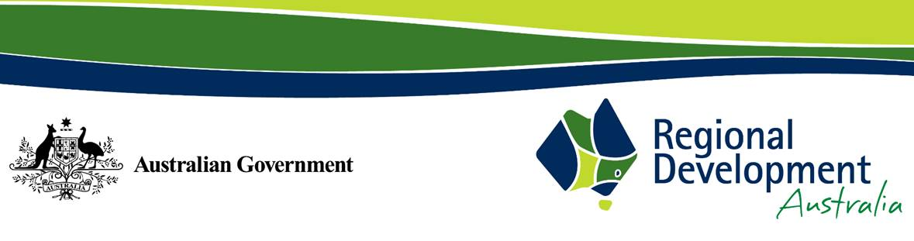

17 May 2023

Early Childhood Education and Care

Productivity Commission

Locked Bag 2, Collins Street East

MELBOURNE VIC 8003

# RE: Submission on the Inquiry into Early Childhood Education and Care (ECEC)

Thank you for the opportunity to provide a submission on the Productivity Commission inquiry into Early Childhood Education and Care (ECEC).

# Regional Development Australia (RDA)

Regional Development Australia (RDA) is a partnership between the Australian, state and territory and local governments to support the growth and development of Australia's regions.

This Australian Government initiative brings together all levels of government, business and community to support the development of regional Australia.

RDA Committees have an active and facilitative role in their communities with a clear focus on growing strong and confident regional economies that harness their competitive advantages, seize economic opportunities and attract investment.

Regional Development Australia Barwon South West (RDA BSW) regularly provides advice to the Australian Government and is committed to working with stakeholders across the region on critical development issues that positively and negatively affect the region.

# Childcare in the Barwon South West

With low childcare availability, our rural workforce is further depleted, and children are missing out on important early-years education. The ‘Enabling Early Childhood Education & Childcare in Rural Areas’ report says investing in the recommended interventions would have a BCR of $1.32 for every $1 spent.

While there are many reasons driving women’s workforce participation, access to childcare is recognised as a significant factor, particularly in the Barwon South West region and even more so in remote towns such as Apollo Bay and Hawkesdale. The largest employing sectors for women are healthcare and social assistance, retail trade, education and training, accommodation and food services, all experiencing significant workforce shortages.

Issues with accessing childcare are most acute in rural and regional areas. Of the 1.1 million Australians with no access to centre-based day care within a twenty-minute drive, almost all of these are outside Australia’s major cities. (Mitchell Institute and Victoria University - Election 2022 Education policy brief: Early childhood education and care).

Please see attached case studies that outline some of the challenges faced in regional and rural areas. (Case Study 1 and Case Study 2).

Should you wish to discuss any details within the submission, please do not hesitate to contact me via email [rda.barwonsouthwest@rdv.vic.gov.au](mailto:rda.barwonsouthwest@rdv.vic.gov.au).

Yours sincerely,

Anita Rank

Chair

Regional Development Australia Barwon South West

# Attachments

* Case Study 1: Productivity Commission Inquiry into Early Childhood Education – Apollo Bay Case Study
* Case Study 2: Productivity Commission Inquiry into Early Childhood Education – Glenelg Shire Council Case Study

