










Western Victoria Grain Industry Supply Chain Study
  - Final Report

March 2025


The Power of Commitment



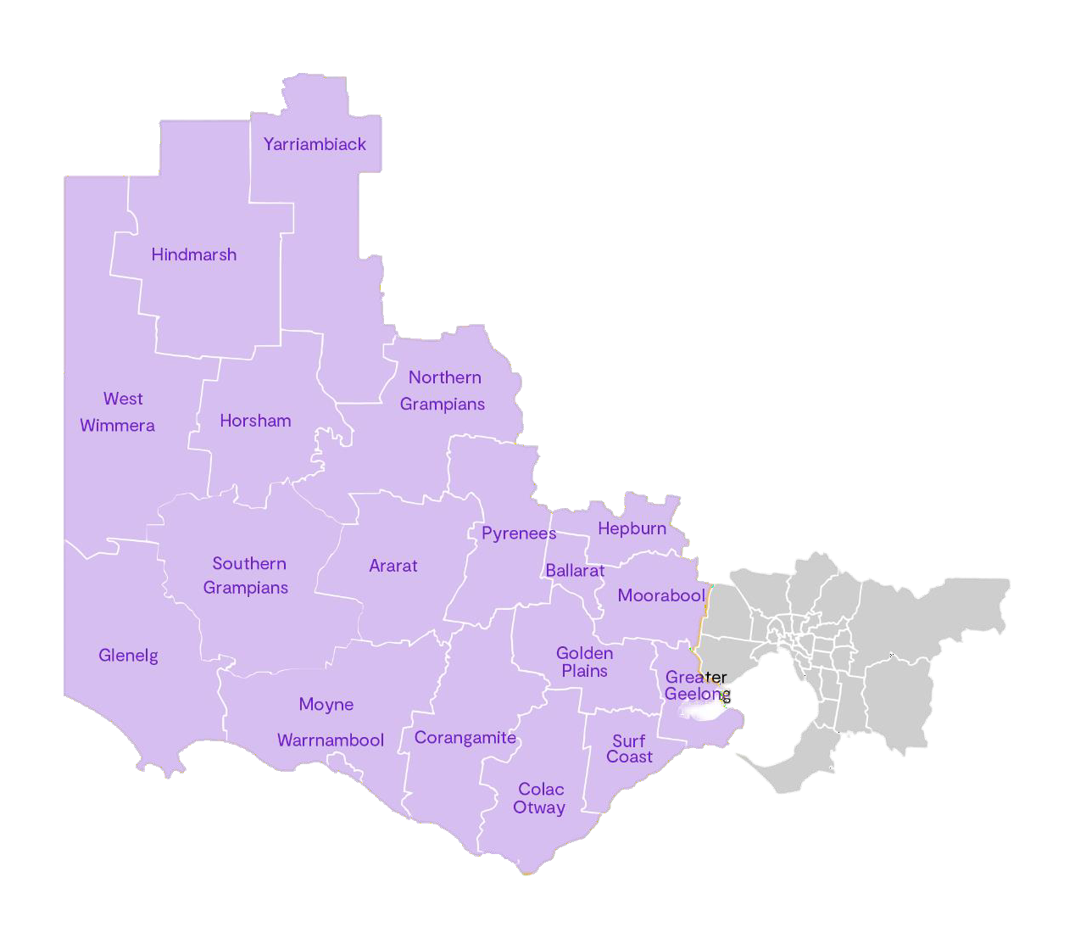
Executive Summary

Victoria’s grain industry plays a pivotal role in the agricultural sector, with six million tonnes of various grain crops exported internationally in 2021 and 2022, accounting for 39 per cent of all national exports. During the same period, Victoria’s grain consumption was the second highest in Australia, representing 25 per cent of national consumption. This demand, combined with bulk export needs, exerts pressure on both the domestic and international supply chain.

The grain industry in Victoria is on an upward trajectory, with bulk exports in 2021 and 2022 soaring 124 per cent above average. A significant portion of this supply comes from
Victoria’s Western Region. Both rail and road transport are vital to the domestic and bulk export supply chain, transporting produce from farms and regional areas to storage facilities and ports. Despite recent improvements to the regional transport infrastructure, there are still opportunities for further enhancements to bring lasting benefits and improved freight efficiency to the grain industry and supply chain network.

The study area encompasses local government areas in Victoria’s west which service the three commercial ports including Port of Portland, Geelong Port and Port of Melbourne. It is important to note that the grain production
inputs informing the supply chain mapping extend beyond the study area into northwest Victoria, South Australia and southern New South Wales, as these inputs significantly influence both the upstream and downstream supply chain. The study area is summarised in the figure below.

The study area boundary was determined by the Steering Committee However, most of the grain production occurs outside this boundary, where local road activity is primarily observed, as confirmed through stakeholder engagement. Consequently, the local road analysis in this report is limited. within the study area.

Study area
11.61m
Tonnes consumed
3.85m
Tonnes consumed domestically
1.71m
Total exported in containers

6.05m
Tonnes exported in bulk
Source: ACCC Bulk Grain Monitoring
Report – 2021-22

The grain supply chain plays a crucial role in the Victorian economy

The grain industry is a key driver of the state’s economy, with major grain commodities contributing significantly to the gross value. Wheat, barley, and canola alone account for $1.27 billion, $850 million, and $437 million respectively, according to Agriculture Victoria.
Furthermore, the sector employed approximately 9,700 individuals on grain production farms during the 2020- 2021 period.

In a wider context, Western Victoria significantly contributes to the national grain production landscape. Victoria represents a significant 17.5 per cent of the national gross value of grain production, amounting to
$20.3 billion. This positions Victoria as the third-largest grain producer in Australia, following New South Wales and Western Australia, which contribute $6.8 billion and
Grain production in Western Victoria caters to both bulk export and domestic demand. The supply chain primarily involves key freight routes between regional storage facilities and ports in Portland, Geelong, and Melbourne. However, overlooking local roads between major areas of activity could potentially create efficiency gaps in the supply chain. The main challenge for a multi-modal supply chain network is to identify where efficiencies can be achieved between modes, without overloading specific routes.

In 2020-21, grain farms in Western Victoria, specifically within the Great South Coast, Wimmera Southern Mallee, Barwon, and Central Highlands Regional Partnerships areas accounted for approximately half of Victoria’s total grain production. Including Regional Partnerships areas


$5.85 billion respectively. These figures highlight the region’s crucial role in the Australian grain industry,
reinforcing its economic importance.
in Victoria’s northwest, such as the Mallee and Loddon Campaspe areas, this figure rises to almost 90 per cent.
Western Australia
18.18m
tonnes exported
Queensland
2.90m
tonnes exported
South Australia
7.21m
tonnes exported
New South Wales
6.23m
tonnes exported
$20.3 billion
Victoria
6.05m
tonnes exported
Worth of grain produced in Victoria 2020-21

2021-22 bulk grain exports tonnage by state compared to average (Image source: ACCC)

The grain supply chain in Western Victoria is complex

The grain industry thrived during the high annual rainfall harvests of 2022-23, leading to a record harvest. Above- average winter rainfalls for 2021-22 and 2022-23 have resulted in the expected area planted for grain crops in 2023-24 being six per cent above the historical 10-year average. This increase is likely due to grain farmers capitalising on the soil’s high moisture content to realise their full planting intentions.

Inputs into grain production, including seed grain, fertiliser, agricultural chemicals, machinery, water, fuel, and skilled labour, significantly impact crop yield and, consequently, the volume of products entering the supply chain. However, this study only considers these inputs at a high level.

Stored grains undergo processing before being dispatched to export gateways or domestic consumption channels. This processing step, categorised as either ‘wet’ or ‘dry’, is a crucial element in the grain supply chain as it enhances operational efficiencies by reducing waste and improving the nutritive value of the grain. Grains requiring ‘wet’ processing techniques, such as sorghum
and corn, represented less than one per cent of Victoria’s
total grain production in 2020-21.

Approximately 40 per cent of processed grains are sent to the market for domestic consumption or towards ports in Portland, Geelong, or Melbourne for bulk exportation. Victoria boasts four bulk grain port terminal facilities, operated by GrainCorp, Emerald, Port of Portland, and Riordan, which enhance the efficiency of the supply chain.

The next step of the supply chain sees approximately 40 per cent of processed grains sent to market for domestic consumption, or towards ports in Portland, Geelong or Melbourne for bulk exportation. Victoria has four bulk grain port terminal facilities. GrainCorp operates facilities at Geelong and Portland, Emerald operates a facility at the port of Melbourne, and Port of Portland (POPL) operates a facility at Portland. Riordan also utilises a mobile ship loading facility that moves between Geelong and Portland.

EXPORT SUPPLY CHAIN

Road

On-Farm Storage

Road
Packer
Rail / Road

Port
Ship (bulk/ container)

Off-Farm Storage

Bulk
Rail/ Road

On-Farm
Storage
Wholesaler/ warehouse

Seedlings, fertiliser, chemicals, machinery, water and fuel

INPUTS

Farm Grain Grower
Domestic Market (livestock)

Off-Farm Storage

Farm feedlot
Domestic Market (human)

Processor
Restaurants, bakeries, retailers, industrial, supermarkets, farms and feedlots
DOMESTIC CONSUMPTION





Import

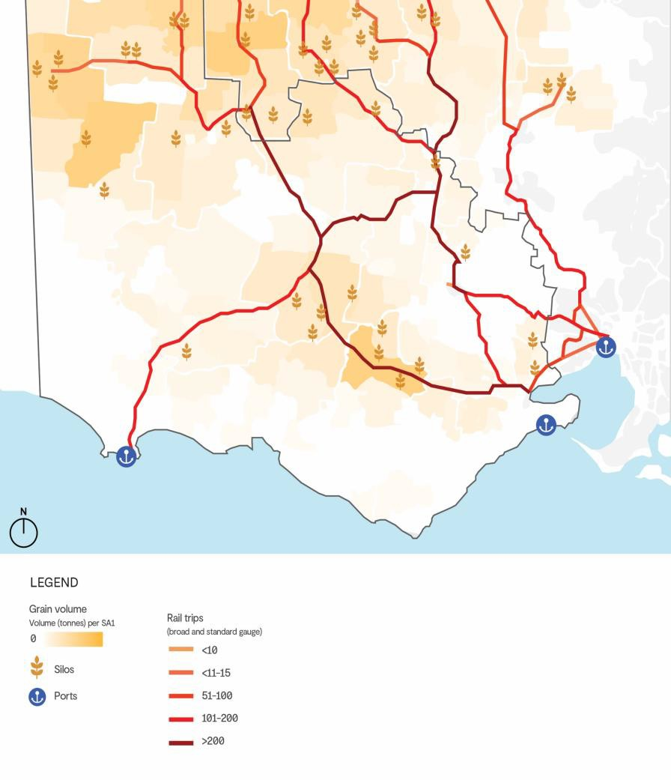
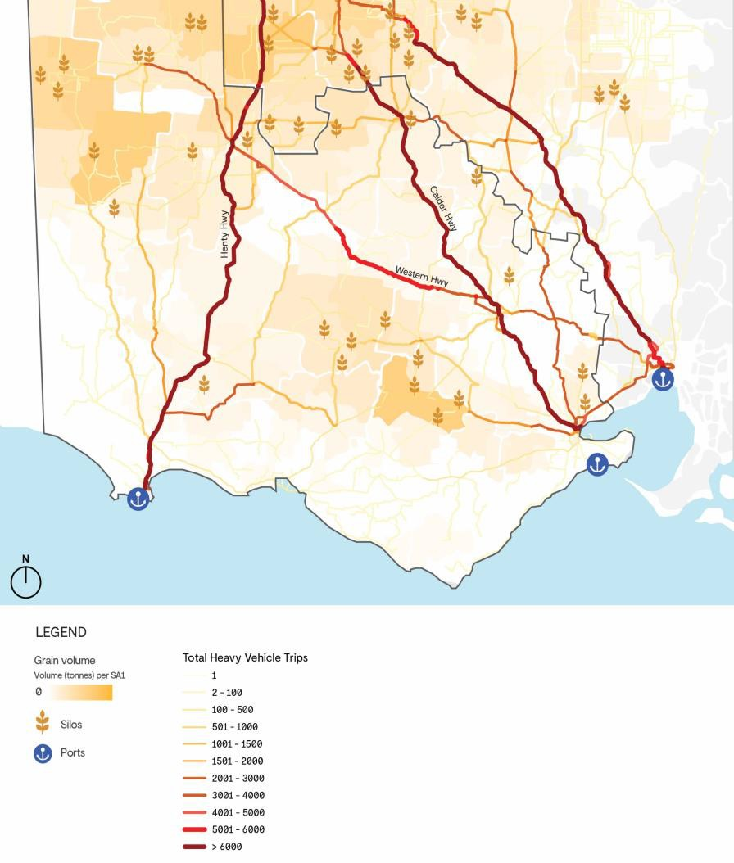
Road trips

Grain holds a crucial position in Victoria's export activities, leading to a concentration of grain transportation towards key export gateways such as the Port of Portland, Geelong Port, and the Port of Melbourne. Road and rail transport contribute significantly to the grain supply chain, each fulfilling distinct roles:
- Rail plays a crucial role in transporting grain over extensive distances, following planned, high-capacity routes. This is especially evident in moving grain from domestic cultivation regions to ports, where rail often offers a cost advantage over road freight.
- Road freight, on the other hand, presents a cost-effective alternative for the grain industry over shorter distances or in scenarios requiring route flexibility due to multiple and/or changing origins and destinations.
The introduction of larger truck configurations to meet the growing grain production and demand has created a challenge on the regional road network. This challenge is the condition of existing road infrastructure to accommodate these larger configurations given the impacts that the heavier payloads have on bridges across the network and which the structures may not currently accommodate. This may warrant the need for load limiting on bridges should this challenge not be adequately addressed.

Rail also remains an essential part of transport requirements. Similarly, there is a large focus on maximising the rail network to move more grain volumes and provide more direct journeys for exports.
Rail trips

Infrastructure barriers are reducing the efficiency of the supply chain
There were several infrastructure-related challenges identified through consultation with industry and other jurisdictions which include:

Freight
efficiency
Addressing underutilisation of heavy vehicles (instances where heavy vehicles are restricted by conditionally approved structures with constrained mass limits) involves aligning key grain freight routes with state-defined strategic corridors to facilitate funding support for corridor improvements, harmonising regulation and management of freight routes. Consideration needs to be given to the future heavy vehicle routes (Both A and B Roads) to note development growth and spread together with projected industrial and residential developments. This to enable effective HV access and connections and consider and address community safety and access.



Structures are reducing road productivity
The assessment has revealed several structures within the network that need upgrading to accommodate Performance Based Standards Level 3A heavy vehicles. Presently, these structures are causing bottlenecks throughout the network, hindering high productivity freight vehicle access. Addressing these upgrades progressively can significantly enhance high productivity freight vehicle access and alleviate congestion issues across the network.

Need for network maintenance
Surface quality, surface construction for the volume and loads, line marking and signage, structure capacity, widths, safety and signage treatments are issues across both A and B networks. Additional heavy vehicles on Priority A routes will also cause downstream impacts across the whole network Pavement resurfacing and upgrades are essential not only to accommodate HPFVs but also to enhance safety and reduce transport costs by minimizing wear and tear on heavy vehicles. Safely accommodating Performance Based Standards Level 3A heavy vehicles coupled with the volume of traffic, necessitates providing a 1.5-metre-wide shoulder on the Priority A network. Similarly, improvements to shoulder width and road conditions are also required in various sections of the Priority B network.

Gaps in the rail network
Recent investments in the V/Line network have resulted in significant improvements in the volume of grain transported via rail. Additional upgrades enabled through funding are necessary to fully capitalise on these benefits and ensure the continued transportation of grain via rail.

Investment principles

Strengthen corridors to support the export task
Enhance the main corridors leading to commercial ports to facilitate export activities, which includes permitting high productivity freight vehicles with a weight of
85.5 tonnes. Focus on eliminating network restrictions by addressing the issues caused by infrastructures that are incapable of supporting high productivity freight vehicles weighing 85.5 tonnes.
Continue to promote the use of the rail network
Promote increased use of the rail network for grain transportation. This involves enhancing the rail infrastructure to make it the preferred mode of transport for operators.
Maintain the supporting network to improve resilience, efficiency, safety and effective coordination
Improve the standard of the road network that supports the key arterials. Addressing pavement condition and structure can have improve safety, network resilience and safety.



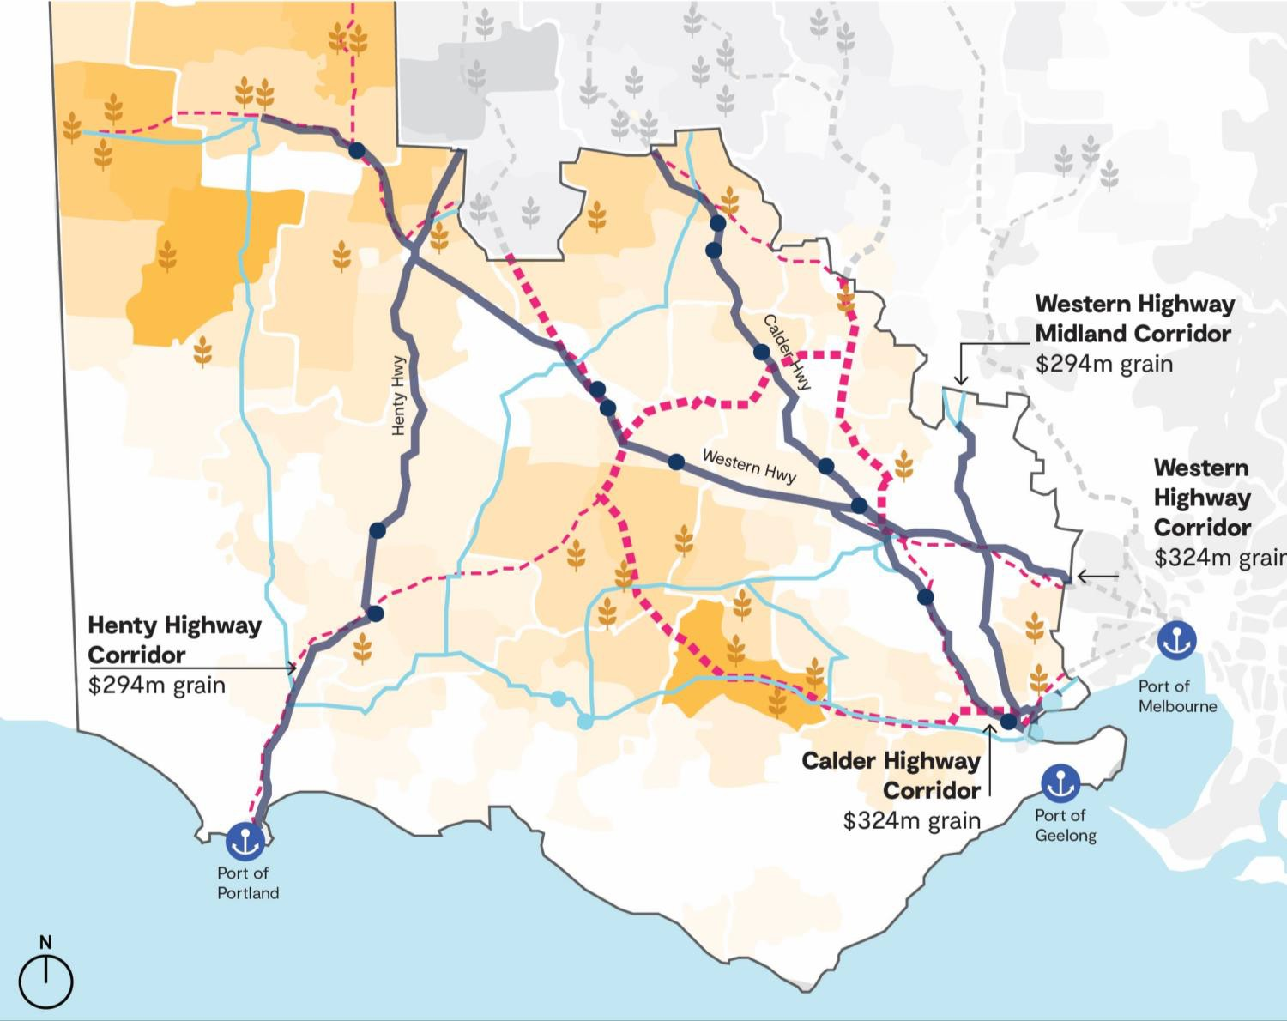
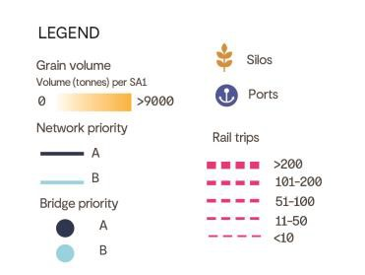
The benefits of addressing the challenges

The implementation of a higher percentage of A-Doubles across the network yields multiple advantages. These include a decrease in operational expenses for industry stakeholders and enhanced environmental impacts, such as diminished air and water pollution, greenhouse gas emissions, and noise pollution for the entire supply chain.
The charts provide a scenario for the heavy vehicle fleet mix if bottlenecks in the road network were unlocked through targeted investment.

Importantly, the industry realises cost savings due to the decreased number of trips needed to transport grain. This reduction in transport operating costs enhances the international competitiveness of industry participants. Over time, this could stimulate more investment in the region’s grain industry, leading to job creation and improved economic conditions. The average cost per tonne is expected to decline, where a trip transporting 25 tonnes of
grain is projected to cost approximately $965 in 2025, compared to an estimated $802 in 2041, marking a 17 per cent decrease. This cost reduction is mainly attributed to the larger capacity of A-Doubles compared to semi-trailers and B-Doubles, resulting in fewer trips needed to transport the same grain volume.

A Cost-Benefit Analysis evaluated whether the required investment is warranted by the resulting benefits. Within the scope of the study, the anticipated economic advantage includes a Net Present Value of $430 million and a Benefit- Cost Ratio of 1.0. These favourable economic results endorse the proposed levels of investment. This modelling is predicated on the development of a zero emission solution for HPFV’s and should be caveated as such with respect to being cost-effective against rail over the long term

A
$212 million
Funding needed to improve Priority A network
B
$407 million
Funding needed to improve Priority B network

3,680 jobs
generated from improving the road network

$460 million
in benefits enabled by network invest including operational savings, environmental benefits and safety benefits.
$
17% decrease
In the average cost per tonnes is expected by 2041 with network investment.



Contents

- Introduction and Strategic Context 1
  - Scope of study 1
  - Regional significance 3
- The Grain Freight Task 5
  - Freight task trends 6
  - The export task 7
  - Cropping and farming practices 8
  - Supply chain modelling and forecasts 10
- Transporting Grain 12
  - Road freight 12
    - The performance based standards 13
    - The grain road-based fleet 14
    - Supply chain characteristics 15
  - Rail-based network 15
- Grain movements 18
  - Road movements 18
  - Rail movements 20
- Infrastructure Condition Requirements 22
  - Measuring road network condition 22
    - Road pavement strength and condition 22
    - Bridges and culverts 23
  - Improving road network condition 23
    - Road pavements 24
    - Bridges and culverts 25
    - Road formation 25
  - Rail condition and maintenance 26
- Infrastructure Assessment 28
  - Road condition assessment findings 30
  - Pavement formation findings 30
  - Bridges 31
    - Bridge Assessment 31
  - Rail infrastructure assessment 34
    - ARTC network 34
  - V/Line network 35
    - Planned infrastructure improvements 36
    - Ballarat Line operational considerations. 36
- The Infrastructure Challenges 39
  - The cost of addressing the challenges 39
- Network Investment Prioritisation 41
- Conclusion 48
  - Non-infrastructure considerations 48
    - Grain Supply Chain Dashboard’s and AgTransport Platform - Canada and the US 48
    - Workforce 48
    - Policy to promote supply chain efficiency 49
    - Review mode shift incentives 50
    - Growing resource demand in Northwest Victoria 50
    - Climate adaptation and resilience 50

Table index

Table 1 | Victoria port terminal facility market share (Source: ACCC) | 7
Table 2 | PBS level maximum length and GCM | 14
Table 3 | Overview of typical heavy vehicles for the grain freight task | 14
Table 4 | Number of trips and tonnage on major corridors | 18
Table 5 | Summary of rail volumes and trips by destination | 20
Table 6 | Summary of responsible authorities for road maintenance | 22
Table 7 | Summary of pavement factors used in the infrastructure assessment | 22
Table 8 | Maintenance work types | 24
Table 9 | PBS3a pavement geometry requirements for rural areas | 26
Table 10 | Shoulder width analysis | 31
Table 11 | Potential corridor and terminal improvements for Grain | 36
Table 12 | Maintenance type unit costs (Source: DTP) | 39
Table 13 | Bridge strengthening and structure replacement escalated unit costs | 40
Table 14 | High level costings – road infrastructure | 40
Table 15 | Priority structures that require additional assessment or capital works | 42
Table 16 | Strategic actions for the rail network | 45
Table 17 | Project Governance members | 69

Figure index

Figure 1 | Study area (Image source: maps Melbourne) | 2
Figure 2 | 2021-22 bulk grain exports tonnage by state (Image source: ACCC) | 4
Figure 3 | Key 2021-22 statistics – Victoria (Image source: ACCC) | 4
Figure 4 | Victorian grain supply chain | 5
Figure 5 | Victoria grain production and usage (Source: ACCC) | 7
Figure 6 | Cropping annual tonnage by SA1, 2021-22 (Source: ABARES) | 9
Figure 7 | Grain forecasts for annual production including bulk, container, domestic human and domestic animal (tonnes) | 11
Figure 8 | Victoria PFN Road network (Image source: Victorian State Government) | 13
Figure 9 | Typical A-double road train (Image Source: GLT Trailers) | 15
Figure 10 | Victorian Regional freight rail network (Image source: DTP) | 17
Figure 11 | Total aggregated heavy vehicle trips for grain industry with restrictions and grain receival sites (Modelled by GHD – data sourced from ACCC and Graincorp) | 19
Figure 12 | Total rail trips for grain industry (Modelled by GHD – data sourced from ACCC) | 21
Figure 13 | Pavement formation example | 26

Figure 14 | Victorian regional rail network (Image Source: Essential Services Commission &  VICSIG) | 27
Figure 15 | Priority A and B networks | 29
Figure 16 | Road condition assessment outcomes- rutting, roughness and cracking | 30
Figure 19 | Bridge assessment outcomes of conditionally approved structures that do not support 85.5t A-Doubles | 33
Figure 20 | Victorian regional freight rail network – TAL limits | 34
Figure 21 | Maryborough to Melbourne standard vs broad gauge routes | 37
Figure 22 | Priority A network structures | 43
Figure 21 | Program Logic and Summary of Issues and Benefits | 64
Figure 24 | Targeted road segments and structures for investment – Priority A network | 66
Figure 25 | Targeted road segments for investment – Priority B network | 67

Appendices
Appendix A Regional Roads Victoria Maintenance Program Update – 2023-2024 Appendix B Investment Logic Map
Appendix C Targeted segments for investment Appendix D Project Governance Members Appendix E Economics assessment

Abbreviations Table
AADT Annual Average Daily Traffic
ABS Australian Bureau of Statistics
ACCC Australian Competition and Consumer Commission ARTC Australian Rail Track Corporation
CAGR Compounded Annual Growth Rate
DTP Department of Transport and Planning
GCM Gross Combination Mass
GRIP Grain Rail Improvement Plan
HPFV High Productivity Freight Vehicles
km Kilometre
IRG Industry Reference Group
IRI International Roughness Index
LGA Local Government Area
NHVR National Heavy Vehicle Regulator
MTM Metro Trains Melbourne
PBS Performance Based Standards
PFN Principal Freight Network
POPL Port of Portland
RMC Road Maintenance Category
SA1 Statistical Area Level 1
SG Steering Group
TAL Truck Axle Load

Disclaimer
This report: has been prepared by GHD for the Steering Group Members and may only be used and relied on by for the purpose agreed between GHD and the Steering Group Members as set out in section of this report.
GHD otherwise disclaims responsibility to any person other than [Client name] the Steering Group Members arising in connection with this report. GHD also excludes implied warranties and conditions, to the extent legally permissible.
The services undertaken by GHD in connection with preparing this report were limited to those specifically detailed in the report and are subject to the scope limitations set out in the report.
The opinions, conclusions and any recommendations in this report are based on conditions encountered and information reviewed at the date of preparation of the report. GHD has no responsibility or obligation to update this report to account for events or changes occurring subsequent to the date that the report was prepared.
The opinions, conclusions and any recommendations in this report are based on assumptions made by GHD described in this report. GHD disclaims liability arising from any of the assumptions being incorrect.
Recommendations in this report were developed using road asset data (Data) provided to GHD by the Department of Transport and Planning (Department) on [date] and are intended for use by the Department and Glenelg Shire Council only (Intended Recipients). If you are not an Intended Recipient, any reliance on the recommendations in this report by you will be at your own risk. GHD will not be responsible for any loss (including indirect and consequential loss) which you may sustain as a result of your reliance on the report.GHD has prepared this report on the basis of information provided by [Client name] the Steering Group Members and others who provided information to GHD (including Government authorities)], which GHD has not independently verified or checked beyond the agreed scope of work. GHD does not accept liability in connection with such unverified information, including errors and omissions in the report which were caused by errors or omissions in that information.
The study focuses solely on intrastate grain movements related to road and rail transportation.
The assessment considers road conditions and infrastructure within the Local Government Areas (LGAs) represented by the Project Steering Committee.
Third parties who provided information to GHD (including Government authorities), which GHD has not independently verified or checked beyond the agreed scope of work. GHD does not accept liability in connection with such unverified information, including errors and omissions in the report which were caused by errors or omissions in that information.

GHD has prepared the preliminary cost estimate set out throughout this section (“Cost Estimate”) using information reasonably available to the GHD employee(s) who prepared this report; and based on assumptions and judgments made by GHD in Section 4.

The Cost Estimate has been prepared for the purpose of high level estimates for road and bridge upgrades and must not be used for any other purpose. Due to limited availability of detailed costing information for railing and sensitivities around available costing data, we have not included comprehensive rail costing as part of this report.

The Cost Estimate is a preliminary estimate only. Actual prices, costs and other variables may be different to those used to prepare the Cost Estimate and may change. Unless as otherwise specified in this report, no detailed quotation has been obtained for actions identified in this report. GHD does not represent, warrant or guarantee that the works can or will be undertaken at a cost which is the same or less than the Cost Estimate.

Where estimates of potential costs are provided with an indicated level of confidence, notwithstanding the conservatism of the level of confidence selected as the planning level, there remains a chance that the cost will be greater than the planning estimate, and any funding would not be adequate. The confidence level considered to be most appropriate for planning purposes will vary depending on the conservatism of the user and the nature of the project. The user should therefore select appropriate confidence levels to suit their particular risk profile.
The scope of this study does not include decarbonization, and solutions related to decarbonization have not been considered in this analysis.

Accessibility of documents
If this report is required to be accessible in any other format, this can be provided by GHD upon request and at an additional cost if necessary.

- Introduction and Strategic Context
The grain industry is a crucial component of the agriculture sector in Victoria, where in 2021 and 2022, 6.0 million tonnes of cereal grains, legumes, and other grain crops such as canola were exported, which represented 39 per cent of all national exports. In that same period, Victoria’s grain consumption of 3.85 million tonnes was Australia’s second largest, representing 25 per cent of national consumption on average, which culminated with the bulk export demand, puts pressure on both the domestic and national supply chain¹.
The grain industry in Victoria continues to grow, where bulk exports in 2021 and 2022 were 124 per cent above average, and significant supply is contributed to this total from the Western Region of Victoria². Both rail and road transport form an integral part of the domestic and bulk export supply chain from farms and regional areas to storage facilities and ports. Road and rail transport support two different supply chains for bulk and containerised grains and while there have been some recent improvements to the State’s regional transport infrastructure supporting increased capacity, and reduced transport costs, further opportunities are still present to deliver lasting benefits and improved freight efficiency to the grain industry and supply chain network.
With the introduction of larger truck configurations to address increased grain production and demand, the burden on the regional road network is showing impacts, which will lead to the cost of rehabilitation and resurfacing to surge. Ultimately, this can affect the region and the state economically, socially, and environmentally due to increased truck volumes, fuel usage, and reductions in road safety due to increased heavy and light vehicle interactions. As a result of larger road vehicle configurations and an increase in on farm storage with delivery direct to market, rail has become less competitive, yet it remains a crucial part of transport requirements.
The significance of early transport infrastructure intervention leads to many benefits, including reliability, safety, longevity, and cost-effectiveness. However, to ensure the grain supply network remains robust, there is a requirement for ongoing infrastructure improvements. Importantly, examination beyond current infrastructure conditions is also necessary to understand the progressive impacts and appropriate prioritisation of investment. The efficiency and sustainability of the grain supply chain network requires targeted investment decisions based on key operational characteristics of the network, including logistical coordination, demand variability, sustainability practices, regulatory compliance, and technology integration.

  - Scope of study
The Western Victoria Grain Supply Chain Study is sponsored by the State Government through the Flexible Local Transport Solutions Program. The remainder of the funding for this study is sourced from the respective local government areas (LGAs) amongst the Great South Coast, Wimmera Southern Mallee, and Central Highlands Regional Partnerships. Figure 1 illustrates the study area, which extends across these three Regional Partnerships, as well as the Barwon Regional Partnership, due to the Region’s proximity to major ports in Geelong and Portland, along with the relevant transport infrastructure. It is important to note that the grain production inputs informing the supply chain mapping extend beyond the study area. These inputs play a significant role in considering both upstream and downstream impacts.
The study area boundary was determined by the Steering Committee However, most of the grain production occurs outside this boundary, where local road activity is primarily observed, as confirmed through stakeholder engagement. Consequently, the local road analysis in this report is limited. Section 2, which includes grain infrastructure and cropping data, demonstrates that the state road network supports the movements within the study area.

¹ ACCC. (2022). Bulk grain ports monitoring report - data update - 2021-22: Appendix 1 - Supplementary spreadsheet - tables and charts.
ACCC.
https://view.officeapps.live.com/op/view.aspx?src=https%3A%2F%2Fwww.accc.gov.au%2Fsystem%2Ffiles%2FAppendix%25201%2520-
%2520Supplementary%2520spreadsheet%2520-%2520tables%2520and%2520charts_3.xlsx&wdOrigin=BROWSELINK.
² ACCC. (2022). Bulk grain ports monitoring report - data update - 2021-22. ACCC. https://www.accc.gov.au/system/files/Bulk%20grain%20ports%20monitoring%20report%20-%20data%20update%20-%202021-22.pdf

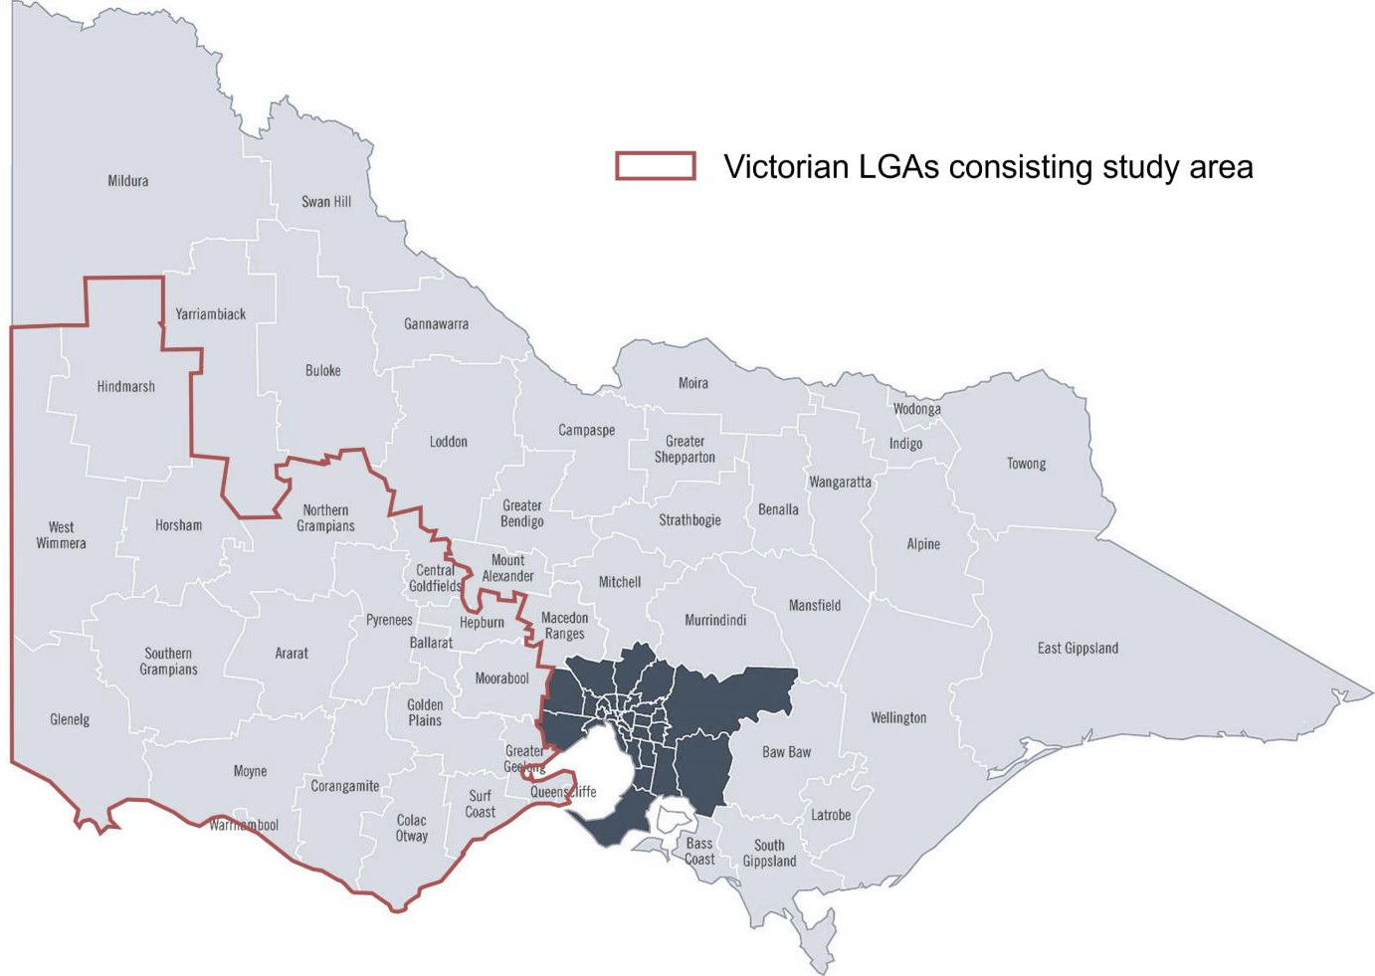
Figure 1 Study area (Image source: maps Melbourne)

The project governance consists of a Steering Group (SG) and an Industry Reference Group (IRG) to assist with decision making throughout the study’s three stages, which are listed below. The SG and RG consists of a combination of project sponsors from Department of Transport and Planning (DTP), Corangamite Shire Council, Glenelg Shire Council, SouthWest Victoria Alliance, Great South Coast, Central Highlands, and Wimmera Southern Mallee Regional Partnerships, together with other Councils, and key stakeholders. A full list of organisations is provided in Appendix D.

Stage 1: Supply chain mapping and demand assessment
The objective of this stage is to assess and quantify the grain supply chain and related current and future freight (both heavy vehicle and rail) volumes across the grain industry in Western Victoria. This stage will draw upon volume data obtained from arterial roads, local roads, and railway connecting farms and regional areas to storage facilities and ports, ultimately demonstrating both local and bulk export demand priorities throughout Western Victoria.

Stage 2: Infrastructure asset assessment
Following consultation with relevant authorities, Stage 2 of the study will address development needs pertaining to the existing grain supply chain infrastructure condition, including bottlenecks, limiting factors, and key factors of failure within the grain supply chain. Specific emphasis will be placed on assessment of the present risks relating to the condition of road, rail, and bridge assets, and identifying opportunities to improve infrastructure for specific axle loadings on key freight routes and increase demand. Freight volume data assessed within Stage 1 of this study will assist in identifying key areas within Western Victoria that require infrastructure development due to demand priorities.

Stage 3: Economic assessment
A transport investment plan linking back to improving operational, safety, and environmental supply chain outcomes will form the final stage of this study. This stage will employ the findings from Stages 1 and 2 to assess the economic impact, and quantify the revenue generated by the Western Victorian grain industry on a Regional, State, and National level. Cost benefits relevant to the infrastructure and operational improvements discussed proposed within the investment plan will be assessed on a project net present value and benefit-cost ratio basis
The purpose of the study is to map demand priorities grounded in evidence concerning the grain industry supply chain in Western Victoria. It also aims to propose enhancements to the grain supply chain, targeting tangible benefits to both industry and governments.

  - Regional significance
The Western Victorian region holds significant importance as a thriving agricultural region, providing essential support to various industries such as transportation, warehousing, food manufacturing, mining, dairy feed and horticulture. Its diverse economic contributions have made it a vital component of the Victorian economy.
The grain industry plays a pivotal role in bolstering the state economy. According to Agriculture Victoria, the gross value of major grain commodities in the state is substantial, with $1.27 billion attributed to wheat, $850 million to barley, and $437 million to canola³. Additionally, this sector also sustains a substantial workforce, with around 9,700 individuals employed on farms dedicated to grain production during the 2020-2021 period³.
In a broader context, the Western Victoria area significantly enhances the national grain production landscape. Victoria accounts for a noteworthy 17.5 per cent of the national gross value of grain production, which amounts to
$20.3 billion³. This makes Victoria the third-largest grains producer in Australia, trailing behind New South Wales with $6.8 billion and Western Australia with $5.85 billion in value³. These statistics underscore the region's substantial role in the overall Australian grain industry, solidifying its importance in the country's economic framework. Figure 2 demonstrates the volume of exported bulk grain across Australia.

³ Karanja, F. (2023). Victoria grains industry: Fast Facts January 2023. Agriculture Victoria. https://agriculture.vic.gov.au/ data/assets/pdf_file/0007/921166/GRAINS_FAST-FACTS_JANUARY-2023.pdf

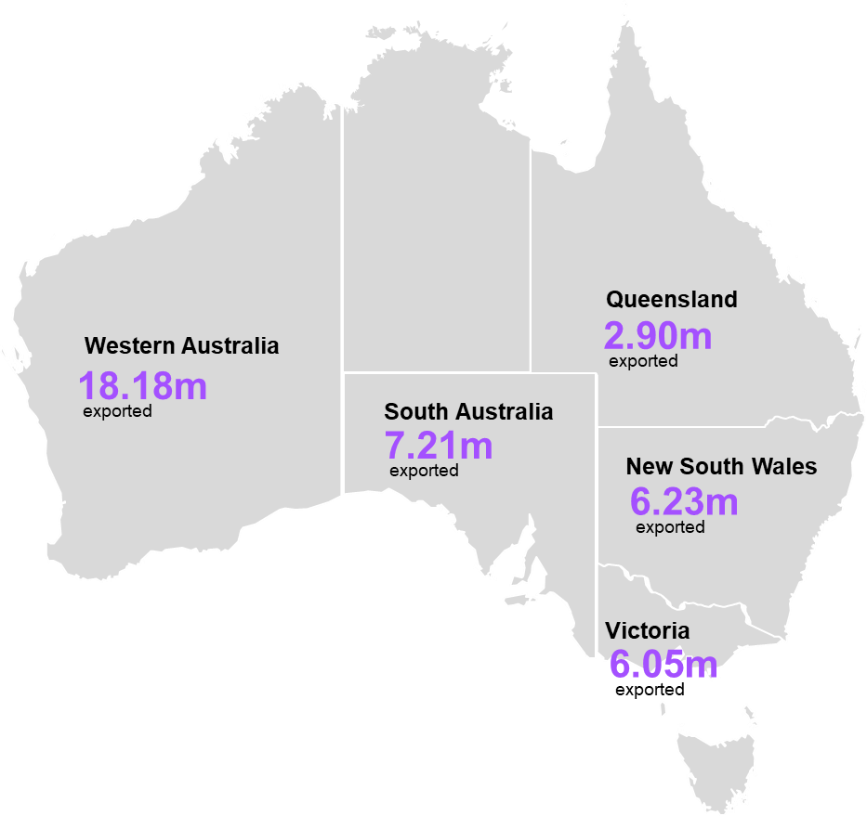
Figure 2 2021-22 bulk grain exports tonnage by state (Image source: ACCC)

In the Australian Agricultural Census 2020-21, it was reported that grain farms in Western Victoria (within the Great South Coast, Wimmera Southern Mallee, Barwon, and Central Highlands Regional Partnerships areas) represented approximately half of Victoria’s total grain production. The inclusion of Regional Partnerships areas in Victoria’s northwest (Mallee and Loddon Campaspe Regional Partnership areas) saw this figure rise to almost 90 per cent⁴.  Production of grain within Western Victoria services both export and domestic demand, where the supply chain primarily concerns key freight routes between regional storage facilities and ports in Portland, Geelong, and Melbourne. However, discounting local roads between significant areas of activity would likely lead to gaps in efficiency forming throughout the supply chain. Local roads enable first and last mile access to grain farms, and the benefit of sustaining their upkeep stems beyond freight efficiency, to being key to community connectedness and safety.  The greatest challenge for a supply chain network that offers multiple transportation modes, is identifying where efficiencies can be achieved between modes, while being cognisant of not over inducing demand on  specific routes. | 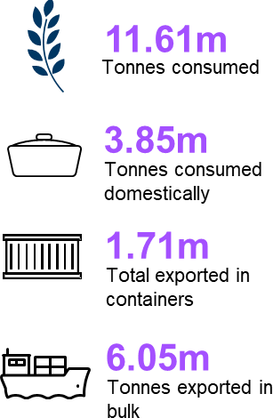  Figure 3 Key 2021-22 statistics – Victoria  (Image source: ACCC)

⁴ Department of Agriculture, Fisheries and Forestry. (2022). Australian Agricultural Census 2020-21. ABARES - DAFF. https://www.agriculture.gov.au/abares/aclump/land-use/agriculture-census-dashboards-lga

- The Grain Freight Task
The grain industry in Western Victoria consists of cereal grains such as wheat and barley, which is typically used for human consumption or industrial purposes. Grain production thrives during high annual rainfall harvests, which saw a record harvest in 2022-23 because of the high soil moisture content. Higher than average winter rainfalls for the 2021-22 and 2022-23 in Victoria⁵, has led to the expected area planted of grain crops for 2023-24 to be six per cent above the historical 10-year average⁶. This is likely attributed to grain farmers seeking to realise their full planting intentions due to the soil’s high moisture content. Inputs into grain production include grain seedlings, agricultural chemicals such as fertilisers, herbicides, pesticides, and fungicides, as well as machinery, machinery parts, water, and fuel. All these inputs, including skilled labour and impact crop yield, ultimately dictates the volume of product that enters and influences the supply chain. However, the scope of this study only considers these inputs at a high level and they have not been extensively detailed.
Stored grains are processed prior to being sent to export gateways or into domestic consumption channels. The processing step is an important element in the grain supply chain, influencing operational efficiencies in the supply chain by reducing waste and enhancing the nutritive value from a given type of grain. Grain processing typically is categorised as either ‘wet’ or ‘dry’, where ‘wet’ processing usually incurs greater operational and capital costs, due to requirements for machinery to perform more complex processing techniques to improve digestibility and/ or caloric intake of the starch. Grains, such as sorghum, and corn, that require ‘wet’ processing techniques represented less than one per cent of Victoria’s total grain production in 2020-21.
The next step of the supply chain will see approximately 40 per cent of processed grains sent to market for domestic consumption, or towards ports in Portland, Geelong, or Melbourne for bulk exportation. Victoria has four bulk grain port terminal facilities. GrainCorp operates facilities at Geelong and Portland, Emerald operates a facility at port of Melbourne, Port of Portland (POPL) operates a facility at Portland. Riordan also utilises a mobile ship loading facility that moves between Geelong and Portland.
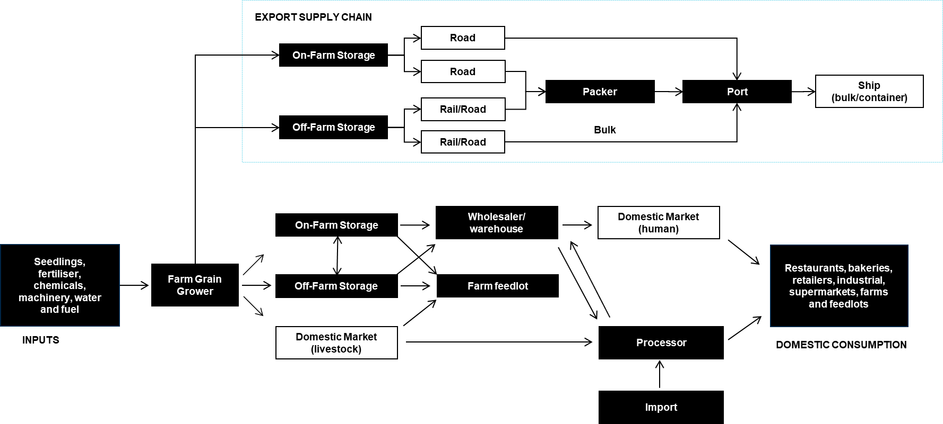
Figure 4 Victorian grain supply chain

⁵ Bureau of Meteorology. (2024, March). Australian climate variability & change – Time series graphs. Australian Government, Bureau of Meteorology. http://www.bom.gov.au/cgi-bin/climate/change/timeseries.cgi?graph=rain&area=vic&season=0608&ave_yr=0.
⁶ Department of Agriculture, Fisheries and Forestry. (2024, March). Australian Crop Report: March edition: Victoria. Australian Government, Department of Agriculture, Fisheries and Forestry. https://www.agriculture.gov.au/abares/research-topics/agricultural-outlook/australian- crop-report/victoria.

  - Freight task trends
Freight task for grain within the study area is significant in terms of the volumes produced, and while grain production levels fluctuate due to varying seasonal conditions, the nature of the freight task has undergone significant transformations over the past decade. Several factors have influenced these changes:
- There has been an increase in on-farm grain storage as it provides more flexibility to hold and market grain throughout the year and allows growers to deliver goods directly to key gateways such as commercial ports⁷.
- The rising costs of handling at grain receival points have made on-farm storage increasingly financially attractive to farmers. These cost dynamics have stimulated the demand for the efficient movement of grain directly from cost-effective on-farm storage to the port or to domestic customers in a single, cost-effective operation. Many farmers prefer the use of direct transport via road to move grain from the field to the port or customer during the harvest, reducing the need for double handling associated with short-haul deliveries to local grain receival sites and to hold market grain throughout the year.
- There has been an increase in domestic consumption, primarily due to population growth and the heightened demand for grain used in Southeast Australian chicken meat production, livestock feed, and local flour milling. Projections from Australian Grain Innovation suggest that the domestic market will consume more than half of the increased grain production leading up to 2030⁸, highlighting the growing demand for domestic livestock feed and grain for the food and beverage market.
- Changes in grain exports from Victoria, particularly bulk exports, have played a significant role in grain supply chain and the transport requirements. Although the trend had been moving away from bulk export shipments, a record 5 million tonnes of grain were exported in bulk in 2020-21 due to an exceptional harvest, disrupting this trend. Bulk grain shipments constituted nearly half of all grain usage, a stark increase from the 14% observed the previous year.
- Victoria boasts a large and growing containerized grain market, one of the most stable in Australia. Containerised grain export gained momentum in the early 2000s, and in the 2020-21 shipping year, over 1.7⁹ million tonnes were exported via containers, marking an increase from the previous year's 1.1 million tonnes. Packing of grain predominantly occurs in regional locations, spread across the harvesting areas, with both rail and road serving as transportation options for bulk and 'up country' containerized grain.

⁷ LEK Consulting Australia Pty Ltd. (2023). Connecting the dots: Improving Australian grain supply chain efficiency. GrainGrowers Limited. https://cdn.sanity.io/files/1nr0ob5f/production/d232a7a0c81357fa87000d58885528664e0090f6.pdf
⁸ Kingwell, R. (2021). Australia's Grain Outlook 2030. Australian Export Grains Innovation Centre. https://aegic.org.au/wp- content/uploads/2021/03/AEGIC-Australias-Grain-Outlook-2030.pdf
⁹ ACCC. (2022). Bulk grain ports monitoring report - data update - 2021-22. ACCC. https://www.accc.gov.au/system/files/Bulk%20grain%20ports%20monitoring%20report%20-%20data%20update%20-%202021-22.pdf

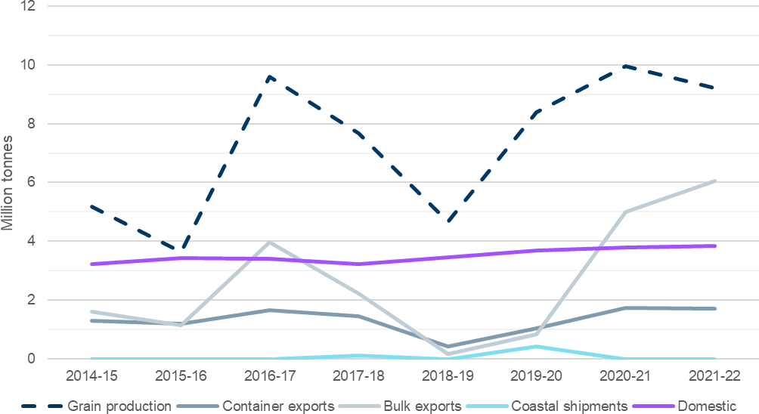

Figure 5 Victoria grain production and usage (Source: ACCC)

  - The export task
Historically, Victoria has been a significant contributor to Australia's grain export market. The state is known for its diverse agricultural production, including wheat, barley, oats, and canola, which collectively contribute to its role in the country's grain industry.
Australia has been a major global player in the grain export market, with a reputation for producing high-quality grains. Victoria, as one of the leading grain-producing states, has played a crucial role in meeting domestic and international demand. The economic value of the grain export market in Victoria is substantial, contributing significantly to the state's agricultural sector and overall economy with $4.4 billion of grain exported (2021-22)¹⁰. The export of grains not only provides income for farmers but also supports related industries such as logistics, transportation, and processing.
In the 2021–22 season, GrainCorp handled 55 per cent of all bulk exports in Victoria, as indicated in Table 1 below. This represented the lowest market share among dominant providers in any state. Notably, GrainCorp's market share remained nearly identical to the previous season, 2020–21. Furthermore, during this recent season, Riordan's market share saw an increase from 13 to 17 per cent, while Emerald experienced a four-percentage point decrease, and POPL saw a one-percentage point increase in its market share. Table 1 also provides insight into the performance of bulk grain ports in Victoria, with Geelong leading the way by handling the largest volume of bulk grain, accounting for 54 per cent of all Victorian bulk exports, surpassing the other two bulk grain ports in the state.

Table 1 Victoria port terminal facility market share (Source: ACCC¹¹)

Facility | 2021-22 | Total share since 2016-17
Geelong Riordan | 12% | 9%
Portland POPL | 8% | 5%

¹⁰ Karanja, F. (2023). Victoria grains industry: Fast Facts January 2023. Agriculture Victoria. https://agriculture.vic.gov.au/ data/assets/pdf_file/0007/921166/GRAINS_FAST-FACTS_JANUARY-2023.pdf
¹¹ ACCC. (2022). Bulk grain ports monitoring report - data update - 2021-22: Appendix 1 - Supplementary spreadsheet - tables and charts.
ACCC.
https://view.officeapps.live.com/op/view.aspx?src=https%3A%2F%2Fwww.accc.gov.au%2Fsystem%2Ffiles%2FAppendix%25201%2520-
%2520Supplementary%2520spreadsheet%2520-%2520tables%2520and%2520charts_3.xlsx&wdOrigin=BROWSELINK.

Facility | 2021-22 | Total share since 2016-17
Portland Riordan | 5% | 3%
Geelong GrainCorp | 42% | 50%
Melbourne Emerald | 20% | 22%
Portland GrainCorp | 13% | 12%
  - Cropping and farming practices
Grain farming in northwest Victoria, particularly in the Mallee and Wimmera regions, is characterised by the cultivation of major crops such as wheat, barley, and canola. The semi-arid climate necessitates the use of dryland farming practices to maximise soil moisture. Modern farming practices, including precision agriculture and advanced machinery, are widely adopted for increased efficiency. The Region's grain farming has a significant economic impact, with exports facilitated through major ports. Ongoing research and community involvement contribute to the sustainability and development of the industry.
Figure 6 illustrates the grain production movement volumes categorized by origin and Statistical Area Level 1 (SA1)¹². The data reveals that a significant portion of grain production originates in the northwest of Victoria, while smaller production volumes are dispersed across central Victoria. Additionally, this Figure 6 indicates that the majority of grain production volumes are transported from the northwest region of Victoria. Moreover, the figure highlights that the largest total agricultural production volumes are concentrated in the northwest, primarily driven by grain, with horticulture as the subsequent major contributor.

¹² SA1 regions, or Statistical Area Level 1 regions, are small, contiguous geographic units used for collecting and analysing detailed demographic and socioeconomic data in countries like Australia. They help ensure uniform population sizes, facilitate data collection during censuses, and support various research, planning, and decision-making purposes while protecting individual privacy.

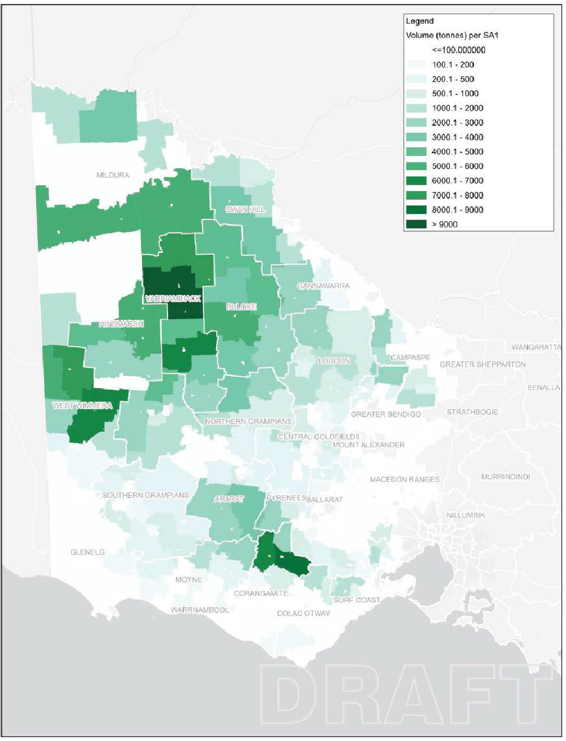
Figure 6 Cropping annual tonnage by SA1, 2021-22 (Source: ABARES)

  - Supply chain modelling and forecasts
A supply chain model was developed to map supply chain volumes across the study area. The model employs a combination of aggregate and disaggregate modelling techniques, supply chain flow balancing to reconcile grain volumes, and tour modelling to determine grain transport routes. It draws on data¹³ from the Department of Agriculture, Fisheries, and Forestry and the Australian Bureau of Statistics (ABS) to identify grain origins, which is then reconciled with export data¹⁴ sourced from the Australian Competition and Consumer Commission (ACCC) and port trade data. The model considers volumes transported via both road and rail. These assumptions and data inputs underwent validation through consultation with various stakeholders and were subsequently endorsed by the SG.
In the supply chain model, ABS grain data has been leveraged to gain a deeper understanding of the grain supply chain. Various end-use scenarios, such as port share, mode share, and distribution splits, have been explored to provide a comprehensive perspective.
To ensure equitable distribution, apportionment principles have been employed to allocate resources efficiently and fairly throughout the supply chain.
The supply chain model examines different usage scenarios, including bulk exports, where products are shipped in their bulk form; containerised goods, which are packed into containers for export; domestic human consumption, including food and flour production; and domestic feed/animal use, with assumptions derived qualitatively from available sources.
The grain forecasts consider both average and peak year cases to explore potential infrastructure solutions and assess the impacts of varying grain volumes effectively. The forecasting horizon spans 30 years, offering flexibility to adapt to changing circumstances. This includes climate change impacts which includes potential increased frequency of drought years, declining average rainfall and extremities like a higher number of freezing days¹⁵
To project grain production, a Compounded Annual Growth Rate (CAGR) is applied, accounting for both average and peak year scenarios, enabling a more nuanced analysis of future trends.

¹³ Department of Agriculture, Fisheries and Forestry. (2022). Australian Agricultural Census 2020-21. ABARES - DAFF. https://www.agriculture.gov.au/abares/aclump/land-use/agriculture-census-dashboards-lga
¹⁴ ACCC. (2022). Bulk grain ports monitoring report - data update - 2021-22: Appendix 1 - Supplementary spreadsheet - tables and charts.
ACCC.
https://view.officeapps.live.com/op/view.aspx?src=https%3A%2F%2Fwww.accc.gov.au%2Fsystem%2Ffiles%2FAppendix%25201%2520-
%2520Supplementary%2520spreadsheet%2520-%2520tables%2520and%2520charts_3.xlsx&wdOrigin=BROWSELINK.
¹⁵ https://www.monash.edu/ data/assets/pdf_file/0011/2760248/Technical-Report-22-Nov-2021.pdf

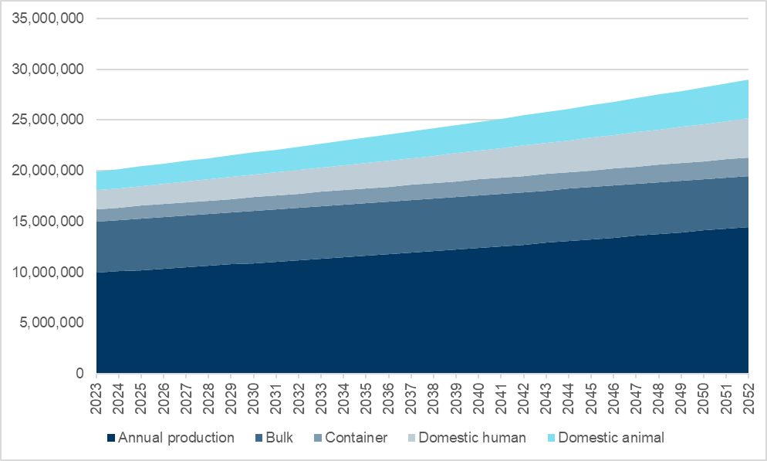
Figure 7 Grain forecasts for annual production including bulk, container, domestic human and domestic animal (tonnes)

The model has been designed to align with headline port throughputs and ABS data, ensuring a comprehensive understanding of domestic grain movement. However, it is worth noting that some data limitations exist, as not all relevant information was available from stakeholders including detailed data regarding on-farm storage and heavy vehicle fleet split. Indications were made during the stakeholder engagement phase which were used as an assumption in the modelling.
To determine farm locations, ABS cropping data has been utilised and aggregated into SA1 regions. This approach provides valuable insights into the initial movements within the grain supply chain at a more granular level, facilitating a better analysis and optimisation of the system.
The ABS cropping data indicates that almost 90 per cent of all production in Victoria is within the western regions of the State, consequently leading to the transportation of grain in Victoria having the greatest burden on the transport network in the defined study area. Further distillation of the cropping data found that 25 per cent of all production occurred in the adjacent LGAs of Yarriambiack and Buloke, located in Victoria’s northwest. Ultimately, production drives demand for grain transportation across Western Victoria, which is reflected on the road and rail networks as discussed in the subsequent sections of this report.
These major production areas were discussed with the Steering Committee and identified as lying outside the study area. Consequently, volume data from the northern part of the state was aggregated as freight volume for both road and rail transport entering the study areas. This consolidation will help allocate additional southbound traffic inputs within the study area.

- Transporting Grain
The supply chain in Western Victoria is supported by a combination of road and rail transport, which offers benefits ranging from flexibility and timely transport via road, to broader large volume transport options by rail. Allowing multiple modes of transport creates a competitive environment for grain produced in Western Victoria, which encourages growth in the industry, however, requires efficiency to be sustained through all aspects of the supply chain.
As State and local governments regulate road regulations for heavy vehicles, supply routes are limited by permitted access to specified roads, similarly current track axle loads (TAL) limit rail-based transport. The ongoing opportunities on rail can be expected to cater in part for the future demand by improving travel times, reliability, and capacity on the rail-based component of the grain supply chain. However, heavy vehicle haulage still forms a critical component of the supply chain, estimated to carry at least 60 per cent of grain produced to export gateways in 2020-21¹⁶. Therefore, these road regulations for heavy vehicles will influence how suppliers choose routes to transport grain in Western Victoria. Consideration needs to be given to the future heavy vehicle routes (Both A and B Roads) to note development growth and spread together with projected industrial and residential developments. This will enable effective HV access and connections and consider and address community safety and access.

  - Road freight
The road freight network in Victoria is a critical component of the state’s economy and infrastructure. It facilitates the movement of goods across the state, connecting businesses with markets, and consumers with products. The road freight network is complex and multifaceted, encompassing various types of roads, vehicles, and freight types, including light commercial vehicles, rigid trucks, and articulated trucks.
To support the road freight sector, the Victorian Government established the Principal Freight Network (PFN). The PFN identifies and protects road corridors and rail freight corridors, and places of national, state, and regional significance that support high-capacity and efficient freight movements around Victoria. Last reviewed in 2020, the PFN is designed to guide future transport network and land use planning, and infrastructure investment, ensuring consideration and prioritisation of freight. It also aims to integrate multi-modal and end-to-end supply chains to achieve productivity gains and industry competitiveness. Figure 8 illustrates a map of the Victorian PFN road network.

¹⁶ Wells, L. (2020). Trucks gain, rail languishes ahead of big Victorian crop. Grain Central. https://www.graincentral.com/news/trucks-gain-rail- languishes-ahead-of-big-victorian-crop/

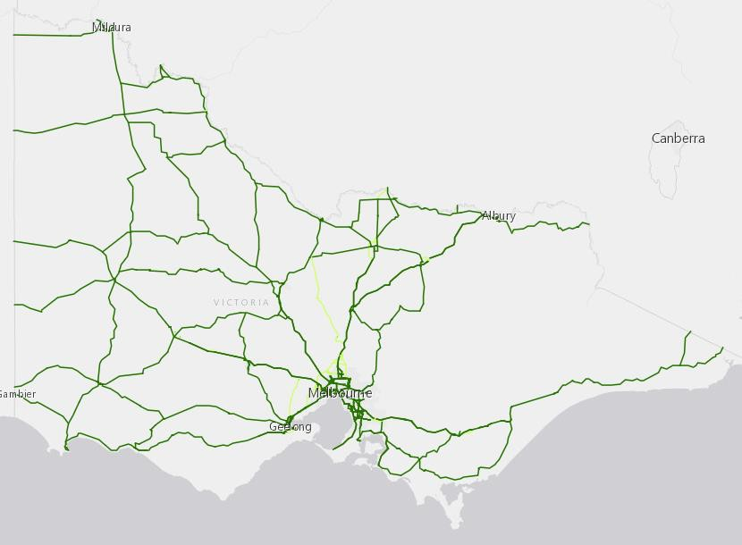
Figure 8 Victoria PFN Road network (Image source: Victorian State Government)¹⁷

    - The performance based standards
All road-based freight is expected to increase by 77 per cent across Australia between 2020 and 2050¹⁸, which will lead to an increased burden on the freight network and further the need to find efficient and safe means to transport freight.
Performance Based Standards (PBS) is a scheme that was introduced by the Australian Government in 2007, aiming to provide truck and transport operators with the opportunity to identify the right vehicle for different tasks, to achieve improved productivity, sustainability, and safety. In 2021, there were over 12,000 PBS approved vehicle combinations in Australia, which has led to safety benefits being realised, where PBS vehicles are involved in 60 per cent fewer major crashes than conventional vehicles¹⁹, which is a figure that has seen significant improvement from 46 per cent in 2018²⁰. The PBS scheme has also seen environmental benefits with fuel savings because of travel reductions with more efficient vehicle movements.
In Victoria, high-productivity freight vehicles (HPFV), which are vehicles that exceed 26 metres and/or have a gross combination mass (GCM) greater than 68.5 tonnes, must operate under the PBS scheme, which in Victoria is governed under two PBS level requirements, which are summarised below in Table 2.

¹⁷ Department of Transport and Planning. (2023). Principal Freight Network. Department of Transport and Planning. https://www.vic.gov.au/principal-freight-network.
¹⁸ Bureau of Infrastructure, Transport and Regional Economics. (2022). Australian aggregate freight forecasts – 2022 update (Summary).
Bureau of Infrastructure, Transport and Regional Economics. https://www.bitre.gov.au/sites/default/files/documents/bitre_rr154_summary_report.pdf.
¹⁹ National Truck Accident Research Centre. (2021). Review of Major Crash Rates for Australian Higher Productivity Vehicles: 2015 – 2019.
National Heavy Vehicle Regulator. https://www.nhvr.gov.au/files/202105-1232-cilta-ntarc-review-of-major-crash-rates-hpv-2015-19.pdf.
²⁰ National Transport Commission. (2017). Assessing the effectiveness of the PSB Scheme: Discussion Paper. National Transport Commission https://www.ntc.gov.au/Media/Reports/(EE70D6AE-0895-3CE0-C3C4-6AEE88C7138F).pdf

Table 2 PBS level maximum length and GCM

PBS Level Requirement | Access class ‘A’ | Access class ‘B’
PBS Level 2 | Up to 26.0 metres and 74.5 tonnes GCM | Up to 30.0 metres and 85.5 tonnes GCM
PBS Level 3 | Up to 36.5 metres and 85.5 tonnes GCM | Up to 36.5 metres and 91.0 tonnes GCM
Through stakeholder consultation with industry groups such as the Victorian Farmers Federation, A-doubles are the benchmark for the future network, with the intention to unlock infrastructure to enable these movements, which led to the PBS Level 3A Network being the target and basis for the road-based component of this study. These vehicle types are seen to be the most efficient way of moving large quantities of grain and are being endorsed by industry.

    - The grain road-based fleet
The grain fleet comprises a series of heavy vehicles including semi-trailer, B-double, and A-double trucks to offer a variety of load carrying options for differing needs. The largest vehicle that operates on the network is the A- double, shown in Table 3, which can be up to 36.5 metres in length and has a GML limit of 85.5 tonnes. Currently, conditions of bridges and the road create restrictions along key routes, which limit the carrying capacity by up to 17 tonnes across the network, which leads to the fleet operating below maximum capacity.
The PBS access specifications are derived from the National Heavy Vehicle Regulator (NHVR) and are applied to the road network. The PBS class denotes the constraints on vehicle size and mass, including PBS 1 for Semi- trailers (19 metres), PBS 2A for B-Doubles (26 metres), PBS 3A for Type 1 road trains (36 metres), and PBS 4A for Type 2 road trains (53 metres). In grain production regions of Victoria, PBS 2A predominates across the road network, with the exception of a few roads in the northwest.

Table 3 Overview of typical heavy vehicles for the grain freight task²¹

Truck type | Description (typical movements) | GML | Average payload | Example
Semi- trailer | Semi-trailer is a type of articulated truck commonly used for transporting goods. It consists of two main components: a prime mover and a trailer. | 39.0-  42.5 | 24.13-  27.13 | 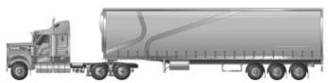
B-  double | B-double refers to a specific type of combination vehicle used for freight transportation on roads. It is a type of articulated truck configuration that consists of two trailers linked together on the rear of the lead trailer. The B- double configuration is widely used in Australia for long-haul transport, providing a balance between increased freight capacity and manoeuvrability compared to longer road train configurations. | 55.5-  62.5 | 38.93-  44.43 | 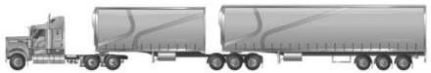
A-  double | Similar to a B-double, an A-double consists of a prime mover (truck) pulling two trailers, but there are key differences in the configuration.  The total length of an A-double combination is subject to regulatory limits, but it is generally longer than a B-double, often reaching up to 36 metres more. | 79.0-  85.5 | 47.77-  53.77 | 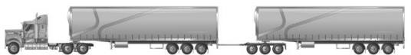

²¹ National Heavy Vehicle Regulator. (2023). PBS Vehicle Configurations. National Heavy Vehicle Regulator. https://www.nhvr.gov.au/files/201810-0923-pbs-vehicle-configurations.pdf.

      - Heavy vehicle fleets are evolving
A-doubles are considered ideal for transporting grain in Australia due to their increased capacity, efficiency, and cost-effectiveness. Their ability to carry larger loads in a single trip reduces fuel consumption and overall transport costs. A-doubles are also more manoeuvrable than some other heavy vehicle configurations, making them suitable for navigating various road conditions in agricultural regions. Their flexibility in loading and compliance with regulations further contribute to their suitability for grain transport in the Victoria.
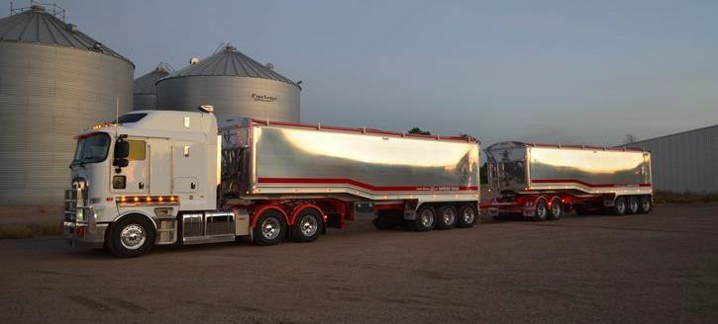
Figure 9 Typical A-double road train (Image Source: GLT Trailers)

    - Supply chain characteristics
The supply chain mapping exercise aggregated trips based off the ACCC’s 2020/21 grain production data for semi-trailer, B-double, and A-double trucks to determine how the road-based grain fleet operated across Western Victoria, and to identify the major corridors towards distribution and storage facilities, as well as ports in Melbourne, Geelong, and Portland.
Through the consultation phase it was identified that semi-trailer and B-double combinations were observed to cater for most domestic movements, and to service direct exports from off-farm storage facilities to the ports of Geelong and Portland. A-double freight movements were concentrated along the Henty Highway between Horsham and Portland, and on the Princes Freeway between Geelong and Melbourne.
While the analysis into aggregated trips identifies key arterial roads and highways, it is important to note that the local road network connecting all aspects of the supply chain play a pivotal role in operational efficiency. These roads provide a more direct alternative to arterials, but are however, constrained by spatial and capacity constraints.

  - Rail-based network
The 2018 Delivering the Goods – Victorian Freight Plan underscored the Victorian Government's commitment to increasing the proportion of freight transported by rail. Priority 3 of the plan emphasised the "better use of our rail freight assets," recognising the heightened importance of increasing rail freight volume amid a growing freight task and urban congestion. This is further supported by the states mode shift ambitions and target of achieving 30% of Melbourne's metropolitan freight containers being transported by rail by 2050 through the under review mode shift incentive scheme. Rail transport also stands out for its environmental benefits, generating fewer greenhouse emissions per tonne-kilometre (km) compared to road transport²², resulting in a fivefold reduction in emissions with every new train added to the network.

²² Pettit, J. (2021, April). Facilitating sustainable development in the transport sector. Australasian Railway Association. https://ara.net.au/about- rail/environmental-benefits/

Victoria's rail freight network encompasses standard-gauge and broad gauge lines, with some sections configured as dual-gauge to accommodate both broad and standard-gauge trains. VicTrack owns the Victorian interstate, regional, and metropolitan rail networks, leasing them to DTP, who in turn, sub-leases to three network managers known as 'the access providers'—Metro Trains Melbourne (MTM), V/Line, and the Australian Rail Track Corporation (ARTC)— that are responsible for operations, maintenance, and access provision.
The presence of standard and broad gauge non-electrified railways in Western and Central Victoria respectively, influences demand patterns for rail trips from storage facilities to port locations or domestic markets. Rail transport plays a vital role in streamlining logistics and reducing heavy vehicle traffic on the network, especially in a region where agriculture is a significant economic activity.
Victoria's freight train companies handle a diverse range of commodities, including export containers of agricultural and bulk products like grain, hay, potatoes, peas, fruit, grapes, wine, meat, dairy, paper products. In 2016, rail freight accounted for 41 per cent of regional and interstate export containers through the port of Melbourne, constituting 16 per cent of total loaded export containers and eight per cent of the port's throughput²³. However, since 2006, the proportion of port containers transported by rail has decreased from 14 per cent due to increased port business and a greater reliance on heavy road-based transport²³.
Victoria’s port rail system transports a significant volume of bulk grain to Port, where during good harvests, the Port of Melbourne reports up to 10,000 tonnes of bulk grain arriving daily at the Port²⁴. Due to climatic and market conditions, the proportion of grain transported over port rail systems between containerised and bulk varies significantly. However, bulk rail movements were reported as 78 per cent of total rail movements in 2010/11²⁵, with capacity constraints cited as a major factor affecting the large split. The Port of Melbourne is currently the only port in Victoria with containerised capacity, however, bulk grain exports are still transported via rail to the Port of Portland and Port of Geelong. The Port of Portland and Port of Geelong report approximately 20 per cent²⁶ and 50 per cent²⁷ of bulk grain is transported to Port via rail respectively.
Intermodal terminals serve as pivotal hubs for seamlessly transferring goods between different modes of transportation, facilitating the transition from rail to road and vice versa. Trains loaded with bulk grain containers arrive, where the containers are transferred to trucks for final delivery to ports or other distribution points. The rail network in northwest Victoria thus plays a crucial role in the grain supply chain, contributing significantly to the efficiency and sustainability of the regional agricultural industry. Within the supply chain model, efforts were made to calibrate the volume of grain transported via rail to reach a target of 20 per cent of overall grain production, aligning with stakeholder and industry information to accurately represent the distribution of volume between road and rail-based transport in Western Victoria.

²³ Rail Futures Institute. (2016). Getting freight back on track in Victoria. Rail Freight Alliance. https://railfreightalliance.com/wp- content/uploads/2014/06/Rail-Futures-Freight-Paper.pdf
²⁴ Port of Melbourne. (2020). Our Plan for Rail 2020. Port of Melbourne. https://www.portofmelbourne.com/wp-content/uploads/PoM-Our-Plan- for-Rail-2020.pdf
²⁵ Department of Transport. (2011). Grain Logistics Taskforce Report. Victorian Government, Department of Transport. https://railfreightalliance.com/wp-content/uploads/2014/06/Grain-Logistics-Taskforce-report.pdf
²⁶ Cooper, J. (2015). Port of Portland Submission. Regional Development Victoria, Port of Portland. https://www.rdv.vic.gov.au/ data/assets/file/0003/1376220/Port-of-Portland.docx
²⁷ Port of Geelong. (2018). Port Development Strategy 2018. Port of Geelong. https://vrca.vic.gov.au/wp-content/uploads/2019/08/2018- Geelong-Port-Development-Strategy.pdf.

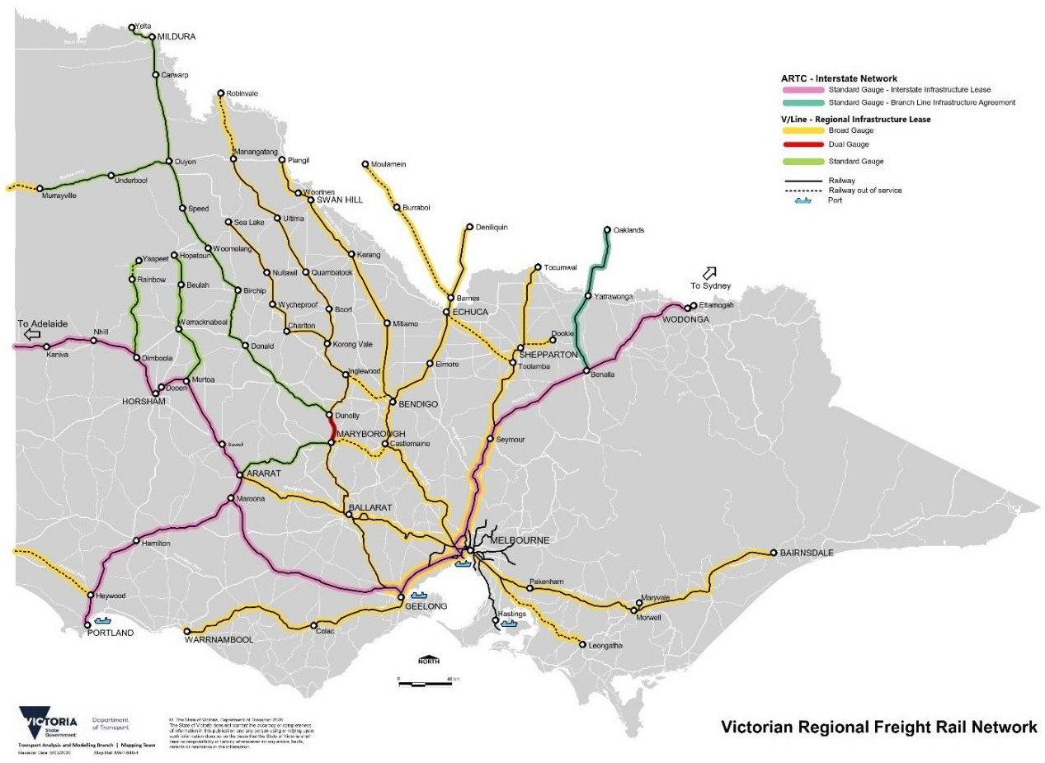

Figure 10 Victorian Regional freight rail network (Image source: DTP)

- Grain movements
Grain holds a crucial position in Victoria's export activities, leading to a concentration of grain transportation towards key export gateways such as the Port of Portland, Geelong Port, and the Port of Melbourne, and for domestic consumption. Road and rail transport contribute significantly to the grain supply chain, each fulfilling distinct roles:
- Rail plays a crucial role in transporting grain over extensive distances, following predetermined, high-capacity routes. This is especially evident in moving grain from domestic cultivation regions to ports, where rail often offers a cost advantage over road freight.
- Road freight, on the other hand, presents a cost-effective alternative for the grain industry over shorter distances or in scenarios requiring route flexibility due to multiple and/or changing origins and destinations.
Efficiency in both road and rail freight is paramount to establishing a competitive supply chain for any market route.

  - Road movements
Table 4 shows the spatial extent of the grain freight movements that use the road transport network within and around the study area. It shows the annual number of vehicles carrying freight for those movements. It was identified through stakeholder consultation that the state road network was predominately used to move grain within the study area and in some cases, grain facilities are located adjacent to the state network.
As shown in Figure 11 the main corridors used to transport grain on road include the:
- Henty Highway – the Henty Highway is a significant regional road in Western Victoria, Australia, connecting the towns of Portland and Horsham over a distance of approximately 340 kms. Serving as a crucial transport corridor, it plays a vital role in supporting freight transportation, agriculture, and local commuting. The highway passes through agricultural regions, contributing to the movement of goods, particularly agricultural produce, to ports for export.
- Western Highway – the Western Highway stands as a vital east-west artery in Victoria, linking Melbourne to the city of Adelaide in South Australia. Spanning approximately 314 kms, it plays a pivotal role as a transport corridor for a variety of purposes, including the movement of freight, commuter traffic, and tourism. The highway traverses key towns such as Ballarat, Ararat, and Stawell, with several sections having undergone upgrades over the years to enhance safety and efficiency. Key stages of the Western Highway duplication project are still in progress, with Ararat to Stawell in planning and development
- Sunraysia Highway – the Sunraysia Highway extends across approximately 331 kms, connecting the city of Ballarat to Mildura in the northwest. This regional highway intersects towns like Avoca, Maryborough, and Swan Hill and holds particular significance due to its passage through vital agricultural areas. The Sunraysia Highway facilitates the transportation of agricultural products, including citrus fruits and wine, contributing to local economies by supporting trade and tourism.
- Calder Highway – the Calder Freeway, forming part of the National Highway network, is a major thoroughfare linking Melbourne to Bendigo and beyond. As a critical transport link, it supports commuter traffic, freight transportation, and tourism, particularly for towns like Gisborne, Kyneton, and Castlemaine. The freeway has seen various upgrades to improve capacity and safety, solidifying its place as an essential component of Victoria's regional road network.

Table 4 Number of trips and tonnage on major corridors

Corridor |  | Estimated tonnes per annum (2023)²⁸ | Total trips (max)
Henty Highway | North - south | 813,300 | 14,787
Western Highway |  | 744,800 | 13,542
Sunraysia Highway |  | 562,100 | 10,220
Calder Highway |  | 895,700 | 16,285

²⁸ Derived from average payload across the heavy vehicle fleet





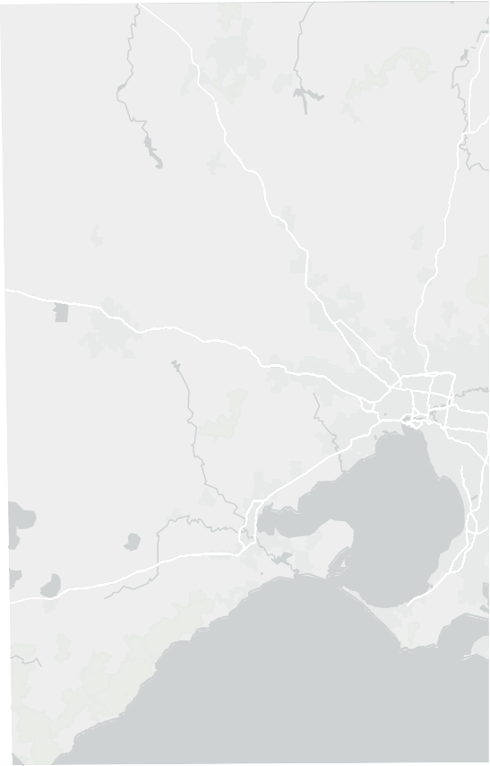
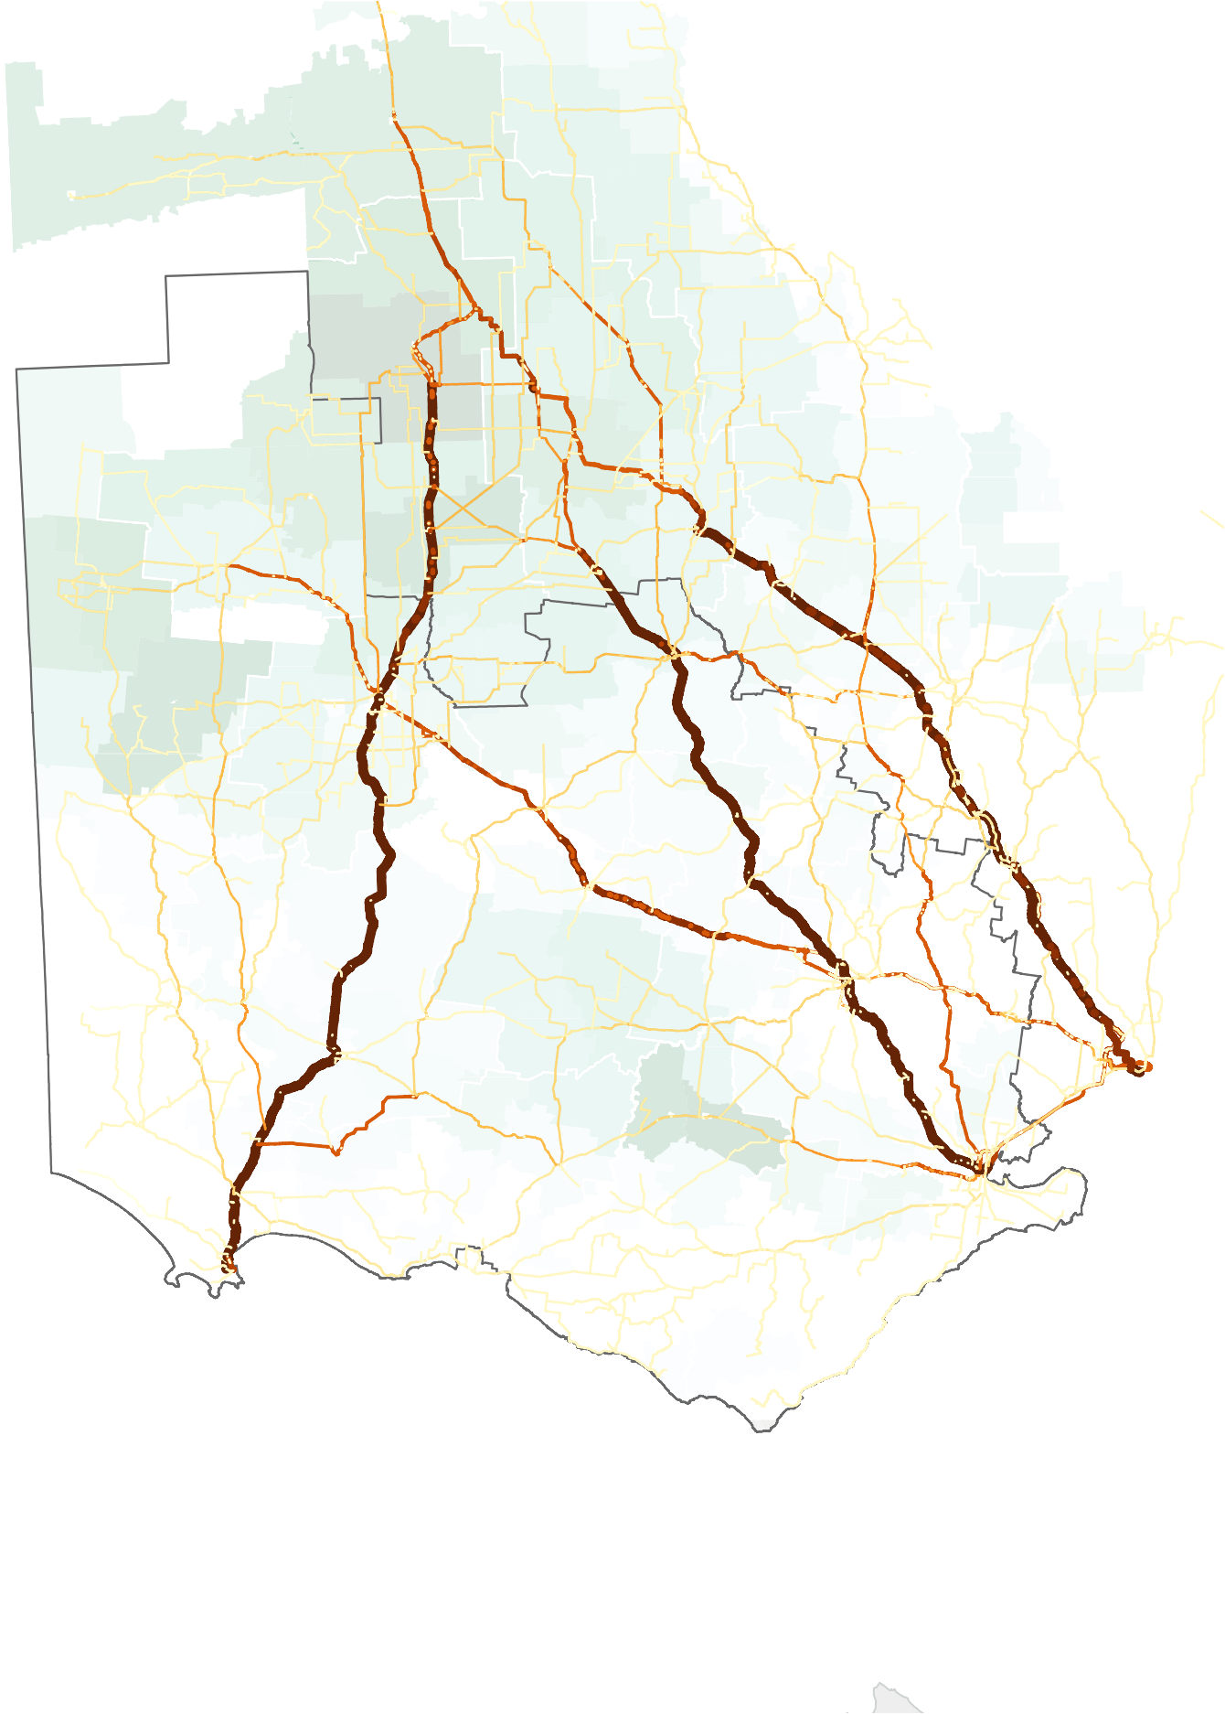















MILDURA
Legend
Total Heavy Vehicle Trips 1
2 - 100
100 - 500
501 - 1000
1001 - 1500 (45,000-68,000t)
1501 - 2000 (68,000-90,000t)
2001 - 3000 (90,000-135,000t)
3001 - 4000 (135,000-180,000t)
4001 - 5000 (180,000 -225,000t)
5001 - 6000 (225,000 - 270,000t)
> 6000
Study Area
(>270,000t)
Ports

Grain Receival Sites
Wimmera Intermodal Freight Terminal

Feedlot
Silos/bunkers
SWAN HILL

GANNAWARRA

BULOKE

HINDMARSH

YARRIAMBIACK
Hwy
LODDON
N
CAMPASPE
GREATER SHEPPARTO

WEST WIMMERA
Henty

NORTHERN GRAMPIANS
Western
Hwy

CENTRAL GOLDFIELDS
Hwy
Sunraysia

GREATER BENDIGO

MOUNT ALEXANDER

STRATHBOGIE

SOUTHERN GRAMPIANS
Road
Hwy

ARARAT
Gramp
ion

PYRENEES
Western Highway

BALLARAT

MACEDON RANGES
s
MURRINDINDI

NILLUMBIK
Hwy
Western
Henty
Fwy

GLENELG
Princes
Hamil
Princes

Port of Portland

MOYNE
ghway
ton
Hi

WARRNAMBOOL

CORANGAMITE

COLAC OTWAY
Hwy
Princes

SURF COAST

Port of Geelong
Hwy
Port of Melbourne

Volume (tonnes) per SA1
<=100.000000
100.1 - 200
200.1 - 500
500.1 - 1000
1000.1 - 2000
2000.1 - 3000
3000.1 - 4000
4000.1 - 5000

Paper Size ISO A4
5000.1 - 6000
6000.1 - 7000
7000.1 - 8000
8000.1 - 9000
> 9000


o

Glenelg Shire Council

Project No.

12608290

0 10 20 30 40

Kilometers
Map Projection: Lambert Conformal Conic Horizontal Datum: GDA 1994
Grid: GDA 1994 VICGRID94
Western Victoria Grain Industry Supply Chain Study

Total Road Trips
Grain SA1 production heatmap
Revision No. A
Date 15/05/2024

Figure 11

\
\ghdnet\ghd\AU\Melbourne\Projects\91\12608290\GIS\Maps\Working\12608290_KBM\12608290_K Print date: 15 May 2024 - 14:54
Data source: DEECA, VicMap, 2023; Volume data derived from ABS LGA data; ESRI Gray Basemap Created by: jreid6

© 2024. Whilst every care has been taken to prepare this map, GHD (and DATA CUSTODIAN) make no representations or warranties about its accuracy, reliability, completeness or suitability for any particular purpose and cannot accept liability and responsibility of any kind (whether in contract, tort or otherwise) for any expenses, losses, damages and/or costs (including indirect or consequential damage) which are or may be incurred by any party as a result of the map being inaccurate, incomplete or unsuitable in any way and for any reason.

  - Rail movements
Victoria’s rail freight network plays a vital role in transporting grain to ports. The volume of grain on rail varies year to year with a high focus on export grain to ports however significant domestic grain is also transferred to the Melbourne area and Geelong for flour and malt production. In larger harvest years additional grain is exported and the rail mode share generally increases. Around 52 per cent of grain is traditionally transported from upcountry receival sites to ports via rail.
In terms of cost efficiency, Australian rail freight proves to be comparatively more expensive per tonne-km than international counterparts. This is attributed to shorter haulage distances, low utilisation, and capacity constraints resulting from historical underinvestment and insufficiently coordinated planning²⁹. However, recent enhancements to the V/Line network have instilled confidence and led to increased grain movements by rail.
The current regional network operates generally for two main commodity types; grain and containerised product. However, the containerised operations on the northwest of Victoria are focused on the Mildura Yelta line (Merbein and Donald) and on the Manangatang line at Ultima.
The Victorian regional network remains divided across standard and broad-gauge operations with flexibility of standard gauge operations on some lines and constraints on the broad-gauge network with older locomotives and no flexibility to use these assets outside of Victoria without substantial gauge conversion.
The grain industry operates on variable harvest outcomes dependent on annual weather conditions and with often wide variations from state to state across Australia. In good Victorian seasons, additional rail assets can be applied to the standard gauge network to bolster rail capacity for the harvest, maximising rail mode share, however, as broad gauge locomotives are only used in Victoria on this network, the same flexibility does not apply Transporting grain by rail from northwest Victoria to ports like Geelong and Portland involves navigating different rail gauges. Challenges include gauge mismatches, infrastructure conditions, and last-mile connectivity.
Opportunities lie in the efficiency of rail transport for large volumes, reduced road congestion, environmental benefits, integrated logistics, and investment potential in rail infrastructure. Overall, optimising rail transport offers the potential for cost savings, sustainability, and a more efficient grain supply chain.
Various improvements as part of the Murray Basin Rail Project aim to meet growing industry demand for rail services. The introduction of new passing loops and railway upgrades on the Victorian railway network will enable efficiency, capacity, and flexibility upgrades by allowing higher axle loads and longer length freight trains to operate on the network.
Based on January 2024 V/Line reporting, 128 grain train services operated across the network, with 64 loaded trains delivering 108,000 tonnes of bulk grain for export to North Geelong and Appleton Dock, as well as domestic grain to Kensington³⁰. This compares with 64 loaded services and 102,000 tonnes for the same period in 2023.
Figure 12 summarises the rail transport for trips travelling within or with an origin or destination in Victoria, showing the freight volumes along the rail network.

Table 5 Summary of rail volumes and trips by destination

Destination | Estimated tonnes per annum (2023) | Total trips per annum
Port of Portland (standard gauge) | 442,000 | 180
Port of Geelong (dual gauge) | 1,649,000 | 673
Port of Melbourne (dual gauge) | 440,000 | 179

²⁹ LEK Consulting Australia Pty Ltd. (2023). Connecting the dots: Improving Australian grain supply chain efficiency. GrainGrowers Limited. https://cdn.sanity.io/files/1nr0ob5f/production/d232a7a0c81357fa87000d58885528664e0090f6.pdf
³⁰ Information supplied by V/Line.
GHD | 12608290 | Western Victoria Grain Industry Supply Chain Study 20

MILDURA
Legend
Total Heavy Vehicle Trips 1
2 - 100
100 - 500
501 - 1000
1001 - 1500 (45,000-68,000t)
1501 - 2000 (68,000-90,000t)
2001 - 3000 (90,000-135,000t)
3001 - 4000 (135,000-180,000t)
4001 - 5000 (180,000 -225,000t)
5001 - 6000 (225,000 - 270,000t)
> 6000
Study Area
(>270,000t)
Ports

Grain Receival Sites
Wimmera Intermodal Freight Terminal

Feedlot
Silos/bunkers

SWAN HILL

GANNAWARRA

BULOKE

HINDMARSH

YARRIAMBIACK
Hwy
LODDON
N
CAMPASPE
GREATER SHEPPARTO

WEST WIMMERA
Henty

NORTHERN GRAMPIANS
Western
Hwy

CENTRAL GOLDFIELDS
Hwy
Sunraysia

GREATER BENDIGO

MOUNT ALEXANDER

STRATHBOGIE

SOUTHERN GRAMPIANS
Road
Hwy

ARARAT
Gramp
ion

PYRENEES
Western Highway

BALLARAT

MACEDON RANGES
s
MURRINDINDI

NILLUMBIK
Hwy
Western
Henty
Fwy

GLENELG
Princes
Hamil
Princes

Port of Portland

MOYNE
ghway
ton
Hi

WARRNAMBOOL

CORANGAMITE

COLAC OTWAY
Hwy
Princes

SURF COAST

Port of Geelong
Hwy
Port of Melbourne

Volume (tonnes) per SA1
<=100.000000
100.1 - 200
200.1 - 500
500.1 - 1000
1000.1 - 2000
2000.1 - 3000
3000.1 - 4000
4000.1 - 5000

Paper Size ISO A4
5000.1 - 6000
6000.1 - 7000
7000.1 - 8000
8000.1 - 9000
> 9000

o

Glenelg Shire Council

Project No.

12608290

0 10 20 30 40

Kilometers
Map Projection: Lambert Conformal Conic Horizontal Datum: GDA 1994
Grid: GDA 1994 VICGRID94
Western Victoria Grain Industry Supply Chain Study

Total Road Trips
Grain SA1 production heatmap
Revision No. A
Date 15/05/2024

Figure 11

\
\ghdnet\ghd\AU\Melbourne\Projects\91\12608290\GIS\Maps\Working\12608290_KBM\12608290_K Print date: 15 May 2024 - 14:54
Data source: DEECA, VicMap, 2023; Volume data derived from ABS LGA data; ESRI Gray Basemap Created by: jreid6

© 2024. Whilst every care has been taken to prepare this map, GHD (and DATA CUSTODIAN) make no representations or warranties about its accuracy, reliability, completeness or suitability for any particular purpose and cannot accept liability and responsibility of any kind (whether in contract, tort or otherwise) for any expenses, losses, damages and/or costs (including indirect or consequential damage) which are or may be incurred by any party as a result of the map being inaccurate, incomplete or unsuitable in any way and for any reason.

- Infrastructure Condition Requirements
  - Measuring road network condition
Roads in Victoria are managed and maintained through collaboration between different entities. DTP plays a central role in overseeing major roads and highways, focusing on planning, development, and road safety.
Municipal councils are responsible for managing and maintaining local roads within their areas. DTP ensures a coordinated approach to road management and transportation planning. The specific responsibilities depend on the classification of roads, with major highways falling under DTP, while local streets are managed by municipal councils which is summarised in Table 6.

Table 6 Summary of responsible authorities for road maintenance

Road classification | Coordinating road authority | Responsible road authority
Arterial (urban) | DTP | VicRoads (through traffic), Council (service roads, pathways and roadside)
Arterial (non-urban) | DTP | VicRoads Council (service roads, pathways)
Municipal | Council | Council

    - Road pavement strength and condition
Measuring road pavement condition and strength involves assessing various factors such as surface distress, roughness, texture, pavement deflection, thickness, material properties, moisture content, load-bearing capacity, visual inspection, non-destructive testing, and environmental influences. These assessments provide insights into the structural integrity, durability, and overall health of road pavements. Regular and comprehensive evaluations aid transportation authorities in making informed decisions for maintenance, rehabilitation, and reconstruction to ensure the long-term effectiveness and safety of the infrastructure. However, key attributes that are considered in this assessment include rutting, cracking and roughness which are summarised in Table 7.

Table 7 Summary of pavement factors used in the infrastructure assessment

Pavement factor | Description
Rutting  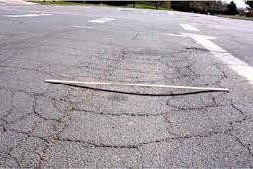 | Rutting in road pavement is the creation of longitudinal depressions due to heavy vehicles’ repeated use. It is caused by factors like insufficient pavement thickness, compaction, and weak subgrade soils. Excessive rutting negatively impacts road safety, drainage, and ride quality, and can increase hydroplaning risk due to water accumulation. Rutting management involves addressing these causes and improving pavement structural integrity
Roughness  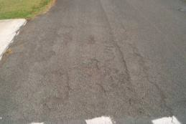 | Road roughness, which affects ride smoothness, is measured by the International Roughness Index (IRI). It is influenced by factors like surface distress, construction quality, traffic, and weather. High roughness can lead to discomfort, higher vehicle costs, and less efficient transport systems. Therefore, smoother roads are crucial for better fuel efficiency, reduced vehicle damage, and improved user experience.
Cracking   | Road pavements show different cracks, each hinting at specific issues. Alligator cracking indicates structural failure, longitudinal cracking results from thermal stress and traffic, transverse cracking is due to temperature changes or inadequate support, and block cracking is linked to asphalt aging. Prompt crack repair is vital for road longevity.

      - The impact of heavy vehicles and climate on pavements
Heavy vehicles, such as trucks and buses, impose a greater impact on pavement condition compared to passenger cars. The higher axle loads, concentrated loading from multiple axles, and the frequency of heavy vehicle operation contribute to accelerated wear and fatigue on road pavements. This results in issues such as rutting, pavement deformation, and increased maintenance costs for road authorities. In contrast, passenger cars, with their lighter axle loads and more evenly distributed weight, have a comparatively lower impact on pavement. Road design considerations and maintenance strategies need to account for the distinct challenges posed by heavy vehicles to ensure the longevity and safety of the road infrastructure.
In northwest Victoria, the local climate significantly influences the condition of road pavements. The region experiences hot temperatures, especially during summer, which can lead to the softening of asphalt, causing rutting and deformation under heavy traffic. In contrast, winter brings colder temperatures, contributing to thermal cracks and frost heave. The area is prone to occasional heavy rainfall, which may weaken subgrade and base materials, leading to distress such as potholes and rutting. Additionally, the use of de-icing salts during colder months can impact pavement integrity. The region's transition seasons with temperature fluctuations may induce stress and strain on pavements, potentially resulting in cracking and distress.
Pavements in southwest Victoria experience higher rainfall and cooler climates when compared to the northwest region. Higher rainfall can significantly impact road pavements. It leads to issues such as cracking, potholes, and decreased durability. Flexible pavements, commonly used for roads, become vulnerable due to changes in bitumen viscosity caused by rain. This can result in rutting and roughness. Climate also impacts the ability to complete renewal works, with failed works occurring during extremities or if poorly timed seasonally. The geology of much of the Wimmera have highly reactive soils which contribute to greatly reduced road pavement lives and increased maintenance burden.

    - Bridges and culverts
Heavy vehicles, such as trucks and buses, impose immediate and long-term impacts on bridges and culverts compared to passenger cars. The higher axle loads and dynamic forces generated by heavy vehicles contribute to concentrated stress, potentially causing immediate damage and compromising the structural integrity of these critical infrastructure elements. Over time, the repeated use of heavy vehicles accelerates the deterioration of materials, leading to issues like fatigue, fractures, and localised damage. Older structures, not initially designed for modern heavy vehicle loads, face increased vulnerabilities and may require more extensive maintenance and retrofitting efforts to ensure continued safety and functionality. Regular inspections and strategic interventions are crucial to address the distinct challenges posed by heavy vehicle traffic on both older and newer bridges and culverts.

  - Improving road network condition
As industries continue to develop in regional Victoria, there is a growing need for increased mass limits on the current road and bridge infrastructure. The transition to High Productivity Freight Vehicles (HPFVs) with expanded dimensions and greater load capacities is hindered by the condition of pavements and bridges. This limitation prompts industries to consider less direct, cost-effective, and efficient options. The rise in traffic volumes further adds to the strain on pavements. It is estimated that the population in the Barwon South West Region has increased to 446,000³¹ (10 per cent increase compared to 2016) in 2022 whilst other regional centres such as Horsham are experience population growth at an estimated rate of 0.2 per cent³² per annum which is all contributing to demand for goods and traffic on the road network.
In the past decade, the arterial road network in south-west Victoria has experienced an uptick in both traffic and larger vehicle types, placing additional demands on the existing infrastructure. This trend is also observed in other industries, such as the dairy sector adopting larger combinations of dairy tankers to enhance supply chain efficiency. Additionally, the Green Triangle timber industry around Portland is experiencing growth in volumes. The

³¹ idcommunity. (2024, March). Barwon South West Region: Population and dwellings. https://profile.id.com.au/g21- region/population?WebID=150
³² Regional Development Victoria. (2024, March). Regional City of Horsham. Victorian Government, Regional Development Victoria. https://www.rdv.vic.gov.au/victorias-regions/horsham

growth in mining activities, particularly for construction materials and mineral sands, in south-west Victoria has led to an increase in truck usage to transport these resources to major cities and project sites.³³Over a seven year period (between 2013 and 2020), data³⁴ reported by DTP points to an uptick in total and commercial vehicle volumes of approximately 30 and 25 per cent respectively across the A class road network within the South West and Western Regions.

    - Road pavements
Improving the condition of road pavements involves a range of treatment options tailored to address specific issues and enhance overall durability. Surface seals like chip seals or micro surfacing are applied to create a protective layer, sealing cracks, and providing improved skid resistance. Asphalt overlay involves adding a new layer to the existing pavement, enhancing ride quality and addressing surface distress. In-place recycling methods, such as cold or hot in-place recycling, efficiently reuse existing pavement materials to enhance structural strength and reduce the need for new materials.
The choice of treatment depends on factors such as the extent of distress, pavement condition and traffic loads. Combining these treatments within a comprehensive pavement management plan optimizes performance and extends the life of road pavements, ensuring safe and efficient transportation infrastructure.

      - Road maintenance work types
Maintenance is integral to the operation of Victoria's road network, ensuring safe and reliable journeys for all users. There are three main work types that are summarised in Table 8The service levels reflect the relative functional classification levels of the roads, which depend on key factors such as route connectivity and access, traffic volumes, number of commercial vehicles/ PFN, tourist priority route and public transport.
Table 8 illustrates road condition and remediation as determined by different service levels. The service levels reflect the relative functional classification levels of the roads, which depend on key factors such as route connectivity and access, traffic volumes, number of commercial vehicles/ PFN, tourist priority route and public transport.

Table 8 Maintenance work types³⁵

Work type | Description
Routine maintenance | These activities address minor issues before they escalate into major problems. Regular maintenance tasks involve fixing potholes, maintaining clean gutters and drains, repairing damaged signs, and clearing litter.
Periodic maintenance | Cost-effective road maintenance, such as resurfacing and corrosion protection for bridges, is employed to preserve roads and prevent more expensive rehabilitation. Road resurfacing, also known as resealing, is effective when the surface layer is damaged, but the underlying structural pavement is still intact. By addressing surface cracks and damage through resurfacing, further harm to the underlying layer is prevented, saving costs and restoring the road to its original standard.
Rehabilitation | In cases where the "road pavement" layer sustains damage, rehabilitation efforts are employed to bring the road back to its initial standard. These extensive works entail the replacement of both the pavement and road surface layers. Consideration should also be given to building roads higher than standard to accommodate for new vehicle types and volume.

      - Regional road programs
The Victorian Government is implementing a new multi-year funding approach, investing an additional $2.8 billion over the next decade in road maintenance. This initiative aims to establish a long-term maintenance program, strategically addressing the state's road network, including the ongoing prioritisation of road sealing – especially where there are projected traffic volume increases further justifying it. In the 2023-24 financial year, $770 million

³³ https://regionalroads.vic.gov.au/Map/Barwon-South-West-improvements/Green-Triangle-freight-routes-in-south-west-Victoria
³⁴ DTP traffic volumes.
³⁵ VicRoads. (2021, August). Pavement Management Strategic Plan. Victorian Government, Department of Transport. https://www.vicroads.vic.gov.au/-/media/files/documents/utilities/about-vr/strategy/vr-pavement-management-strategic- plan_report_august-2021.ashx.

will be allocated to road maintenance, including repairs resulting from recent flooding. Unprecedented rainfall in 2021 and 2022 has led to road damage, particularly in areas with record-high annual rainfall. The focus will be on addressing potholes and conducting major patching work on severely flood-damaged roads, critical freight routes, and travel routes to ensure efficient movement across Victoria. The government acknowledges the frustration of road users and is adjusting maintenance priorities in response to the impact of the October 2022 floods on road conditions³⁶.
The use of recycled materials or innovative asphalt mixes like crushed concrete, brick and glass also offers promise for road maintenance programs and have been trialled incrementally by VicRoads.³⁷ In most cases, these provide equivalent or improved performance compared to traditional asphalt, with greater longevity and resilience leading to reduced frequency and cost of repairs To enhance coordination on forward road maintenance programs, more dedicated joint council-state government forums or fast tracked approval processes for priority projects should be explored . ³⁸ In the wider funding context, the Development Facilitation Program aims to accelerate approval of priority projects and similar interfaces could be investigated for road infrastructure. There is also a complex interplay between road vegetation and road maintenance, with approval processes for vegetation removal adding administrative overhead, but needing to be carefully balanced given the role vegetation plays in mitigating erosion.
A list of roads earmarked for upgrades over 2023-24 has been included in Appendix A.

    - Bridges and culverts
Treatment options for strengthening or reconstructing bridges and culverts involve various techniques tailored to address specific structural issues and improve overall performance. Structural retrofitting is a common approach that includes modifications like adding external post-tensioning tendons or steel and carbon fibre-reinforced to enhance load-carrying capacity and durability.
Deck replacement is employed to address issues like deterioration or insufficient load-bearing capacity, often using materials like high-performance concrete or composites. Substructure repair focuses on fixing components like piers and abutments through concrete patching, epoxy injection, or protective coatings.
Expansion joint replacement is crucial for maintaining flexibility and preventing water infiltration. Reinforcement of critical members involves adding external steel or fibre reinforced polymer as reinforcement, increasing section size, or introducing additional support elements or other protective coatings.
Culvert relining restores structural integrity by adding new interior layers using materials like reinforced concrete, high-density polyethylene, or corrugated metal. Underpinning stabilizes foundations through methods like grout injection or micropiles, and corrosion protection measures include coating systems, cathodic protection, and corrosion inhibitors. Geotechnical solutions address soil-related issues, employing techniques such as soil stabilization, ground improvement, or deep foundation solutions. The choice of treatment method depends on a thorough assessment considering material condition, load-carrying capacity, and environmental factors.

    - Road formation
Road formation and construction critical components include land width, shoulder width, seal width, and pavement type, each playing a vital role in ensuring the functionality and safety of the infrastructure. Land width, encompassing the entire road reserve, influences the overall design and accommodates travel lanes, shoulders, and essential features. Shoulder width, the lateral distance from the travel lane to the road's outer boundary, is pivotal for emergency situations, vehicle recovery, and overall road stability. Seal width, specifically the asphalted portion, defines the road surface covered by sealing materials, impacting driving experience, load-bearing capacity, and longevity Properly maintained table drains are critical in collecting and diverting water runoff to keep the road surface and subgrade dry, minimising excess water infiltration and erosion damage which both exacerbate long term maintenance costs and road serviceability.

³⁶ Regional Roads Victoria. (2024, February). Maintenance: Regional roads maintenance program 2023-24. Victorian Government, Department of Transport and Planning. https://regionalroads.vic.gov.au/about-us/maintenance.
³⁷ https://bigbuild.vic.gov.au/ data/assets/pdf_file/0011/739847/ecologiQ-Recycled-Crushed-Glass-Technical-Note.pdf
³⁸ https://bigbuild.vic.gov.au/ data/assets/pdf_file/0011/739847/ecologiQ-Recycled-Crushed-Glass-Technical-Note.pdf

Additionally, pavement type, indicating the composition and structure of the road surface, influences load-bearing capacity and durability. With respect to heavy vehicle loading, design loads will be key to determining adequate pavement profiles ranging from granular to deep strength asphalt pavements in areas where the stratum may be compromised under heavier vehicle loads. Sufficient land and shoulder width ensure safe road operation, while appropriate seal width and pavement type contribute to a resilient and enduring infrastructure. Collectively, these elements are fundamental in creating roadways that meet safety standards, provide optimal driving conditions, and withstand the demands of varying traffic loads.
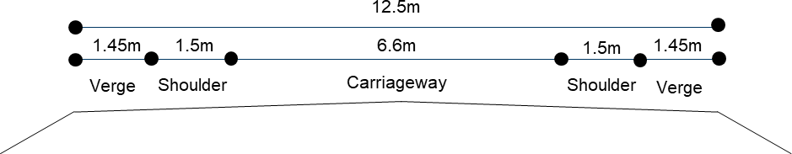
Figure 13 Pavement formation example

The assessment of the pavement cross-section aimed to determine the adequacy of seal, lane, and shoulder widths for facilitating passing movements for both heavy and light vehicles. This information played a crucial role in a multi-criteria assessment process, guiding the identification of priority upgrades.
In this context, shoulder widths refer to the asphalt or sealed pavement at the edge of a trafficable lane. On unsealed roads, shoulders are typically composed of gravel or grass. The consideration of partially or fully sealed shoulders offers additional benefits, presenting opportunities for widening or new construction of pavements.
The road cross-section, encompassing travel lanes and shoulders, aligns with the required standards for the Annual Average Daily Traffic (AADT) and the intended function of each road. The recommended specifications entail 3.3 metre travel lanes with a minimum of 1.5 metres of sealed shoulder along the entire PBS3a route.

Table 9 PBS3a pavement geometry requirements for rural areas³⁹

Vehicle Classification | AADT (vehicles) | Lane (m) | Shoulder (m)
PBS Level 3 vehicles | 500 - 1,500 | 3.2 | 1.2
 | 1,501 — 3,000 | 3.3 | 1.5
 | 3,000 | 3.5 | 1.5

  - Rail condition and maintenance
Without essential ongoing maintenance and uplift, the rail freight network’s ability to operate safely and reliably for its users and the wider community will become compromised. This can result in the rail infrastructure becoming less desirable as an alternative to road freight, which can impact the mode shift ambitions supported by the Victorian Government. Similarly, decreasing rail maintenance reduces industry confidence and willingness to invest in rail freight, lowering mode share. This could result in a rapid return to speed restrictions, load restrictions, and line closures, as bridges and culverts are deemed unsafe. Ultimately, non-investment in maintenance will see Western Victoria’s grain freight rail network fail to deliver key outcomes related to increasing rail freight volumes and rail freight mode share, limiting the longevity and long term growth of the rail network,
Speed restrictions, load restrictions, and line closures across the freight network impact performance and introduce the risk of freight rail services becoming commercially unviable, lowering rail freight’s value proposition.

³⁹ National Heavy Vehicle Regulator. (2007). Performance-Based Standards Scheme – Network Classification Guidelines. National Transport Commission. https://www.nhvr.gov.au/files/0018-pbsnetwrkclassglines.pdf.

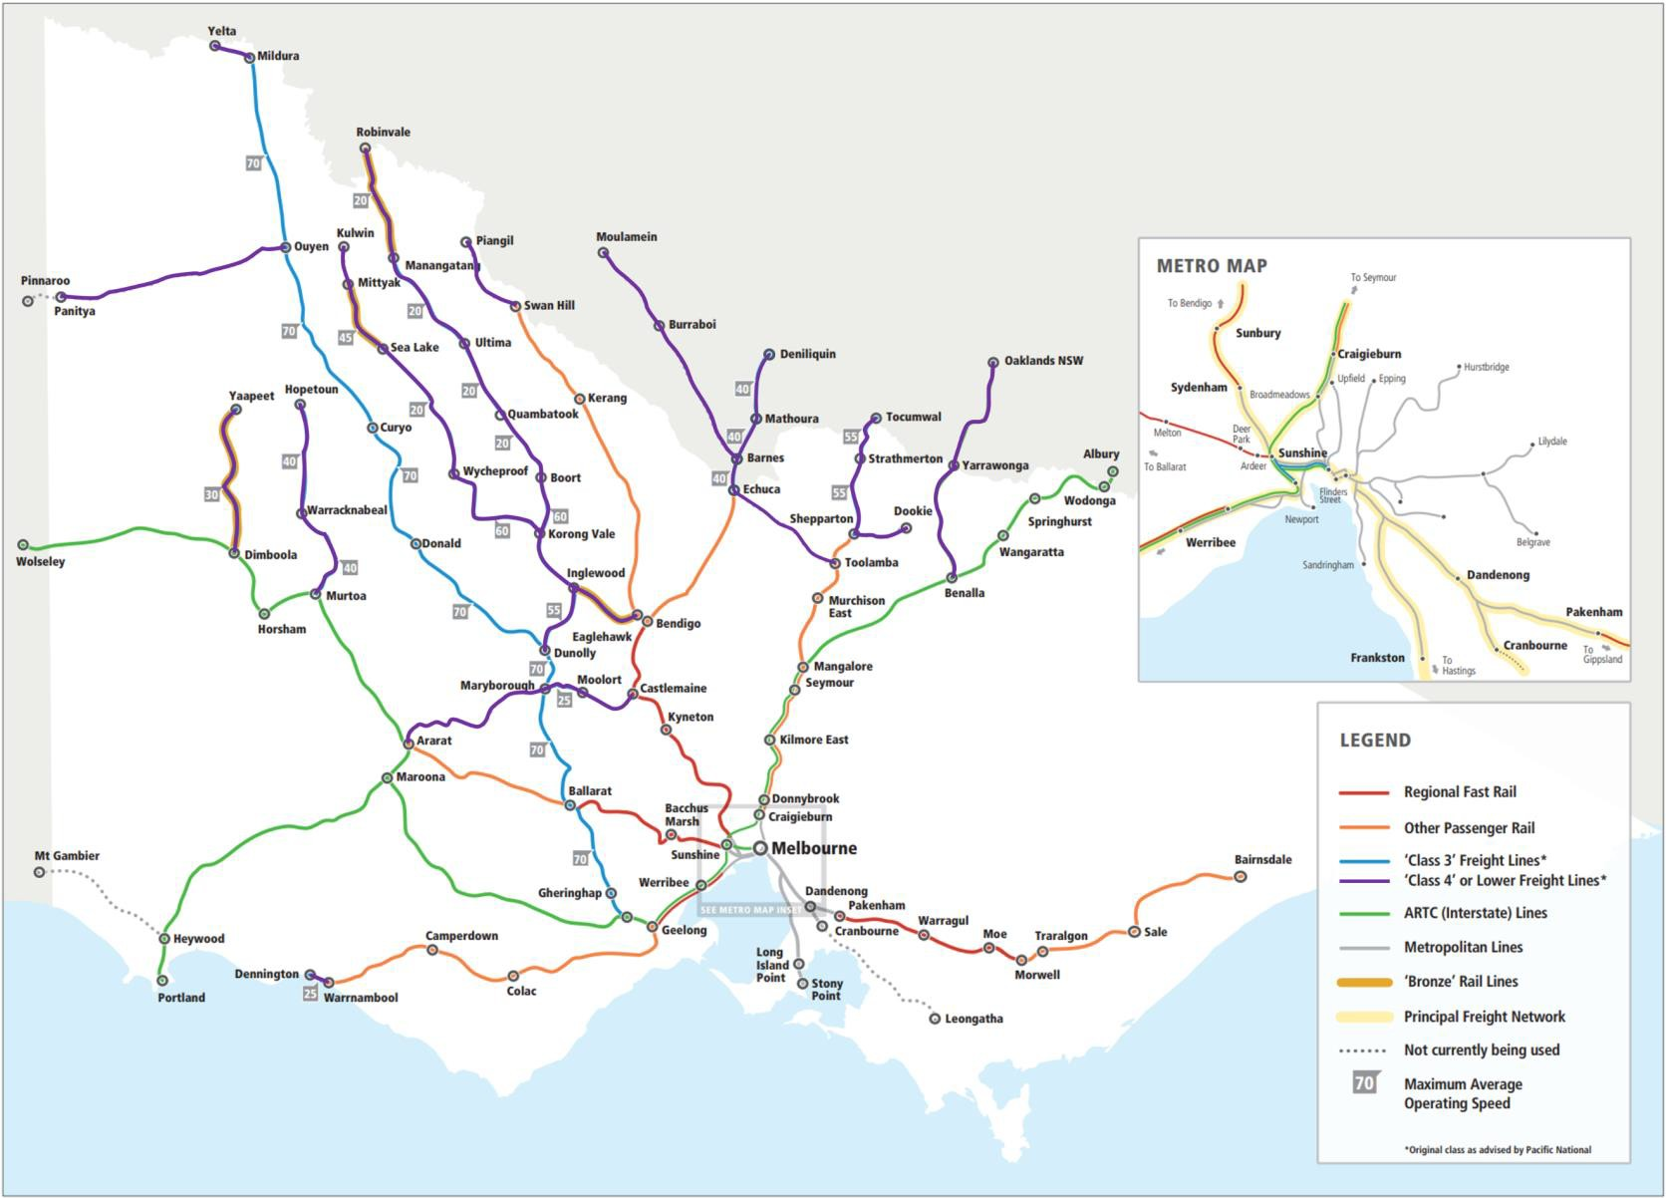
Figure 14 Victorian regional rail network (Image Source: Essential Services Commission & VICSIG)

- Infrastructure Assessment
The road network has been classified into two categories based on an assessment of traffic volumes. These categories are determined by identifying where the most significant volumes of transportation occur. For instance, corridors that serve as the backbone for exports are considered the most significant, while other corridors feed into these main routes. This categorisation takes into account supply chain examples and the importance of grain transport, among other factors. These are reflective of the supply chain journey requirements and their:
- Priority A (1.03 million kilometres of pavement assessed) – this network is focused on the main arterial links and their connections with major export gateways such as the Port of Portland, Geelong Port and Port of Melbourne. This network cumulatively carries significant volumes and has been recommended to support the use of HPFVs. Key corridors include the Henty Highway, Midland Highway, Western Highway and the Calder Highway.
- Priority B (1.23 million kilometres of pavement assessed) – supports the A network by feeding volumes into the main arterials and often serve as alternatives to larger corridors. In most cases, they are not HPFV approved and have been considered in this instances as part of the infrastructure assessment.
The Priority A and B networks are mapped in Figure 15 below.

Legend
Study Area
Priority
A B
<all other values>

Ports




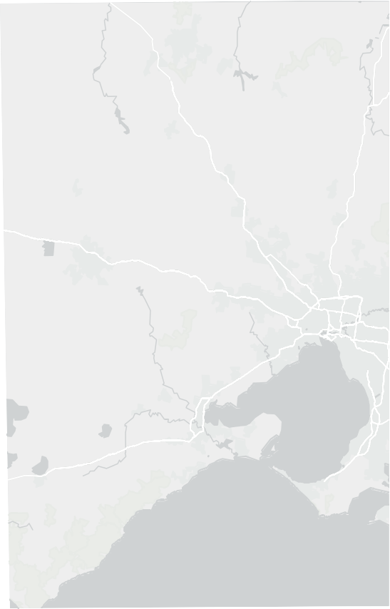
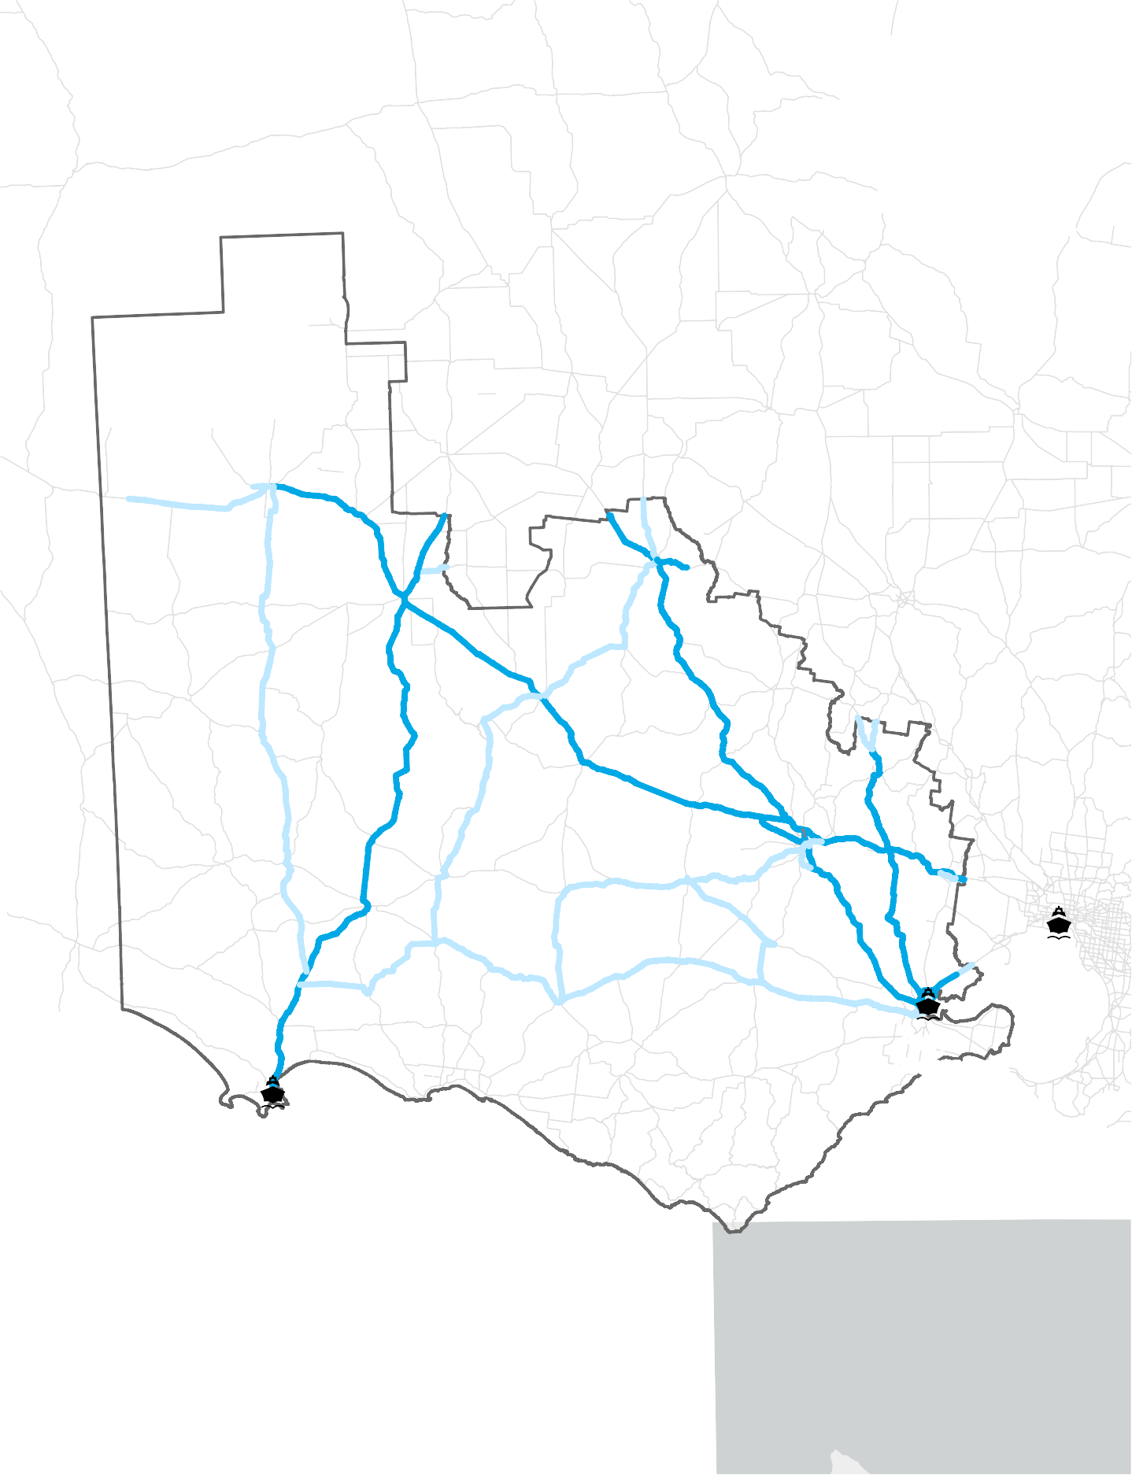

Port of Melbourne
ghway
Western Highway
Hwy
Western
Princes
Hwy
Henty
Road
Gramp
s
ion
Hwy
Fwy
Hamil
Princes
ton
Hi

Port of Portland
Hwy
Princes
Port of Geelong

Paper Size ISO A4
o
0 10 20 30 40

Kilometers
Map Projection: Lambert Conformal Conic Horizontal Datum: GDA 1994
Grid: GDA 1994 VICGRID94
Glenelg Shire Council
Western Victoria Grain Industry Supply Chain Study

Priority A and Priority B Network
Project No. 12608290
Revision No. E
Date 21/05/2024

Figure 15

\
\ghdnet\ghd\AU\Melbourne\Projects\91\12608290\GIS\Maps\Working\12608290_KBM\12608290_K Print date: 21 May 2024 - 18:46
Data source: DEECA, VicMap, 2023; Volume data derived from ABS LGA data; ESRI Gray Basemap Created by: jreid6

© 2024. Whilst every care has been taken to prepare this map, GHD (and DATA CUSTODIAN) make no representations or warranties about its accuracy, reliability, completeness or suitability for any particular purpose and cannot accept liability and responsibility of any kind (whether in contract, tort or otherwise) for any expenses, losses, damages and/or costs (including indirect or consequential damage) which are or may be incurred by any party as a result of the map being inaccurate, incomplete or unsuitable in any way and for any reason.
Western
Hwy
Hwy
Sunraysia
Henty
Hwy

  - Road condition assessment findings
Recent road infrastructure improvements in the region have significantly enhanced pavements on major arterial roads. As a result, these roads require limited renewal works based on criteria such as rutting, roughness, and cracking. However, feeder roads that form part of the Priority B network still need additional work to improve pavement standards, particularly in reducing rutting, shoulder deterioration and potholes.
The graphs provide insights into the current state of the corridors. They highlight areas where resurfacing or renewal efforts might be necessary to enhance road standards. These improvements aim to facilitate existing heavy vehicle traffic and promote the use of PBS Level 3A vehicles.
The assessment of pavement condition data provided by the DTP led to the identification of necessary interventions based on a Road Maintenance Category (RMC). Each road section corresponds to a DTP assigned RMC which is determined through a risk evaluation process, considering factors such as road classification, road type, traffic volume, and traffic type.
The results for the assessed road segments, as demonstrated in Figure 16, represent the total percentage assessed across the Priority A and B network. The data shows the following:
- The Priority A network requires resurfacing work to address high levels of cracking (46% of the assessed network) and pavement roughness (29% of the assessed network).
- Renewal work for the Priority A network is primarily triggered by rutting (20% of the assessed network) in specific areas.
- The Priority B network necessitates more significant intervention, with cracking (54% of the assessed network) and roughness (33% of the assessed network) requiring attention through pavement resurfacing.
Renewal for the Priority B network is prompted by high rates of rutting (55% of the assessed network).This is data represents a snapshot in time and it is expected that pavement condition with continue to deteriorate without further intervention and investment. Pavement interventions are mapped in Appendix C.

60%

50%
Resurfacing Renewal
Prioriry A Network
Resurfacing Renewal
Prioriry B Network

40%

30%

20%

10%

0%

Rutting Roughness Cracking

Figure 16 Road condition assessment outcomes- rutting, roughness and cracking⁴⁰

  - Pavement formation findings
Pavement cross-section was assessed to determine whether there are satisfactory shoulder widths to adequately provide passing movements for heavy vehicles and areas to pull over.

⁴⁰ Assessment findings using data provided by DTP

In this instance, shoulder widths are considered as the asphalt or sealed pavement at the edge of a trafficable lane. In the case of unsealed roads, shoulders are typically gravel or grass. Partially or sealed shoulders offer further advantages for pavements that could be considered for widening or new construction.
DTP provided pavement data that indicated existing shoulder widths. This information was used to determine where improvements are required based on the minimum requirement for both the Priority A and Priority B network. These are based on high level AADT requirements demonstrated in Table 9. The results are demonstrated in Table 10.

Table 10 Shoulder width analysis⁴¹

Priority network | Minimum requirement (m) | % of network less than minimum requirement
A | 1.5 | 60
B | 1.2 | 86

  - Bridges
The growing road freight task and drive towards greater efficiency across Victoria has required the need for the upgrade of existing infrastructure to accommodate higher productivity vehicles and their greater loads. In this instance, existing bridges may require widening, or strengthening to meet the growing demand and the more recent design standards.
The SM1600 traffic standard was introduced in response to the increasing truck mass, truck axle loads and new configurations. The design code recognises that lane widths and height clearances are relatively fixed and that materials loaded on the vehicles are packed to certain densities.
Hence, with the increasing demand for higher mass vehicles it is important that asset managers understand the capacity of existing bridges, their current conditions and the demands by current and evolving vehicles. In the absence of information, load capacity assessments should be undertaken by experienced bridge engineers.
Techniques are in-place to strengthen structures that were constructed in the 1960s-70s to meet the requirement of 75 per cent of SM1600 truck loadings. Structural strengthening can include the use of carbon fibre (rod and laminate) on crossheads, external post tensioning and concrete web thickening on pre-steel I-girders, the use of steel plates on I-girders, and the use of anchored dowels to connect elements to act as composite sections ⁴².

    - Bridge Assessment
The assessment compared the relative difference between existing approved A-doubles and the A-double design vehicle adopted by the grain industry (typical trailer that complies with PBS3a standards). The assessment also considers the number of spans and structure length to determine moment, shear and reaction ratios. This assessment yields a ratio to determine the additional loading requirement to accommodate a PBS3a vehicle.

      - Assumptions and limitations
At the time of this initial desktop assessment, no testing or sampling was undertaken as part of this assessment. Furthermore, no structural analysis or hydraulic assessment were undertaken. Information was gathered from the Victorian Open Data platform which provided data for the high-level assessment including condition ratings. Spans and age of structures were obtained from local government databases. This assessment has identified bridges that will require a VicRoads Level 2 Bridge Inspection. Some assumptions were made in the absence of available information including:
        - The structures are currently performing satisfactorily for the 30m A-doubles at vary capacities
        - For bridge structures, the review consisted of a comparison of the bending moment and shear force
        - An assumed design load for the bridge

⁴¹ Analysis of DTP data
42 R. Al-Mahaidi, Kalra, R., & Mikhael, S. (2017). Design and constructability challenges of strengthening existing bridges. Austroads. https://www.onlinepublications.austroads.com.au/items/ABC2017-124-17.

The assessment identified several structures within the study area that are conditionally approved (can only be crossed by combinations operating at the allowed weight). Therefore, PBS 3A vehicles are able to operate on the network but cannot exceed 85.5t creating inefficiencies in the network. The results of the assessment are shown in Figure 17 and highlight bottlenecks across the network.

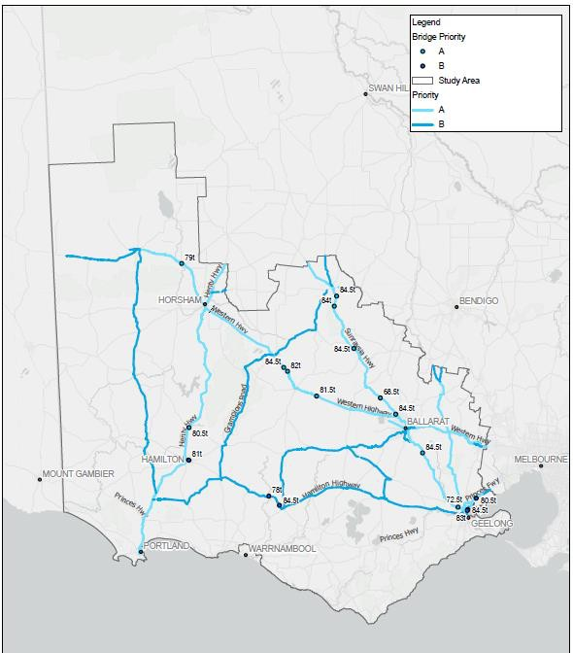
Figure 17 Bridge assessment outcomes of conditionally approved structures that do not support 85.5t A-Doubles

  - Rail infrastructure assessment
Due to sensitivities, asset condition data for both the V/Line and ARTC networks were not provided. However, discussions were held to seek available information on key routes and information was provided regarding the ongoing improvements across the network. The below map provides an overview of standard, broad and dual gauge across the Western Victorian grain lines, spanning approximately 1,100 kilometres of the rail concerned within the Study Area.
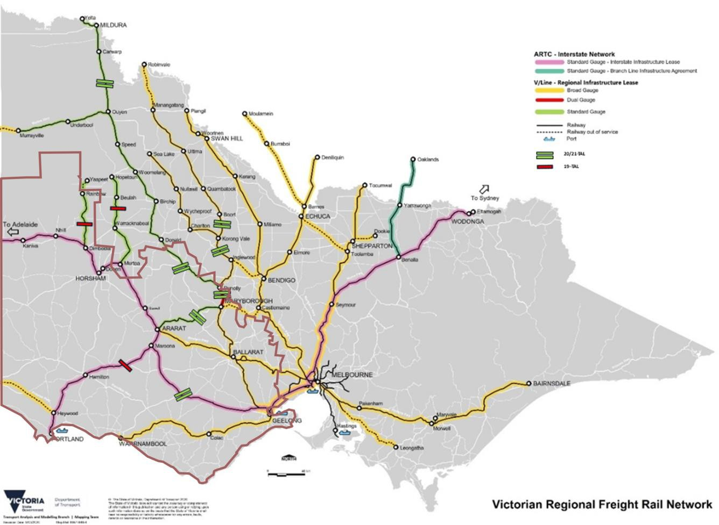
Figure 18 Victorian regional freight rail network – TAL limits

    - ARTC network
The western ARTC mainline from Melbourne through Geelong to the South Australian Border essentially operates at 23 tonne Track Axle Load (TAL) and provides a core network access for standard gauge grain trains for both the ARTC and V/Line networks supporting the west and northwest of Victoria.
The Maroona to Portland Line provides access to the port of Portland from the western standard gauge mainline which is also managed by ARTC under a lease arrangement with the Victorian Government. There is currently an operating standard of 19 tonne TAL at an operating speed of 80kph, however, the operating speed and axle loading experienced by operators is 40kph at 19 tonne TAL. Discussion with ARTC indicated a concern on the current tonnages carried on the corridor and its value for investment with a business case submitted to the Federal infrastructure department seeking funding to support additional upgrade of the track to the agreed lease standard. ARTC see this funding as the only option for current investment in the corridor.

»The latest Federal Government budget (Tuesday 14 May 2024) has now approved
$150 million funding for a comprehensive upgrade of the Maroona to Portland line. This will bring the operating standards up to 21 TAL at 80 kph and 23 TAL at 65 kph. This will restore the corridor’s competitive advantage relative to alternative routes to the ports of Geelong and Melbourne. A further important potential improvement would be an upgrade to rail receival facilities at the Port of Portland itself. «
  - V/Line network
V/Line is addressing network standards regarding train speed and axle weight capacities with available funding toward a 23 tonne TAL based on upgraded rail and track conditions. There are approaches for joint collaboration with industry and specific focus areas to gain best outcomes for available funds. This also includes private investment by grain marketers and suppliers with benefits to all parties. Further available funds to support this program (and other works) are a key to network efficiencies. To some degree the total cycle time approach is an example of best outcomes although additional further track upgrades should include opportunities on track speed as part of this scope.
Progressive updates of TAL on the V/Line network are proposed as funding is available to increase TAL levels to 23 tonne TAL in alignment with the ARTC mainline. The Victorian Government also issued a Statement of Freight Network Capability in December (2023) providing some insights to current works and improvements on the rail network as part of the Freight Network Capability Statement indicating the intended changes⁴³.
Currently, some routes to export ports such as the Hopetoun and Rainbow lines only support a 19 tonnes axle load. Ararat to Maryborough track sections were re-railed and now permit 21TAL for all wheel sizes. To fully activate this outcome, freight operators and grain terminal operators will need to upgrade their facilities to accommodate higher axle loads.
V/Line has undertaken a prioritisation of essential works and large builds/expansion projects through its Grain Rail Improvement Plan (GRIP). This is through a combination of maintenance, renewal and network efficiency changes across various areas of the network including:
- The Hopetoun and Rainbow lines have had a level of regular maintenance but limited broader improvements at the current time. A focus on rerailing of the key corridors is considered a key to further upgrades as heavier rail and welded joints form the basis of next steps toward TAL upgrades and overall train capacity and efficiency improvements on the V/Line network.
- Further funding for rerailing of the Murtoa-Hopetoun line is seen as a key development of these two additional standard gauge lines. This is supported by V-Line assessment around slow load rates, short sidings and lack of available/sufficient stabling at sites such as Jeparit and Beulah. Any axle load increases will also require bridge and other structures to be assessed and upgraded/replaced.
- Following TAL upgrades between Geelong and Ballarat to 20/21 tonne TAL and 21 tonne TAL between Maryborough to Dunolly 2023 rerailing and track welding to Inglewood and Korong Vale has provided 20/21 tonne TAL.
- Remaining light rail sections to Wycheproof and Charlton are replaced and 20TAL trains are permitted to operate for all wheel sizes. Boort rerailing is subject to future funding.
- Operations on the standard gauge networking includes the Ararat-Yelta line and the Ouyen to Murrayville branch line which is major grain link to the northwest and the Murtoa - Hopetoun and Dimboola - Rainbow corridors also link back to the ARTC Western mainline. The Ararat - Yelta corridor has been a focus area for both grain and container traffic with progressive improvements in track condition including a TAL which is now available for 21 Tonne. New culvert replacements between Ararat and Maryborough have also been a critical

⁴³ Victorian Government. (2023, December). About Victoria’s rail freight network. Victorian Government. https://www.vic.gov.au/about-victorias- rail-freight-network#statement-of-freight-network-capability

part of the overall Yelta line upgrades. However, TAL uplifts do not deliver improved efficiency unless rail operators use rolling stock that can take advantage of them and grain terminal operators have facilities that can load larger trains in reasonable timeframes

    - Planned infrastructure improvements
Concurrently with GRIP, Victoria’s Big Build program is delivering an expansive programme of rail upgrades, including:
- Additional options for freight trains and wagons to be stored when not in use (Completed)
- The construction of new crossing loops at Tourello, between Ballarat and Maryborough, and at Elmhurst, between Ararat and Maryborough will increase capacity on the Merbein, Sea Lake and Manangatang corridors. Planned V-Line Maintenance and Improvements:
While still subject to finalisation, a prioritisation and multi-criteria analysis process for its ongoing and forward maintenance and upgrade schedule are listed below. To note, theses high value areas of improvement are subject to a medium to long term time horizon and are only in the context of grain, with other more holistic cross- commodity investments higher in the pipeline.
Critically, further outcomes for grain are dependant on private investment to catalyse the progress made through Victoria’s Big Build program and the ongoing maintenance program by V-Line. This includes opening new silos and intermodal facilities at key upgrade sites.

Table 11 Potential corridor and terminal improvements for Grain

Corridor | Gauge | High Value Area of Improvement
Rainbow-Dimboola | Standard | - Corridor TAL upgrade  - Increase load rate at Rainbow terminal  - Lengthening sidings at Jeparit
Hopetoun-Murtoa |  | - Corridor TAL upgrade  - Lengthen siding and improve load rate at Beulah and reopen station loop at Warracknabeal.
Yelta-Dunolly |  | - Extend sidings  - Woomelang and Donald and reconfigure near the mainline  - Increase to 23 TAL
Sea Lake-Korong Vale | Broad | - End of line stabling at Sea Lake and extending loop at Nullawil.  - Extending sidings at Charlton
Manangatang-Korong Vale |  | - End of line stabling at Manangatang  - Reconfigure Ultima and Quambatook terminal to load clear of the mainline and load rate  - Extend sidings at Boort.  - Increase to 23 TAL  - Speed increases

    - Ballarat Line operational considerations
Currently, rail services operating on the Mildura and Murrayville to Donnolly corridors are experiencing a 128km detour around Ballarat – i.e. a 256 km round trip to the ports of Geelong or Melbourne –, as shown in Figure 22. This is due to the Maryborough to Gheringhap lines which are not standardised. This does, however, create more rail paths but has increased operating costs.

Presently, this contributes to road freight pressures, higher resultant emissions and exposes grain movements to time sensitivity pricing risks if not efficiently moved.⁴⁴

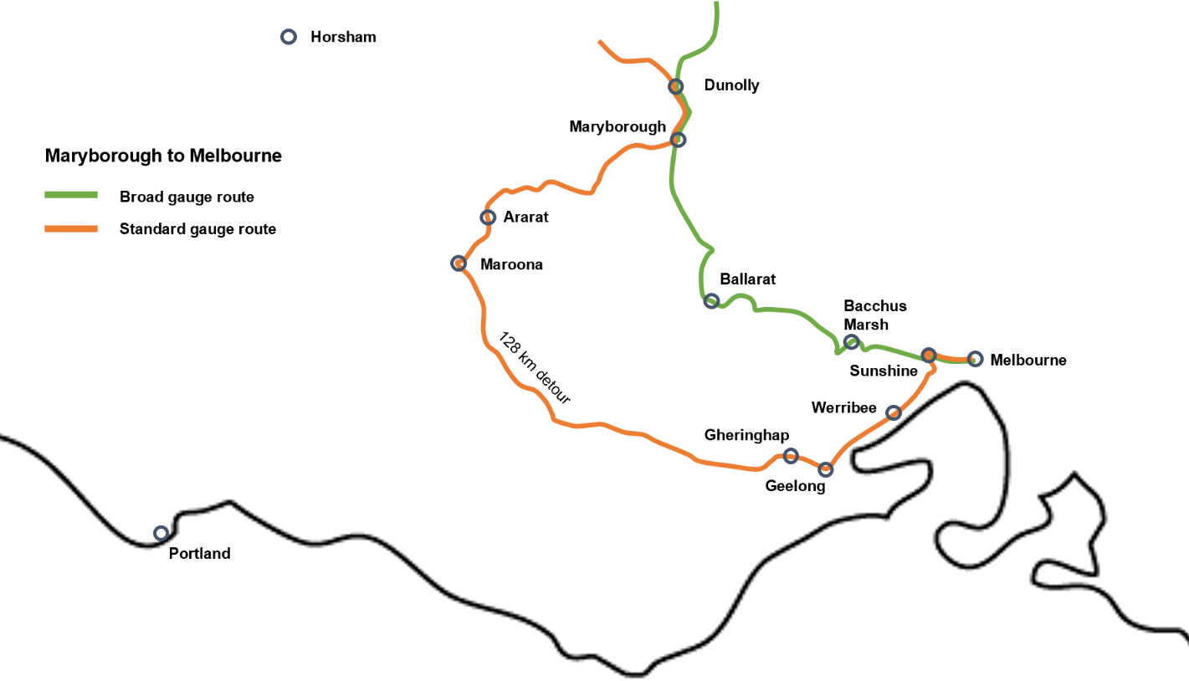

Figure 19 Maryborough to Melbourne standard vs broad gauge routes

In 2022, the Parliamentary Budget Office published a summary of proposed findings on potential infrastructure initiatives on the line, to the effect of: ⁴⁵
- converting 68 km of track between Maryborough and Ballarat North Junction from broad to standard gauge
- converting west of Lydiard Street to Gheringhap (via Ballarat Station and Humffray Street) from broad to standard gauge track
- converting Ballarat North Junction to west of Doveton Street from broad to standard gauge track and link to the Maryborough line
- recommissioning 550 m of existing broad-gauge track from west of Doveton Street to Ballarat North Junction and link to the Wendouree line
- converting 350 m of single line from west Doveton Street to east Armstrong Street from broad to dual gauge track
- converting west Lydiard Street to Ballarat Station (platforms 1 and 2) from broad to dual gauge track
- removing the Macarthur Street level crossing.
However, increased corridor utilisation by rail freight could impact passenger services from Ballarat which are also increasing in frequency. Further analysis would be required to determine feasibility of increased freight services and optimal timetabling to minimise public transport scheduling disruptions. There are solutions are available to

⁴⁴ Testa, C. (2022, April 9). Freight corridor through Ballarat could cut emissions, make country roads safer, say rail advocates. ABC News.
https://www.abc.net.au/news/2022-04-09/ballarat-rail-corridor-critical-to-murray-basin-freight-network/100974280
⁴⁵ https://ouyen.vic.au/data/documents/Ouyen-Inc.s-Reinstatement-of-the-Ballarat-rail-freight-corridor-plan-PBO-costing-16th-Sept- 2022-.pdf

balance grain freight and passenger routes (for example, Standard Gauge bypass options through Ballarat and to Geelong combined with some passenger train changes). This approach remains the best way to improve the efficiency of the network and competitiveness for grain on rail from the Yelta, Manangatang and Sea Lake corridors
More broadly, a program of regular maintenance and upgrades should be conducted on the Maryborough to Ararat lines to ensure ongoing serviceability and ability to meet the growing demand identified in this report.

- The Infrastructure Challenges
There were several infrastructure related challenges identified through consultation with industry and other jurisdictions which include:


Freight efficiency
Addressing underutilisation of high productivity freight vehicles (instances where high productivity freight vehicles are restricted conditionally approved structures with constrained mass limits) involves aligning key grain freight routes with state-defined strategic corridors to facilitate funding support for corridor improvements, harmonising regulation and management of freight routes.

Structures are reducing road productivity

Need for network maintenance
The assessment has revealed several structures within the network that need upgrading to accommodate PBS 3A heavy vehicles. Presently, these structures are causing bottlenecks throughout the network, hindering HPFV access. Addressing these upgrades progressively can significantly enhance HPFV access and alleviate congestion issues across the network.
Recent investments in the V/Line network have resulted in significant improvements in the volume of grain transported via rail. Additional upgrades enabled through funding are necessary to fully capitalise on these benefits and ensure the continued transportation of grain via rail.


Pavement resurfacing and upgrades are essential not only to accommodate HPFVs but also to enhance safety and reduce transport costs by minimizing wear and tear on heavy vehicles. Safely accommodating PBS 3A heavy vehicles necessitates providing a 1.5-metre shoulder on the Priority A network. Similarly, improvements to shoulder width and road conditions are also required in various sections of the Priority B network.

Gaps in the rail network

  - The cost of addressing the challenges
There are three main pavement renewal and maintenance activities that are undertaken by DTP, as shown in Table 12. Resurfacing costs of $27/m² were adopted for both state and local government roads, as it aligned closely to current maintenance and rehabilitation unit costs. For widening, pavements with less than 1.5 metre shoulders and insufficient trafficable seal widths have also been estimated at $140/m². Routine maintenance which includes reactive works to address minor defects, repairing potholes, cleaning, culverts and drains has not been included in any costings as it is assumed that these works occur on regular basis.
These costs are preliminary and are subject to change based on further analysis and detailed costing by Quantity Surveyors and extensive engineering reviews. These indicative costs demonstrate a perspective on the works that may be required to improve the standard of the transport network to support he grain freight task. They have also been considered within the context of the study area which has been defined in Section 2.3.

Table 12 Maintenance type unit costs (Source: DTP)

 | Description | $/m2
Resurfacing | More substantial work designed to prevent deterioration of infrastructure at minimum cost. Typical examples include resurfacing the pavement to prevent water infiltrating the pavement structure which would damage the pavement, to address some aspects of surface roughness and to improve the texture of the pavement surface. | 27
Rehabilitation | Significant treatment to improve the structural condition of the pavement and bring the surface profile (roughness and rutting) and texture of the surface back to an acceptable level. | 140

 | Description | $/m2
Widening | Increasing pavement seal width to accommodate a larger trafficable area which may include the shoulder. | 50
Strengthening and replacing structures is a costly task and varies in price between the two options, as shown in Table 13.

Table 13 Bridge strengthening and structure replacement escalated unit costs⁴⁶

Activity | Cost (per m2)
Bridge strengthening | $8,000
Structure replacement | $12,000
The following tables provide a breakdown for road segments (Priority A and Priority B) that require resurfacing, rehabilitation, widening and bridge and culvert works.
The cost calculations were derived by applying the per square metre costs outlined in Table 12 and Table 13 to the road sections earmarked for either resurfacing or renewal. These decisions were informed by the RMC classifications provided by DTP, and the associated costs were applied accordingly. Additionally, the costs related to structures were determined based on the interventions identified during the high-level assessment. For a visual representation of the road segments and structures prioritised for investment, refer to Appendix C. The summarised results of this assessment can be found in Table 14.

Table 14 High level costings – road infrastructure

Priority A Network | Estimated costs ($m)
Resurfacing | $39.1
Renewal | $71.3
Shoulder improvements | $70.7
Structures – strengthening | $21.0
Structures – reconstruct | $9.8
Total | $211.8
Priority B Network | Estimated costs ($m)
Resurfacing | $85.0
Renewal | $198.0
Shoulder improvements | $100.0
Structures – strengthening | $23.6
Structures – reconstruct | N/A
Total | $406.6

⁴⁶ Advantia Transport Consulting. (2016). Transport infrastructure priority development for the Australian dairy industry. Dairy Australia. https://www.advantia.com.au/wp-content/uploads/2016/09/Transport-study-summary-1august16.pdf.

- Network Investment Prioritisation
The transport network that underpins the grain supply chain is vast, consisting of 2.4 million kms of arterials/freeways and local roads across the study area respectively, demonstrating that any investment decisions must be phased due to the supply chain’s extensive geographical coverage. Similarly, additional considerations and comprehensive cost assessments are necessary to bolster this support. However, there are specific areas where targeted investments can be made based on three key investment principles:

Strengthen corridors to support the export task
Objective | Investment Principle
Enhance the main routes leading to commercial ports to facilitate export activities, which includes permitting HPFVs with a weight of 85.5 tonnes. Focus on eliminating network restrictions by addressing the issues caused by infrastructures that are incapable of supporting HPFVs weighing 85.5 tonnes. | Prioritise investment for the Priority A network for both pavements and structures
The support for larger truck combinations is crucial, particularly for export movements, as this constitutes the majority of the task. Through consultation it was identified that these larger combinations are not a constant feature but are often employed during peak seasons to handle the increased load.
The network requires unlocking as some infrastructure prohibits the full utilisation of PBS Level 3A heavy vehicles. This limitation hinders the full potential of using larger truck combinations and needs to be addressed to fully realise the benefits of PBS Level 3A.
The focus should be on targeting road infrastructure, specifically bridges and pavement conditions, to support PBS Level 3A. This is a key factor in ensuring that the infrastructure can handle the increased load and size of the trucks.
Productivity and economic benefits are also a significant consideration. The aim is to ‘move more with less’, essentially improving efficiency by transporting larger loads with fewer resources. This approach not only boosts productivity but also has a positive impact on the economy.

Addressing structures
The key corridors that have conditionally approved structures include the Western Highway, Henty Highway, Calder Freeway, Sunraysia Highway, and Midland Highway. These routes are critical for transport and any improvements or modifications can have a significant impact on overall productivity and efficiency – this includes improving shoulder width, pavement conditions and structures along these corridors.
As part of this principle, the next steps involve conducting a more detailed VicRoads Level 2 Bridge Inspection for structures that may require an upgrade. A Level 2 Bridge Inspection identifies bridge components and assesses their condition. This assessment will help prioritise repairs, major maintenance, rehabilitation, or replacement of the given structure. These inspections are carried out by qualified Level 2 inspectors accredited by Department of Transport and Planning. Among these structures, conditionally approved for less 80 tonnes have been highlighted in purple as a priority. Addressing these structures highlighted in purple can alleviate bottlenecks on the network and provide short-term benefits as shown in Table 15 below.

Table 15 Priority structures that require additional assessment or capital works

Structure ID | Road Name | Locality | Conditionally approved for 36m A-doubles (t) | Potential action | Priority Network
SN0058 | Western Highway | South of Ararat | 81.5 | Strengthen | A
SN0067 | Western Highway | North of Ararat | 82.0 | Strengthen | A
SN0070 | Western Highway | North of Ararat | 84.5 | Strengthen | A
SN6371 | Shell Parade | Geelong | 84.5 | Strengthen | B
SN6372 | Shell Parade | Geelong | 83.0 | Strengthen | B
SN8743 | Western Highway | North of Horsham | 79.0 | Strengthen | A
SN2165 | Sunraysia Highway | North of Ballarat | 68.5 | Reconstruct | A
SN2162 | Sunraysia Highway | North of Ballarat | 84.5 | Strengthen | A
SN2217 | Sunraysia Highway | South of St Arnaud | 84.0 | Strengthen | A
SN2222 | Sunraysia Highway | South of St Arnaud | 84.5 | Strengthen | A
SN2202 | Sunraysia Highway | North of Avoca | 84.5 | Strengthen | A
SN1540 | Midland Highway | Geelong | 72.5 | Reconstruct | A
SN1544 | Midland Highway | South of Geelong | 84.5 | Strengthen | A
SN3632 | Hamilton Highway | Hexham | 78.0 | Strengthen | B
SN3628 | Henty Highway | West of Mortlake | 84.5 | Strengthen | B
SN2102 | Glenelg Highway | Hamilton | 81.0 | Strengthen | B
SN3247 | Henty Highway | Cavendish | 80.5 | Strengthen | A
SN8867 | Western Highway | Ballarat | 68.5 | Reconstruct | A

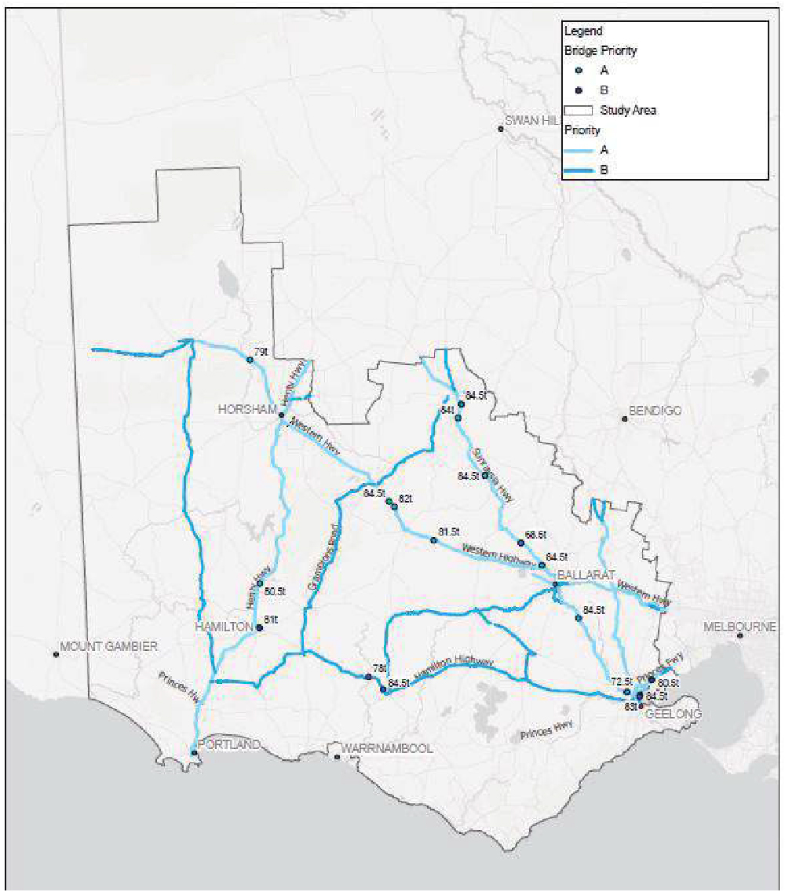

Figure 20 Priority A network structures

Continue to promote the use of the rail network

Objective | Investment Principle
Promote increased use of the rail network for grain transportation. This involves enhancing the rail infrastructure to make it the preferred mode of transport for operators. | Supporting funding for maintenance and improvement programs for the rail network.

The rail network plays an increasingly important role in transporting grain products. With recent investments in the network, there has been a substantial shift in greater utilisation of the rail network for grain. However, further investment is required to gain additional benefits in promoting more grain on rail within Victoria.
This investment could be directed towards improving the efficiency and capacity of the rail network. For instance, upgrading the rail infrastructure, such as axle loading and sleepers which can increase the speed and volume of grain that can be transported.
Moreover, enhancing the connectivity of the rail network to grain production areas and ports can reduce the distance that grain needs to be transported by road, thus reducing transportation costs and increasing the competitiveness of grain producers in Victoria.
The shift towards using rail for grain transport can significantly contribute to reducing greenhouse gas emissions. Rail transport is generally more fuel-efficient than road transport, especially over long distances. This means that for each ton of grain transported, less fuel is burned, resulting in lower carbon dioxide emissions.
Policies and regulations that encourage the use of rail for grain transport can also play a crucial role. This could include financial incentives for grain producers and transport companies that use rail, or regulations that limit the amount of grain that can be transported by road.
Greater certainty around the rail maintenance investment pipeline attracts a higher likelihood of committed industry capital projects downstream which both rely on, and which can mutually support upstream or adjacent public infrastructure. Demonstrating the returns associated with this level of confidence, there is a track record of significant industry-based investment resulting from V-line and Big-Build maintenance enhancements as below, with examples including:
- Pacific National is growing 40 length wagons to 50 to deliver a 25 per cent payload improvement. It is also increasing crew numbers⁴⁷.
- GrainCorp allocating an additional SG grain train to service their Victorian demand from November 2023. It is also upgrading the Deniliquin and Tocumwal grain terminals⁴⁸.
- CHS Broadbent is building a new 80,000 metric tonne bulk grain export terminal in Geelong, with an annual export capacity of 1.5 million metric tonnes⁴⁹.
Concurrently, V/Line is also progressing network planning and rule changes through its Grain Rail Improvement Plan. These include grain access planning to facilitate utilisation, safe working rule changes around loading and designs around end of the line stabling. The principal 2024 initiative under this network optimisation drive is focused on the proactive management and planning of grain services in the period leading up to when train paths are booked. Working in collaboration with train operators and grain companies across the state, this is anticipated to help open up the capacity of the network and meet the projected demand in growth, particularly with the forthcoming harvest season.⁵⁰

⁴⁷ Pacific National. (2023). ESG Report FY2023 (pg. 78). Pacific National. https://pacificnational.com.au/wp- content/uploads/2023/09/PCN12857_ESG_Report_V9_FINAL.pdf.
⁴⁸ GrainCorp. (2021, October). Harvest Update – 25/10/21. GrainCorp. https://www.graincorp.com.au/harvest-update-25-10-21/.
⁴⁹ CHS Broadbent. (2023, November). CHS Broadbent to build bulk grain export terminal in Geelong, Australia. CHS Broadbent. https://www.chsbroadbent.com/chs-broadbent-to-build-bulk-grain-export-terminal-in-geelong-australia.
⁵⁰ V/Line Monthly Report January 2024

Network coordination, alongside targeted actions such as those described below, are likely to spur further growth in the network and meet upward growth trends, with Victorian Grain exports increasing 37% in volume and 73% in value over the 2021-2022 period⁵¹.
In establishing a strategic vision for the rail network, three strategic actions outlined in Table 16 are targeted at enhancing the rail network.

Table 16 Strategic actions for the rail network

Strategic requirement | Description
  Increased train length | It is understood that through consultation with V/Line that there is progress for a 60 wagon grain trains trial on the network. Comparatively, states like WA and NSW have been progressively phasing in supporting infrastructure that would support longer trains – namely through extending rail siding length to improve export capacity.
Other track improvements | Other key improvements on the rail network included extending the length of key grain sidings focused on higher volume sites and where loading throughput supports improved access and train cycle time reductions.  The extension of key sidings allows train lengths of up to 840 metres at the current time and a typical increase in the number of wagons per train from 40 to 50 providing a 25 per cent plus efficiency generally without additional locomotive power requirements. Changes to passing loops, train holding points at the end of corridors and port access through reinstatement of the Gheringhap loop are included to accommodate the 840 m trains forming part of the program. TAL corridor uplift to 20/21TAL has also been completed from Gheringhap to Ballarat.  Rerailing of 40km of rail from Dunolly to Inglewood and rail welding rail from Inglewood to Korong Vale has also enabled larger and heavier trains to operate along those sections of the corridors up to 20/21TAL
Cycle times | Increased train cycle times due to infrastructure constraints reduces train productivity which increases costs to growers from increased train operating costs. Train cycle time depends on network investment by track managers and investment by grain companies in silos which can be loaded and unloaded quickly to reduce train turnaround times. Provided the rail network is maintained in good condition to enable reliable cycle times which maximise train productivity, industry investment in silo capacity which facilitates improved train utilisation will likely follow. Reviews of speed restrictions, crossing loops, operational improvements by grain and rail operators all play a significant role in improving cycle times.  Train cycle times are an area of focus for V/Line and the Grain Rail Improvement (GRIP_ group. Some grain locations have limited loading throughput from approximately 300 tonne per hour at the slower sites to 1000 tonne /hour at more efficient locations. While track speed is an issue in the overall train cycle an 8- 10 hour loading time with inputs at several locations is also a key issue for cost assessment. Building a focus on the total task, a program of cycle time improvements toward 48- and 24-hour cycles (where possible) is also part of current works/ m. Sites within the study’s limits that have been identified by V-line for cycle time improvements are Beulah and Manangatang.  Per Victorian government projections, a grain train cycle time of 36 hours from silo to port and return will enable the train to transport 300,000 tonnes of grain per annum. A train cycle time of 24 hours can increase the train’s productivity to 500,000 tonnes per annum.⁵²

⁵¹ Agriculture Victoria. (2023, January). Grains. Victorian Government. https://agriculture.vic.gov.au/export/victorias-export-performance/export- performance-by-industry/grains.
⁵² Victorian Government, Grain Logistics Taskforce Report (2014, June), https://railfreightalliance.com/wp-content/uploads/2014/06/Grain- Logistics-Taskforce-report.pdf

Potential rail initiatives

Maroona to Portland Line: increasing axle loading
The Maroona to Portland line has been impacted various condition-related issues which have limited the maximum speeds that can be achieved from 80kph to 40kph.⁵³ With current transit times of circa six hours, this speed limitation places freight as inefficient against road freight transit times, despite the capacity, environmental, safety and reliability advantages of rail⁵³. Rising road freight in the area has led to higher emissions and community/amenity disruptions from continuous B-double movements in the region⁵⁴.
On a comparative basis, it also creates infrastructure standardisation and access issues given the Geelong line offers favourable axle loading of 23 tonnes as opposed to the current 19-tonnes on the Maroona to Portland line⁵³. As described in section 6.4.1, the latest Federal Government budget (Tuesday 14 May 2024) has now approved
$150 million funding for a comprehensive upgrade of the Maroona to Portland line. This will assist greatly in improving operational standard of the Maroona to Portland Line.

Further enhancing rail network connectivity
Further standardisation of the NW regional network is required to support the grain task and flexibility required in efficiency of the network. However, the current standardisation of the Mildura /Yelta Line has diverted the Mildura/ Yelta corridor via Ararat adding approximately 130kms compared to the original corridor through Ballarat and Geelong. The standardisation of the Manangatang and Sea Lake corridors would increase flexibility during peak seasons but the additional distance via Ararat would penalise this option.
Access via Ballarat to Geelong and Melbourne remains the most efficient option on the network under a standardised network providing reduced travel time distance and cost in an industry that competes globally on limited margins compared to northern hemisphere suppliers.
However, the broad-gauge rail network continues to be of importance for other key commodity groups beyond grain like steel, paper products and containerised freight, and for the purpose of this study, standardisation will only be considered in the context of Ballarat Line access issue. Key investments linking and interdependent on the Broad Gauge network are the Somerton Intermodal Terminal (SIT) and the early works on the Ballarat West Employment Zone (BWEZ) intermodal terminal.

Maintain the supporting network to improve resilience, efficiency, safety and effective coordination
Objective | Investment Principle
Improve the standard of the road network that supports the key arterials. Addressing pavement condition and structure can have improve safety, network resilience and safety. | Prioritise investment for the Priority B network
The Priority B network serves as a feeder system to the Priority A network, facilitating transportation across the region. This interconnected network ensures seamless movement of goods and materials, connecting farms to silos and intermodal terminals. By providing vital links between various nodes within the transportation network, Priority B plays a pivotal role in optimising supply chain efficiency and supporting economic growth.
Investment in road resurfacing programs targeted at corridors supporting major arterials, primarily within the Priority B network, is essential for ensuring efficient transportation. These resurfacing efforts are critical for preserving road infrastructure integrity and enhancing overall road safety.
Efforts are underway to enhance the existing priority network to accommodate vehicles weighing up to 85.5 tonnes, necessitating upgrades to route conditions and bridge load capacities in accordance with PBS network

⁵³ Darling, A. & Testa, C. (2022, March 29). Portland-Maroona rail freight line business case funding. ABC News. https://www.abc.net.au/news/2022-03-29/portland-maroona-rail-freight-line-business-case-funding/100948164.
⁵⁴ Southern Grampians Shire Council. (2022). Maroona to Portland Rail Line. Victorian Government. https://www.sthgrampians.vic.gov.au/Page/Page.aspx?Page_Id=3436

standards. These enhancements are essential for ensuring the network's capability to accommodate heavier vehicles, thereby improving the efficiency and effectiveness of freight transportation. By aligning with PBS network requirements, these upgrades can reflect industry’s desire for more efficient movements, enhancing the network's interoperability and facilitating seamless freight movement across different transport modes.
Recognising the significant volumes of grain transported from farms to silos, intermodal terminals, and export gateways, the Priority B network plays a crucial role. While Priority A focuses on supporting the export task, Priority B serves as vital links for transporting products and improving network resilience and safety.

- Conclusion
This high-level analysis has highlighted a number of initiatives for infrastructure components throughout the grain supply chain network. There are several challenges surrounding the pavement condition, road cross-section and bridge load limitations which all have economic and productivity impacts for industry with a “knock-on” effect for the state and federal economy. Evidence shows, structures such as bridges and culverts form one of the biggest limitations in uplifting allowable mass on the network.
The study has also highlighted the need to define a ‘Grain Supply Chain Gazetted Network’ to reduce the regulatory inefficiencies. Currently, permits must be obtained for vehicles to access roads across different local government jurisdictions. The ability to have a defined network, not only reduces the administrative processes, but also allows for targeted tracking for both grain volumes and infrastructure condition that can be accepted across the region.

  - Non-infrastructure considerations
Internationally and in other Australian jurisdictions, there are best practice and market leading tools which warrant further consideration across regulatory, technology and planning dimensions, but which should be balanced against the local Western Victorian context and market composition.

    - Grain Supply Chain Dashboards and AgTransport Platform - Canada and the US
The Grain Supply Chain Dashboard is an initiative by Statistics Canada that provides real time data on the movement of grains by rail. A fully interactive tool which is updated daily, it displays daily grain movement, including estimates of tonnage flows per unit of time along network segments, railways and ports. Such a portal allows for more prescient forecasting based on accurate, relevant, and extremely recent data, leading to lower costs, higher productivity and more informed decision-making The dashboard has been widely praised by stakeholders, including Canadian National Railway who use it to ensure peak performance at each link of the supply chain⁵⁵. The US also has a higher level Agricultural Transportation Open Data Platform which includes regularly updated categories across grain transportation costs, fuel, barge, truck and grain exports and grain price data⁵⁶.
However, it should be caveated that there are key market dynamics between Australia, the United States and Canada’s grain industries. Given the number of private operators in Australia, providing this level of shareable and highly visible metrics around where rival locomotives are moving which could confer commercial advantages and present competition issues.
Nonetheless, given the findings and supply chain mapping in this report, combined with the demonstrated platform benefits, the Victorian government could investigate trialling smaller scale monitoring and modelling proof of concepts at strategic network junctures and key rail corridors to maximise infrastructure improvements through data driven investment prioritisation.

    - Workforce
A long standing and widespread shortage of train and truck drivers is critically impacting grain supply chain efficiency across road and rail. Nationally, there are estimated to around 20,473 truck driver vacancies in Australia as at February 6, 2024⁵⁷. Underlying factors include an aging workforce with lower replacement rates due to youth

⁵⁵ Canadian National Railway Company. (2023). 2023-24 CN Grain Plan. Canadian National Railway Company. https://www.cn.ca/-
/media/files/your-industry/documents-grain/grain-plan/english/2023-24-grain-plan-en.pdf.
⁵⁶ Agricultural Marketing Service. (n.d.) Agricultural Transportation Open Data Platform. United States Department of Agriculture. https://agtransport.usda.gov/.
⁵⁷ Dixon, J. (2024, February 14). Solving the truck driver shortage. MHD Supply Chain News. https://mhdsupplychain.com.au/2024/02/15/solving-the-truck-driver-shortage/.;
McKenzie, M. (2021). Transport & Logistics Industry moves a step closer to a national Heavy Vehicle Driving Apprenticeship. Australian Industry Standards. https://www.australianindustrystandards.org.au/wp-content/uploads/2021/11/20211102-COMMUNIQUE- HVDA_Transport-and-Logistics-IRC.pdf

barriers to entry, lack of industry professionalism, outdated perceptions/role biases and heightened compliance acting as a worker deterrent⁵⁸. This diminishing talent pool has led to underutilised trucks, fleet downsizing and longer cycle times. Similarly in rail, there is a predicted shortfall of 70,000 staff across not just driver positions, but vital operational and project roles.⁵⁹
Using risk-based guidelines, one intervention to explore may be reviewing licensing schemes and offer accelerated (but no less robust) training pathways for apprentice drivers to take up vacant roles or fill surge demand where other drivers cannot be readily sourced. Worker amenity and health strategies such as a more expansive rest area network may also be complementary through providing better working conditions. This is especially so given how important marshalling points are in reducing driver fatigue at ports and silos where drivers can experience long queues. Extending silo opening hours would partially allay these health and safety issues through longer opening hours facilitating faster unloading. However, operators are themselves facing labour availability issues for the workers that would allow them to do so.

    - Policy to promote supply chain efficiency
Beyond Victorian mode shift incentives, other domestic and international jurisdictions have implemented regulatory and policy mechanisms to reduce costs and bottlenecks along the rail supply chain with varying degrees of success. In NSW, Port Botany has fixed rail handling costs at $15 per container following the introduction of the Port Botany Land and has been well-received and this has been attributed as the single most significant contributor to a commercially viable short haul rail offering in Sydney.⁶⁰ Introduced in 2003, Fremantle Port has also has a standing multi-year subsidy for rail freight operators which rose from $30 to $50 per twenty foot container in 2017.⁶¹ Two-years on in 2019, the Port registered a record high of 23.7 per cent of freight on rail reaching the Port, reflecting a 30% increase from just prior the subsidises inception in 2006 .⁶²
Careful and long-term consideration must also be given to least cost grain routes and ensuring that there is a coordinated policy approach to planning, zoning and developments which could encroach upon them. In the Victorian rail context, multidirectional and intersecting passenger, mining and other export good train services present particularly complex integrated logistics issues in this regard. This includes the recent reforms to Clause 18 of Victorian Planning Provisions to recognise planning’s role in contributing to a safe, integrated, and sustainable transport system.
In terms of lessons learned, CBH’s former Grain Express integrated receival centre in Western Australia, while well-intentioned, was viewed to have lessened competition per the ACCC’s ruling due to its creation of an effective monopoly. The scheme was designed to consolidate grain handling, storage and transportation, and anticipated providing increased speeds to the receival process, providing automation and reducing labour and equipment mobilisation⁶³. Despite early traction, the scheme lost partial industry support and was ultimately deemed by the ACCC to amount to “full line forcing” – through the perception it compelled exclusive buying of grain transport services from CBH. The service was re-launched and split in 2016 into two consolidation offerings with an undertaking to the ACCC that CBH would adopt set pricing and ensure users could more freely opt out of the scheme⁶⁴.

⁵⁸ Dalton, T., Delahunty, E., & Parker, F. (2021, November 21). Driver shortage, heavy compliance making life hard for trucking companies.
ABC News. https://www.abc.net.au/news/2021-11-12/driver-shortage-hard-for-victorian-trucking-companies/100611784.
⁵⁹ Duboudin, T. (2023, December). Australia’s rail industry faces critical labour shortage. International Railway Journal.
https://www.railjournal.com/regions/australia-nz/australias-rail-industry-faces-critical-labour-shortage/.
⁶⁰ GHD Advisory. (2022). Freight Modal Shift. Australasian Railway Association. https://ara.net.au/wp-content/uploads/ARA-Freight-Modal- Shift-Report.pdf.
⁶¹ Roads & Infrastructure Australia. (2018, January 8). Fremantle Port rail subsidy increased. Roads & Infrastructure Australia. https://roadsonline.com.au/fremantle-port-rail-subsidy-increased/.
⁶² Fremantle Ports. (2019, July 31). Record high 23.7 per cent of freight on rail in April. Fremantle Ports. https://www.fremantleports.com.au/news/record-high-23.7-per-cent-of-freight-on-rail-in-april.
⁶³ Synergies Economic Consulting. (2008). Benefits of Grain Express. Corrs Chambers Westgarth. https://www.synergies.com.au/wp- content/uploads/2019/09/ACCC-Corrs-Benefits-of-Grain-Express-May-2008-1.pdf.
⁶⁴ ACCC. (2017, October 18). CBH undertaking ensures increased opportunities for grain growers and marketers to use alternative grain transport services. ACCC. https://www.accc.gov.au/media-release/cbh-undertaking-ensures-increased-opportunities-for-grain-growers- and-marketers-to-use-alternative-grain-transport-services.

The original Grain Express service does however offer an interesting case study around vertical integration in the context of cooperatives which should be examined through Western Victorian in light of recurring proposals and plans for grower owned receival at sites like that Bridgewater, and the existing Boort Grain Cooperative .⁶⁵

    - Review mode shift incentives
With the Mode Shift Incentive Scheme (MSIS) being extended to mid-2024 and active considerations around Port Rail Shuttle Network (PRSN) connections, it is timely to explore a range of potential complementary measures and systems that can be deployed to drive rail uptake and achieve the states target of 30% rail share by 2030. The Victorian Auditors Generals Office found that while the MSIS and PRSN kept some containers on trains that would have likely gone to trucks, the programs have not increased rail’s share of container freight in regional areas.
Delays in delivering the shuttle network facilities and services mean the social, economic, and environmental benefits of diverting metropolitan containers from road to rail have also not been fully realised. Per its recommendations, further focus should be given to the feasibility of the 30% mode shift target, the shuttle networks commercial viability and continued engagement with the ARTC about private sector operators on future freight paths.

    - Growing resource demand in Northwest Victoria
Mineral sands are valuable resources found in Victoria, Australia. These deposits contain heavy minerals such as zircon, ilmenite, and rutile. These minerals play essential roles in various industries, from ceramics to medical implants.
Mineral sands deposits in Victoria are remnants of ancient inland seas. The primary location for these sands is the Murray Basin, which extends into South Australia and New South Wales. Similar deposits are also found in these neighbouring regions.
Since 1969, the Murray Basin has been recognized for its mineral sands potential. There are two main types of deposits: strandline and Wimmera-style (WIM). These resources have significant economic value. Given their economic importance and inland location, there is a need for improved road and rail infrastructure to support the growing demand for these mineral resources in northwest Victoria which may compete with grain and other commodities.

    - Climate adaptation and resilience⁶⁶
Whilst climate change is out of scope for this study, it is important to recognise the potential implications that climate may have on farming and infrastructure.
Climate change poses significant challenges for grain production in Victoria, Australia. Rising temperatures impact growth rates. Reduced rainfall during the growing season affects soil moisture availability, leading to water stress. Extreme weather events like heatwaves and storms can damage crops and disrupt planting schedules. Water scarcity due to changing rainfall patterns affects irrigation-dependent farming. Warmer temperatures alter pest and disease dynamics, impacting crop health. Above all, variability across all these climatic factors significantly impacts seasonal grain freight volumes and challenges effective network capacity planning. Victorian farmers are adapting through initiatives like the Carbon Farming Program to build resilience and mitigate climate-related challenges.
The Victorian Government has made a steadfast commitment to reducing emissions within the agriculture sector. With an investment of nearly $20 million over the next four years, the Agriculture Sector Pledge aims to achieve long-term goals. These goals include:
– Investment in flagship trials - the pledge supports cutting-edge research by investing in flagship trials. These trials will explore innovative approaches to reduce emissions while maintaining productivity and profitability for farmers.

⁶⁵ Wells, L. (2017, September 15). Grower-owned grain site planned for Bridgewater. Grain Central. https://www.graincentral.com/trade/domestic-trade/grower-owned-grain-site-planned-for-bridgewater/.;
Boort Grain Co-Op. (n.d.). https://boortco-op.com.au/.
⁶⁶ Agriculture and climate change | Climate and weather | Agriculture Victoria

- Tools and services for emission reduction - the government will provide tools and services to assist farmers in their efforts to reduce emissions. These resources will empower farmers to adopt sustainable practices without compromising productivity.
- Primary Production Adaptation Action Plan (2022–2026) - Over the next five years, the focus will be on building climate resilience within value chains. Research and innovation will play a pivotal role, enabling primary industries to enhance their climate change adaptation capabilities.
- Addressing risks and transformative changes - the plan addresses both current and future risks. It prepares for more hot days and reduced rainfall, as well as extreme events like bushfires and flash floods. Transformative changes will be implemented to ensure long-term adaptation.
- Research insights on wheat yields - a recent research project examined extreme temperature exposures (both hot and cold) and their impact on wheat yields. Predictions for the next 45 years were generated under various climate change scenarios. Approximately 30% of wheat crops are at risk. Factors such as fewer freezing days, warmer temperatures, and improved rainfall may offset higher temperature exposure in some scenarios. Like other industries, grain farms may need to migrate further south as the climate continues to change.
- Emission reductions in transport should be driven by promotion of mode shift from road to rail and active incentives for zero emission fuels such as hydrogen or various forms of electric power and ecofuels for our road based transport fleets

Appendices

Appendix A

Regional Roads Victoria Maintenance Program Update – 2023-2024

Sections of the following roads have been included in the Flood Recovery Program:

Loddon-Mallee

Road Name | Location | LGA
Bendigo-Maldon Road | Bendigo to Maldon | Mount Alexander
Bendigo-Tennyson Road | Between Old Murray Road at Huntly and North Road at Drummartin | Greater Bendigo
Birchip-Sea Lake Road | Between Berriwillock Road, Nullawil and Calder Highway, Sea Lake | Buloke
Boort-Kerang Road | Minmindie-Kerang | Loddon
Bridgewater-Maldon Road | Newbridge to Neereman | Loddon
Byrneside-Kyabram Road | Merrigum to Dunbar Road, Kyabram | Campaspe
Calder Freeway | Between Namnan Way, Diggers Rest and Ravenswood | Macedon Ranges, Mount Alexander and Greater Bendigo
Calder Highway | Ravenswood to Marong Marong to Wycheproof  Between Horace Street, Sea Lake and Mena Road, Cabarita | Mount Alexander and Greater Bendigo Loddon and Buloke
Charlton-St Arnaud Road | Between Wright Street, Charlton and Westcotts Road, Coonooer | Buloke
Donald-Swan Hill Road | Between Banyenong-Jeffcott Road, Jeffcott North, and Back Boga Road, Lake Boga | Swan Hill
Echuca-Kyabram Road | Echuca to Kyabram | Campaspe
Echuca-Mooroopna Road | St Germains to Wyuna | Campaspe
Elmore Raywood Road | Elmore to Raywood | Campaspe
Girgarre-Rushworth Road | Girgarre to McGrath Road, Stanhope | Campaspe
Heathcote-Kyneton Road | Heathcote to Langley | Mount Alexander
Heathcote-Rochester Road | Ladys Pass to Rochester | Campaspe
Hopetoun Sea Lake Road | Between Birchip-Sea Lake Road and Mousers Road, Sea Lake
Kyabram-Rochester Road | Kyabram to Rochester | Campaspe
Lancaster-Mooroopna Road | Lancaster | Campaspe and Greater Shepparton
Loddon Valley Highway | Tragowel to Kerang | Gannawarra
Mallee Highway | Piangil to Manangatang | Swan Hill
Mallee Highway | Between Ouyen-Patchewollock Road and Nunn Road, Ouyen | Mildura Rural City Council
Maryborough-St Arnaud Road | Between Collins Court and Norwood Road, Maryborough | Central Goldfields
Mount Macedon Road | Heskitt to Mount Macedon | Macedon Ranges
Murray Valley Highway | Kotupna to Echuca | Campaspe

Road Name | Location | LGA
 | Echuca to Kerang  Kerang to Wood Wood | Campaspe and Gannawarra  Gannawarra
Prairie Rochester Road | Prairie to Tennyson | Campaspe
Robinvale Sea Lake Road | Manangatang to Cocamba Robinvale to Manangatang | Swan Hill Swan Hill
Sunraysia Highway | Between Russell Road and Kellys Road, Donald | Buloke
Tongala Road | Between Graham Road and Murray Valley Highway, Tongala | Campaspe

Road Name | Location | LGA
Wimmera Highway | Dale Lane, Newbridge  Just south of Cooper Road, Marong | Loddon
Calder Highway | Just north of St Anne’s Winery at Ravenswood  Just north of Yorkshire Road to Peverills Road, Marong | City of Greater Bendigo & Mount Alexander Shire  City of Greater Bendigo
Murray Valley Highway | North of McCoys Bridge at Kotupna to just south of Mitchell Road, Echuca  Just west of Braund Road, Echuca, to just north of Kerang-Marcona Road, Kerang East  Fairley Road, Reedy Lake to just north of Byrnes Lane, Nyah  Milnes Bridge  Just north of Apex Park Road, Reedy Lake West of Maxwell Street, Kerang | Moira Shire & Campaspe Shire  Campaspe Shire & Gannawarra Shire  Gannawarra Shire and Swan Hill Rural City  Gannawarra Shire
Loddon Valley Highway | Just south of the Murray Valley Highway at Kerang  From Loddon Plains Road to just north of Loddon Plains Road, Bridgewater North  Just north of Tucks Road, Woodvale | Gannawarra Shire Loddon Shire  City of Greater Bendigo
Tooleybuc Road (Mallee Highway) | Tooleybuc, to just east of Elston Road, Manangatang | Murray River Council & Swan Hill Rural City
Mount Macedon Road | Just north of Pinchoff Lane, Mount Macedon | Macedon Ranges Shire
McEwen Road (Kyabram- Rochester Road) | Just north of Webb Road, Kyabram, to just east of Echuca-Nanneella Road, Rochester | Campaspe Shire
Bendigo-Maldon Road | East of the Calder Alternative Highway, Lockwood South, to just west of Bridgewater-Maldon Road | City of Greater Bendigo and Mount Alexander Shire
Bridgewater-Maldon Road | Just south of Cemetery Road, Bridgewater, to just south of Ross Road, Neereman | Loddon Shire and Mount Alexander Shire
Heathcote-Kyneton Road | Just south of Chapmans Lane, to just north of Murrays Road, Langley | Mount Alexander Shire
Robinvale-Sea Lake Road | Just south of Webster Road, Bolton to Hattah-Robinvale Road, Bannerton  East of Lake Tyrrell Road, Sea Lake | Swan Hill Rural City Buloke Shire
Boort-Kerang Road | Just north of Sinotts Road, Minmindie to just north of Taverner Road, Kerang | Gannawarra Shire
Echuca-Kyabram Road | From Murray Valley Highway to just west of Day Road, Tongala | Campaspe Shire
Tongala Road | Just north of Graham Road to just south of the Murray Valley Highway, Tongala | Campaspe Shire

Road Name | Location | LGA
Byrneside-Kyabram Road | North of Lilford Road, Lancaster to Dunbar Road, Kyabram | Campaspe Shire
Lancaster-Mooroopna Road | At Ryan Road, Lancaster | Campaspe Shire
Echuca-Mooroopna Road | East of Weller Road to just north of the Murray Valley Highway, Wyuna | Moira Shire
Girgarre-Rushworth Road | From Progress Street, Girgarre to just south of McGrath Road, Stanhope | Campaspe Shire
Rushworth-Tatura Road | South of the Waranga Western Channel to west of Mason Road, Waranga | Campaspe Shire
Heathcote-Rochester Road | West of the Northern Highway to south of Bakers Bridge Road, Colbinabbin  North of Bendigo-Murchison Road, Colbinabbin, to just south of Pascoe Street, Rochester | Campaspe Shire
Kyabram-Rochester Road | At McKay Street-Bridge Road roundabout, Rochester | Campaspe Shire
Mallee Highway | Between Edwards Road and Boland Road, Kulwin | Mildura Rural City
Bendigo-Maryborough Road | Just north of Ross Road, Laanecoorie | Loddon Shire
Castlemaine-Maldon Road | Between Hunter Road and Talbot Road, Muckleford | Mount Alexander Shire
Bridgewater-Dunolly Road | Between Dunolly-Inglewood Road, Arnold and Wimmera Highway, Llanelly | Loddon Shire
Dumosa-Quambatook Road | Between Suttie Road and Murdoch Road, Quambatook | Gannawarra Shire
Boort-Kerang Road | Between Pascoe Road and Parkers Road, Minmindie Between Parkers Road and Frosts Lane, Minmindie  between Frosts Lane and Canary Island-Leaghur Road, Minmindie | Loddon Shire
Boort-Wycheproof Road | Between Powers Road and Praters Road, Wycheproof | Buloke Shire
Dunach-Eddington Road | South of Havelock-Baringhup Road and Carisbrook- Havelock Road, Carisbrook | Loddon Shire
Birchip- Sea Lake Road | Between Marlbed-Curyo Road and Whinmere Road, Marlbed  North of Marlbed-Curyo Road, Marlbed Just south of Opie Road, Karyrie | Buloke Shire
Hopetoun-Sea Lake Road | Just west of Jollys Road, Sea Lake | Buloke Shire
Bendigo-Tennyson Road | Just south of Dingee-Rochester Road, Milloo | Campaspe Shire
Boort-Pyramid Road | Just east of Fyfes Road, Boort | Loddon Shire
Boort-Charlton Road | From Buckrabanyule North Road, Lake Marmal, to Jeruk River Road, Charlton | Buloke Shire
Boort-Mitiamo Road | East of Jarklin-Yarrawalla Road, Calivil | Loddon Shire
Bendigo-Pyramid Road | West of Mitiamo-Forest Road, Mitiamo East of Loddon Park Road, Durham Ox | Loddon Shire

Grampians

Road name | Locations | LGA
Bacchus Marsh-Gisborne Road | Between Bonnie Vale Road and McMullins Lane, Coimadai | Moorabool
Ballan-Daylesford Road | Between Dehnerts Road, Ballan and King Street, Daylesford | Moorabool Hepburn
Beaufort-Lexton Road | Beaufort to Jack Smiths Lane, Lexton | Pyrenees
Charlton-St Arnaud Road | Slaty Creek to Canooer Bridge | Northern Grampians
Colac-Ballarat Road | Between Albert Street, Sebastopol and Hamilton Highway, Cressy | City of Ballarat Golden Plains Colac Otway
Daylesford-Malmsbury Road | Drummond to Malmsbury | Hepburn  Mount Alexander
Daylesford-Trentham Road | Between Knox Street, Daylesford and Lockheads Road, Little Hamptons | Hepburn
Donald-Stawell Road | At Banyena Road, Banyena | Northern Grampians
Fyansford-Gheringhap Road | Between McCanns Lane, Fyansford and Booley Road, Gheringhap | Golden Plains
Geelong-Bacchus Marsh Road | Between Ballan Road, Balliang East and the Princes Highway, Corio | Moorabool
Geelong-Ballan Road | Between Pringles Road, Anakie and Mount Wallace-Ballark Road, Mount Wallace  Between Lights Road, Moorabool and Carrs Road, Anakie | Moorabool Golden Plains
Geelong Road | At Olympic Avenue, Mt Clear | City of Ballarat
Glenelg Highway | At Mortlake-Ararat Road intersection, Lake Bolac | Ararat
Henty Highway | Between Morella Road Warracknabeal and Campbell Street, Hopetoun | Yarriambiack
Hopetoun-Sea Lake Road | Woomelang to Banyan | Yarriambiack
Horsham-Minyip Road | Between the Henty Highway and Murtoa Road, Kewell | Yarriambiack
Inverleigh-Shelford Road | North of Ryans Road, Inverleigh | Golden Plains
Maroona-Glenthompson Road | Between Mortlake-Ararat Road, Maroona and Donald-Forbes Street, Glenthompson | Ararat
Maryborough-St Arnaud Road | Rathscar to Natte Yallock | Central Goldfields Pyrenees
Midland Highway | At Olliers Road, Mt Rowan At Nijams Road, Magpie  Between Woolshed Road and Courts Road, Clarendon  At Taylors Road, Meredith | City of Ballarat City of Ballarat Moorabool  Golden Plains
Pomonal Road | Between Pipetrack Road, Stawell and Mokepilly Road, Lake Fyans | Ararat
Pyrenees Highway | Muckleford South to Maryborough | Pyrenees
Stawell-Avoca Road | Navarre to Frenchmans | Northern Grampians
Stawell-Warracknabeal Road | Between Western Highway, Glenorchy and Morcoms Road, Warracknabeal | Yarriambiack

Road name | Locations | LGA
Sunraysia Highway | Between Hopetoun-Sea Lake Road and Woomelang Golf Club, Woomelang | Yarriambiack
Western Freeway/Highway | Hopetoun Park to Leigh Creek Gordon to Myrniong  Horsham to Nhill Burrumbeet to Middle Creek | Moorabool  Moorabool  Hindmarsh, West Wimmera  Pyrenees
Wimmera Highway | Edenhope to Apsley | West Wimmera
Sections of these roads have been included for works in the Flood Recovery Program for 2023-24:

Road name | Locations | LGA
Ballan-Daylesford Road | North of Stone Hut Lane, Bunding | Moorabool
Beaufort-Lexton Road | Ben Major Track and Biddy Macs Lane, Chute West of Jack Smiths Lane, Lexton | Pyrenees
Daylesford-Trentham Road | West of Quartz Track, Bullarto, to east of Trentham Scenic Reserve Road, Trentham  West of Falls Road, Trentham  South of Leitches Creek Road, Musk | Hepburn
Daylesford-Malmsbury Road | Porcupine Ridge Road, Coomoora, to south of Lauriston- Drummond Road, Drummond | Hepburn
Daylesford-Newstead Road | From Yandoit Creek Road to south of Hallets Lane, Yandoit | Hepburn
Donald-Murtoa Road | Between Lawler-Carron Road and Redfords Road, Minyip Between Minyip-Coromby Road and Waller Road, Minyip | Yarriambiack
Donald-Stawell Road | Between Brewster Road and Kirk Road, Rich Avon East North of Banyena Road, Avon Plains | Northern Grampians
Glenelg Highway | Both sides of Deviation Road intersection, Linton | Golden Plains
Hamilton Highway | At Hopes Plain Road, Inverleigh  West of Friend In Hand Road, Stonehaven | Golden Plains
Inverleigh-Shelford Road | At Ryans Road, Inverleigh | Golden Plains
Inverleigh-Winchelsea Road | South of McCallum Road, Inverleigh | Golden Plains
Midland Highway | At Old Main Road, Eganstown  West of the Lethbridge Airfield, Lethbridge | Hepburn Golden Plains
Pyrenees Highway | East of Warrayadin Road, Ararat, to just west of Baringhup Road, Carisbrook | Ararat Rural City & Central Goldfields
Shelford-Bannockburn Road | At Midland Highway, Bannockburn  Between Pope Street and Milton Street, Bannockburn | Golden Plains
Skipton Road | South of Carngham-Streatham Road, Mt Emu | Pyrenees
Stawell-Avoca Road | From Callawadda-Navarre Road, Navarre, to Frenchmans-St Arnaud Road, Frenchmans | Pyrenees
Sunraysia Highway | At Stud Farm Road, Waubra Eastern Peake Road, Learmonth | Pyrenees Ballarat
Western Highway | East of Ercildoune Road, Trawalla  From Powells Road and Draffins Road, Windermere | Pyrenees Ballarat  Northern Grampians

Road name | Locations | LGA
 | North of Mt Drummond Road to just north of Howard Road, Ledcourt
Wimmera Highway | West of Forster Road, St Arnaud East | Northern

Barwon South West

Road name | Locations | LGA
Camperdown-Lismore Road | Just north of Chocolyn  At Wiridgil Road, Camperdown | Corangamite
Colac Road | At Pioneer Road, Grovedale | Geelong
Cobden-Stoneyford Road | West of Thorntons Road East, Cobden | Corangamite
Colac-Ballarat Road | Between Barpinba Road and just south of Splatt Lane, Cressy | Colac Otway
Colac-Forrest Road | Just north of Meadowell Road, Forrest | Colac Otway
Corio Quay Road (Bayside Road) | Just north of North Shore Road  Just north of Watch’s Road to just south of Foreshore Road, North Shore | Geelong
Glenelg Highway | At Lodge Road intersection, Casterton Just west of Lodge Road, Casterton  At Den Hills Road intersection, Coleraine Just west of Dolmans Road, Coleraine | Glenelg  Southern Grampians  Southern Grampians
Forrest-Apollo Bay Road | Just north of Turtons Track, Beech Forrest | Colac Otway
Grubb Road (Drysdale-Ocean Grove Road) | Between Cerberus Drive and Empress Boulevard, Ocean Grove | Geelong
Great Ocean Road | Just east of Sunnyside Road, Smythe Creek | Colac Otway
Hamilton Highway | Just west of Berrybank-Wallinduc Road, Berrybank Just south of Edgars Road, Derrinallum  Just north of Six Mile Lane, Mortlake  At Gibson Street, Carrumut | Corangamite Moyne
Hamilton-Port Fairy Road | Just south of Henty Highway, Hamilton | Southern Grampians
Hendy Main Road | Between Vickerys Road, Bellbrae and Larcombes Road, Modewarre | Surf Coast
Henty Highway | Just north of Lodge Road, Hamilton  East of Wallacdale North-Hamilton Road, Branxholme At Mt Baimbridge intersection, Hamilton  South of West Reeds Road, Yulecart | Southern Grampians
Lavers Hill-Cobden Road | Just north of Timboon-Colac Road, Jancourt | Corangamite
Macarthur-Penshurst Road | Just north of Boundary Street, Macarthur | Moyne
Princes Highway | At Bowen Street, Camperdown  Just north of Bowen Street, Camperdown Just west of Great Ocean Road, Allansford Just south of Golf Course Road, at Heywood  (Melbourne Road/Corio Waurn Ponds Road) Just south of School Road, Corio | Corangamite Moyne  Glenelg Geelong
Surfcoast Highway (Torquay Road) | At Church street, Grovedale | Geelong
Timboon-Nullawarre Road | East of Glenfyne-Brucknell Road, Timboon | Corangamite
Warrnambool-Caramut Road | At Whittons Lane, Winslow | Moyne

Road name | Locations | LGA
Winchelsea-Deans Marsh Road | Just north of Cape Otway Road, Winchelsea | Surf Coast
Woolsthorpe-Heywood Road | Just east of Troeths Lane, Heywood | Glenelg
Flood Recovery Program works will also be carried out in the Barwon South West region during the 2023-24 maintenance season. They include on:

Road name | Locations | LGA
Ayresford Road | Just south of Princes Highway West, Terang | Corangamite
Barwon Heads Road | Between Saltbreeze Boulevard and Warralily Boulevard, Armstrong Creek | Geelong
Cobden-Terang Road | At Ewens Hill Road, Cobrico | Corangamite
Commercial Road | Between Commercial Place and Spring Street, Koroit | Moyne
Corio Quay Road | Just west of Sea Breeze Parade, North Shore | Geelong
Darlington-Camperdown Road | North of Newminster Road, Bookaar, to just south of the Hamilton Highway, Darlington | Corangamite
Geelong-Bacchus Marsh Road | Between Buftons Road and Gilmores Road, Balliang Between Gilmores Road and Matfins Road, Balliang Just south of Lavers Hill-Cobden Road  Just south of Staceys Road, Lovely Banks  Just south of Carrs Road, Anakie | Geelong Colac-Otway Geelong Geelong  Geelong
Glenelg Highway | From Carapook Road, Carapook, to Shadys Lane, Coleraine | South Grampians, Glenelg
Great Ocean Road | Between Rowans Road and just south of Bartons Road, Nullawarre  East of Adam Road, Yuulong  West of Booringa Road, Princetown  West of Loddon Bridge car park, Peterborough  Just west of Timboon-Peterborough Road, Peterborough Between Blair Street and Old Peterborough Road, Peterborough | Moyne Colac Otway Corangamite Corangamite Corangamite Moyne
Hamilton Highway | South of Cressy-Shelford Road, Cressy North of Boonerah Estate Road, Mortlake South of Castle Carey Road, Hexham  West of Woolsthorpe-Hexham Road, Hexham Just east of Four Mile Road, Caramut  Just west of Barwidgee Road, Caramut  Just west of Blackwood-Dunkeld Road, Penshurst | Colac Otway Moyne Moyne Moyne Moyne Moyne  Southern Grampians
Hendy Main Road | East of Grays Road to just west of Willowite Road, Paraparap | Surf Coast
Lismore-Skipton Road | From just north of Hamilton Highway, Lismore, to just south of Glenelg Highway, Skipton | Corangamite
Mackinnons Bridge-Noorat Road | Between Princes Highway and Pontings Road, Noorat East Between Terang-Mortlake Road and Glenormiston Road, Noorat | Corangamite Corangamite
Mortlake-Ararat Road | East of Hexham-Woorndoo Road, Woorndoo | Moyne
Penshurst-Dunkeld Road | At Hamilton-Chatsworth Road, Croxton East | Southern Grampians
Princes Highway West | Just east of Larpent Road, to just west of Larpent Road, Larpent Just west and just east of Hawks Nest Road, Pirron Yallock East of Swan Marsh-Stonyford Road, Pirron Yallock  East of Craigs Lane, Stonyford At Wiridgil Lane, Weerite | Colac Otway Colac  Otway/Corangamite  Colac Otway/Corangamite  Corangamite

Road name | Locations | LGA
 | Between Ayresford Road and Coombes Road, Terang  (Manifold Street), between Meiklejohn Street and Bowen Street, Camperdown  East of Mackinnons Bridge Road, Terang | Corangamite Corangamite Corangamite
Shell Parade | South of Foreshore Road, Corio | Geelong
Terang-Mortlake Road | At Riley Road, Terang  Just south of Mortlake-Framlingham Road, Mortlake North of Factory Lane, Noorat | Corangamite Moyne Corangamite
Warncoort-Birregurra Road | Just west of Bushy Park Road, Warncoort | Colac Otway
Winchelsea-Deans Marsh Road | Between Bambra-Boonah and Bambra School Road, Bambra | Surf Coast
Woolsthorpe-Heywood Road | Just west of Penshurst-Warrnambool Road to Nardoo Creek, Hawkesdale | Moyne

Appendix B

Investment Logic Map

Figure 21 Program Logic and Summary of Issues and Benefits

Issues Desirable Outcomes Types of Interventions Potential Initiatives Relevant Infrastructure




Infrastructure Limitations and Deterioration Aging transport routes and storage facilities which ore no longer best practice.
84: Enhanced Network Connectivity
KPI 1: Accelerated train and truck turnaround and loading times (i.e. minimizsng queuing)
KPI 2: Reduced vehicle emissions from consolidation of storage locations and mode shifting
KPI 3: Inter-connected communications channels and cooperation between rail and road operators.

Freight Network Coordination & Optimisation
Construct new enabling freight links to improving land side efficiency at ports­ such as through train stabling facilities and enhancing connector roads
onduct a review in regional workforce trends to better enable continuous operations at grain receival sites and
reliability in freight services.

Cost Burden for Supply Chain Participants Inefficiencies, delays, and lock of roil guoge stondordisaition exacerbating operational overheads

Vulnerability and Disruptions
Natural disasters, unplanned maintenance and critical failure point like bridges and culverts.

Examples include poor rood conditions, gouge mismatches and lack of lost-mile connectivity at demand nodes.

Bl: Streamlined Infrastructure Access & Effective Use KPt 1: Streamlined freight terminal and port loading and loading procedures
KPt 2: Reduced grain double handling
KPt 3: Prioritisation of loading facilities such as rail sidings.
KPt 4: Roads meet and exceed acceptable condition standards

Road, Bridges and Associated Infrastructure Maintenance and Upgrades

Resurfacing Priority Network A Roads

Increased Competitiveness
Foster transports time to demand nodes through reduction in queuing, roil speed limit increases and market integration opportunities

B2: Higher Volume capacity
KPI 1: Increased uptake of High Productivity Freight Vehicles due to improved load bearing capacity.
KPI 2: lifting axel loads to reduce the number of B-double trucks required to carry the same volume of grain on road vs rail
KPI 3: Expanding number of higher capacity grain storage sites

B3: Improved Safety & Compliance
KPt 1: Less hazardous equipment and minimized loading safety issues
KPt 2: Reductions in accidental loss of grain due to poor route condrtions.
KPt: Higher adherence to road transport Chain of Responsibility (COR) and the Heavy National Vehicle Law (HVNL)
KPt: Reduced administrative burden and processing time

Rail and Associated Infrastructure Maintenance+ Upgrades

Grain Storage Facilities and Associated Infrastructure Maintenance+ Upgrades

Rehabilitation

Widening

lifting axle loads, gauge standardisation, track and signalling upgrades

Work with industry to support investment in super sites which consolidate grain receival at strategic junctures.

C

Priority Network B Roads

Priority Network C Roads:

New Grain Receival Site

Crossing Loop Opportunities

Re-Railing Opportunities

Sustainability and Emissions Reduction Decarbonisotion potential through moving to more efficient and high performance vehicle types and mode shifting to rail.

Review truck and train scheduling, inter-operator agreements and notification systems for more efficient loading procedures around cycle times.

New Siding Opportunities

GHD | 12608290 | Western Victoria Grain Industry Supply Chain Study 64

Appendix C

Targeted segments for investment

Legend Bridge Priority
A
Study Area Works type
Pavement upgrades
Pavement upgrades and shoulder works
Shoulder works





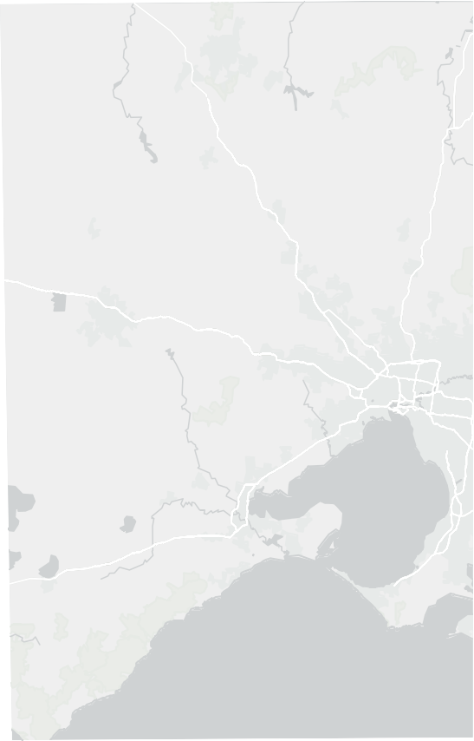
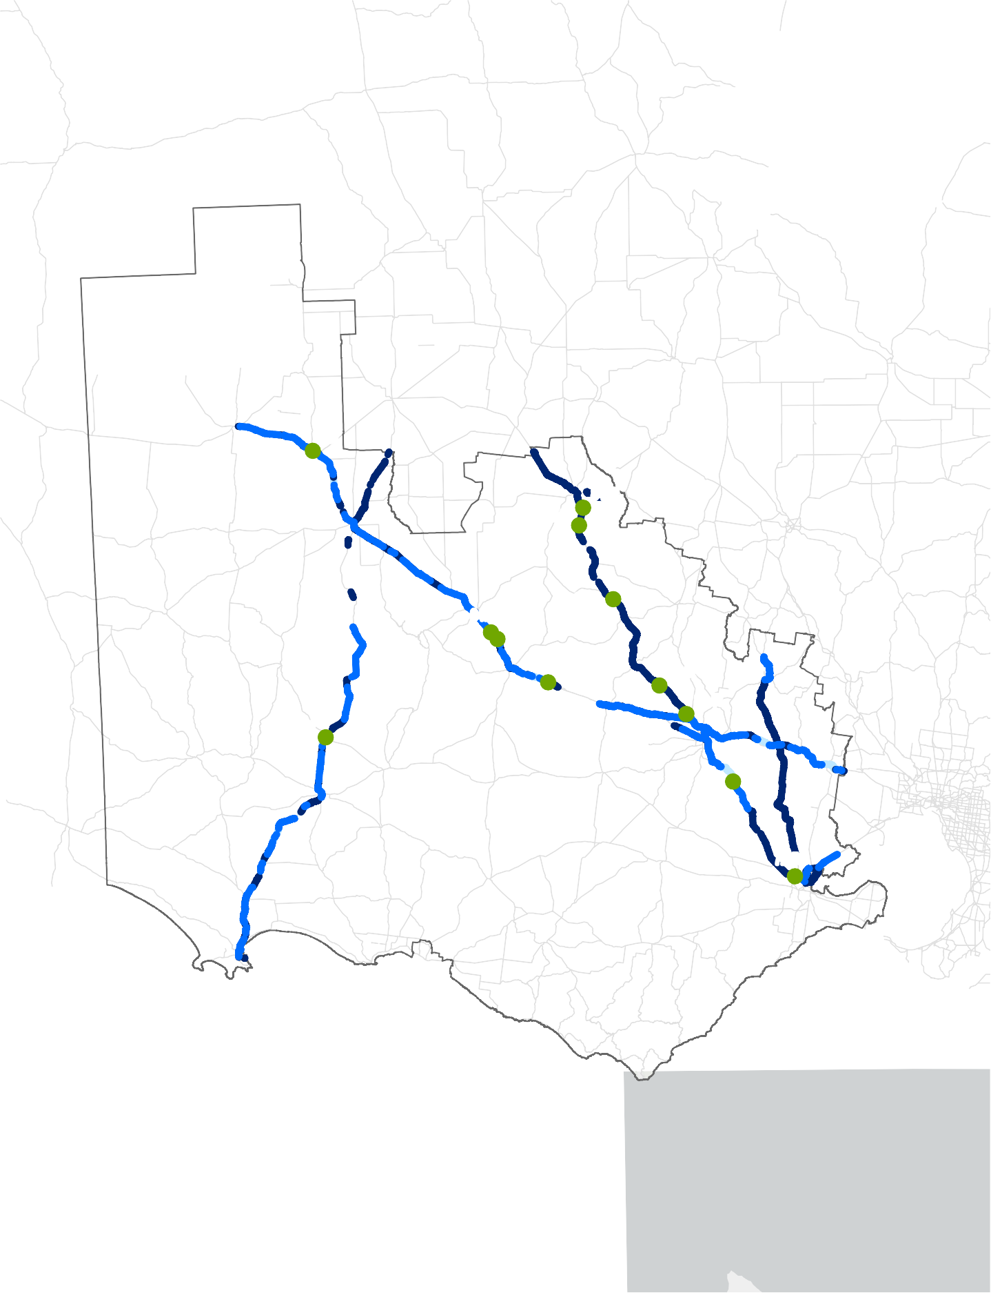
79t
Hwy

84.5t
Henty
84t
Western
Hwy
Sunraysia

84.5t 82t
84.5t

80.5t
Western Highway
Western
s
ion
Hwy
81.5t
68.5t

84.5t
Hwy
Road

84.5t
Hwy
Henty
Gramp

72.5t
ghway
Princes
Hwy
Fwy
Hamil
Princes
Hwy
ton
Princes
Hi

DRAFT

o
Paper Size ISO A4
Glenelg Shire Council
Project No.
12608290
0 10 20 30 40

Kilometers
Map Projection: Lambert Conformal Conic
Western Victoria Grain Industry Supply Chain Study
Revision No. A
Date 15/05/2024

Horizontal Datum: GDA 1994 Grid: GDA 1994 VICGRID94
Pavement and Shoulder Treatments and Types Priority A
Figure 29

Legend
Study Area Bridge Priority
B
Works type
Pavement upgrades
Pavement upgrades and shoulder works
Shoulder works

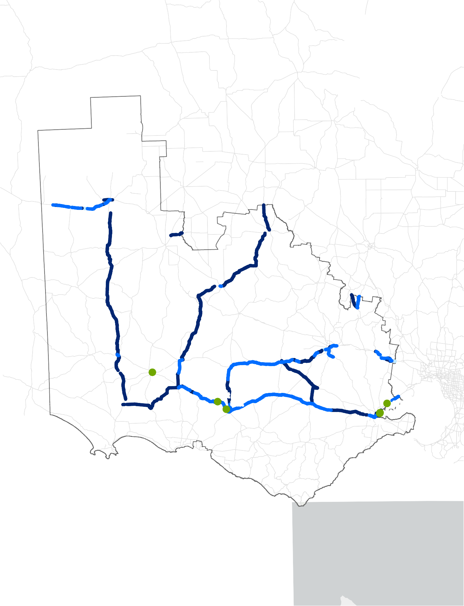
81t
Western Highway
Hwy
Western
Hwy
Sunraysia
Henty
Road
Gramp
s
ion
Hwy

78t
Princes
Hamil

84.5t
ghway
Hwy
Fwy
ton
Hi

83t
Hwy
Princes

80.5t
84.5t
Princes

DRAFT

o
Paper Size ISO A4
Glenelg Shire Council
Project No.
12608290
0 10 20 30 40

Kilometers
Map Projection: Lambert Conformal Conic
Western Victoria Grain Industry Supply Chain Study
Revision No. A
Date 15/05/2024

Horizontal Datum: GDA 1994 Grid: GDA 1994 VICGRID94
Western
Hwy
Henty
Hwy
Pavement and Shoulder Treatments and Types Priority B
Figure 30

Appendix D

Project Governance Members

Table 17 Project Governance members

Organisation | Governance Level
Allied Pinnacle | Reference Group
Ararat Rural Council | Reference Group
Cargill | Reference Group
CHS Broadbents | Reference Group
Corangamite Shire Council | Reference Group
Department of Transport and Planning | Reference Group
Department of Transport and Planning - Rail | Reference Group
Emerald Grain | Reference Group
Glenelg Shire | Reference Group
GrainCorp Limited | Reference Group
GRDC | Reference Group
Horsham Rural City Council | Reference Group
Kelly Grains | Reference Group
Pacific National | Reference Group
Port of Melbourne | Reference Group
Port of Portland | Reference Group
Qube Logistics | Reference Group
Riordan Grain Services | Reference Group
SCT Logistics | Reference Group
South West Victoria Alliance | Reference Group
Southern Shorthaul Railway | Reference Group
Stock Feed Manufacturers’ Council of Australia | Reference Group
VFF Transport & Infrastructure Committee | Reference Group
VLine | Reference Group
Watson's Bulk Logistics | Reference Group
Wimmera Southern Mallee Regional Transport Group | Reference Group
Central Highlands Regional Partnership | Steering Group
Corangamite Shire Council | Steering Group
Department of Jobs, Precincts and Regions | Steering Group
Department of Transport and Planning | Steering Group
Glenelg Shire | Steering Group
Regional Partnership Great South Coast | Steering Group
VFF | Steering Group
V/Line | Steering Group

GHD | 12608290 | Western Victoria Grain Industry Supply Chain Study 69

Appendix E

Economics assessment

GHD | Department of Transport and Planning | 12608290 | Western Victoria Grain Industry Supply Chain Study i
This document is in draft form. The contents, including any opinions, conclusions or recommendations contained in, or which may be implied from, this draft document must not be relied upon. GHD reserves the right, at any time, without notice, to modify or retract any part or all of the draft document. To the maximum extent permitted by law, GHD disclaims any responsibility or liability arising from or in connection with this draft document.

Western Victoria Grain Industry Supply Chain Study
  - Cost Benefit Analysis

Department of Transport and Planning May 06, 2024

Executive Summary
The purpose of this document is to outline the cost benefit analysis component of the Western Victorian Grain Industry Supply Chain Study (’the Study’). The focus of this study is the impact of introducing High Productivity Freight Vehicles (HPFVs) to transport grain to Geelong, Melbourne, and Portland ports following a proposed road upgrades capital program.
The use of HPFVs to transport grain from production to port is currently constrained as a result of the condition / design of sections of the road network along primary carriageways. Following upgrades of road and bridge structures along these key road networks, it is anticipated that HPFVs uptake will increase resulting in reduced operating costs and improved environmental outcomes.
In this study, current and forecast grain supply chain volumes have been evaluated to identify and prioritise road and structure upgrades that will enhance network capacity. This evaluation identified two key networks:
- Priority A – this network is focused on the main arterial links and their connections with major export gateways such as the Port of Portland, Geelong Port and Port of Melbourne. This network carries significant volumes and has been recommended to support the use of HPFVs. Key corridors include the Henty Highway, Midland Highway, Western Highway, and the Calder Highway.
- Priority B – supports the A network by feeding volumes into the main arterials and often serves as an alternative to larger corridors. In most cases, they are not HPFV approved and have been considered in this instance as part of the infrastructure assessment.
As part of the Study, four main road corridors in the region were identified, with volumes and value of grain per corridor listed in Table 1. Over 3 million tonnes of grain are moved on these major corridors per annum, with a combined value of over $1 billion.
Table 1 Number of trips and tonnage on major corridors

Corridor (north south) | Tonnes per annum | Total trips (max) | Value of grain per corridor
Henty Highway (Priority A) | 813,300 | 14,787 | $293,963,855
Western Highway (Priority A) | 744,800 | 13,542 | $269,204,819
Sunraysia Highway (Priority A) | 562,100 | 10,220 | $203,168,675
Calder Highway (Priority A) | 895,700 | 16,285 | $323,746,988
TOTAL | 3,015,900 | 54,834 | $1,090,084,337
The current grain fleet configuration comprises a series of heavy vehicle types including semi-trailers, B-double, and A-double trucks which offer different load carrying options. The largest vehicle that operates on the network is the A- double. Should Priority A and/or Priority B upgrades be completed, it is expected that largely A-doubles will be utilised to reduce the overall operating costs for the freight task. This results from their greater payload reducing the trips required to carry the same freight task. The increased capacity is a key factor as the freight task continues to grow.
Indeed, A-doubles are considered ideal for transporting grain due to their increased capacity, efficiency, and cost- effectiveness.
Key to the cost benefit analysis process is the development of assumptions, which ultimately influence the accuracy and robustness of the results. The key assumptions in this study are listed below (applicable to the Project Case).
- The economic life of the road assets post completion of the upgrades is assumed to be 50 years, in line with industry standards (Transport for NSW and ATAP).

- For modelling purposes, it is assumed that the construction start for Priority A is 30 June 2024, and construction is assumed to take 5 years.
- For modelling purposes, it is assumed that the construction start for Priority B is 30 June 2029, and construction is assumed to take 5 years.
- The capital expenditure for Priority A is assumed to be $210.4m and Priority B is assumed to be $406.6m.
- The composition of the current truck fleet is 15% semi-trailer, 50% B-double and 35% A-double for the grain transport in bulk and 10% semi-trailer, 50% B-double and 40% A-double for the grain transport in containerised form.
- The composition of the future truck fleet is assumed to be 0% semi-trailer, 25% B-double and 75% A-double for the grain transport both in bulk form and containerised.
- The transition period from the current truck fleet to the future truck fleet is assumed to be 10 years.
With an increased proportion of A-doubles operating on the network, a series of benefits are realised such as reduced operating costs for industry participants and improved environmental outcomes (reduction in air pollution, greenhouse gas emissions, noise pollution and water pollution) for the overall supply chain.
There is an increasing freight task over time and costs per km/tonne under the base case is assumed not to decrease. Alternatively, under the Project Case, the marginal cost per km/tonne will decrease. The base case considers business as usual where there is no capital outlay and no changes to the supply chain fleet configuration.
The key findings of this report are that the introduction of HPFVs, following the proposed capital works, results in:
- A reduction in the number of trips required to transport grain to the key ports, due to increased capacity of the A-double.
- A reduction in the overall kilometers travelled by transport vehicles.
- Improved safety outcomes due the reduced kilometers travelled.
- An improvement in vehicle operation externalities associated with less kilometers travelled.
- A commercial improvement in the operating costs for grain supply chain industry participants.
Aligned with the broader study, this assessment considers a key sensitivity to the Project Case which is the transition period of 10 years between the current and future state of the truck fleet. The Sensitivity Case assumes this transition period is reduced to 5 years.
Table 2 below summarises the high-level results of the sensitivity analysis.
Table 2 Sensitivity Analysis

Option | Base case (no upgrades to network) | Project Case – Priority A and B capex with 10-year of transition period | Sensitivity Case – Priority A and B capex with 5-year of transition period
NPV benefits ($ bn) | - | 0.43 | 0.46
NPV costs ($ bn) | - | 0.44 | 0.44
Average cost per tonne | 38.6 | 33.54 | 32.06
BCR (x) | - | 0.99 | 1.05
Economic impact assessment estimates that a combined Priority A and Priority B approach will generate 3,680 jobs and total output of over $1.6 billion across a ten-year period. This output includes the direct increase in economic activity, the supply-chain effects, and consumption effects as servicing sectors increase their own output, employment, and consumption in response to the direct change to the local economy. These effects are summarised in Table 3.

Table 3 Economic impact and job creation – combined Priority A and Priority B

Impact Measures | Direct Effect | Supply-Chain Effect | Consumption Effect | Total Effect
Output ($m) | 617.0 | 521.7 | 515.9 | 1,654.6
Employment (Jobs) | 964 | 1,354 | 1,362 | 3,680
Wages and Salaries ($m) | 140.0 | 126.9 | 105.6 | 372.5
Value-added ($m) | 253.5 | 217.9 | 247.9 | 719.3

Contents

Executive Summary i
- Introduction and Background 1
- Western Victoria Grain Haulage 3
  - Operational Overview 3
  - Assumptions 4
  - Impact on Haulage Costs 4
- Cost Benefit Outcomes 7
  - Cost Benefit Results 7
  - Cost Benefit Sensitivities 8
- Economic Impact and Job Creation 10
  - Purpose and approach 10
  - Priority A and Priority B Results – Economic impact and job creation 10
- Summary of outcomes 13

Table index

Table 1 | Number of trips and tonnage on major corridors | i
Table 2 | Sensitivity Analysis | ii
Table 3 | Economic impact and job creation – combined Priority A and Priority B | iii
Table 4 | Number of trips and tonnage on major corridors | 3
Table 4 | Summary of Economic Results | 7
Table 5 | Sensitivity Analysis | 8
Table 6 | Benefits and costs 2024-2044 | 9
Table 7 | Economic impact and job creation over 5-year construction period – Priority A | 10
Table 8 | Economic impact and job creation over 5-year construction period – Priority B | 11
Table 9 | Number of trips and tonnage on major corridors | 13
Table 10 | Economic impact and job creation – combined Priority A and Priority B | 13

Figure index

Table 1 | Number of trips and tonnage on major corridors | i
Table 2 | Sensitivity Analysis | ii
Table 3 | Economic impact and job creation – combined Priority A and Priority B | iii
Figure 1 | Study Area | 1

Figure 2 | Priority A and Priority B Network Components | 2
Table 4 | Number of trips and tonnage on major corridors | 3
Figure 3 | Total Forecasted Volume of Grain | 5
Figure 4 | Number of Trips by Truck Type | 5
Figure 5 | Average Cost per Tonne for Industry Participants | 6
Figure 6 | Composition of Incremental Benefits Realised | 7
Table 4 | Summary of Economic Results | 7
Table 5 | Sensitivity Analysis | 8
Table 6 | Benefits and costs 2024-2044 | 9
Table 7 | Economic impact and job creation – Priority A | 10
Table 8 | Economic impact and job creation – Priority B | 11
Table 9 | Number of trips and tonnage on major corridors | 13
Table 10 | Economic impact and job creation – combined Priority A and Priority B | 13

- Introduction and Background
This document outlines the cost benefit analysis component of the Western Victoria Grain Industry Supply Chain Study (’the Study’). This study analyses the impact of introducing High Productivity Freight Vehicles (HPFVs) for the transport of grain to the ports of Geelong, Melbourne and Portland, which is possible under the proposed capital program supporting road upgrades. The use of HPFVs for the transport of grain from production sites to the key ports is currently constrained due to the condition/design limits of parts of the road network along the primary carriageways (refer to Section 2 for further details). If the road and bridge structures that exist along the key road networks are upgraded, it is expected that a higher proportion of HPFVs will be utilised by the grain industry participants, reducing operating costs and resulting in improved environmental outcomes, when compared to the current supply chain configuration.
Figure 1 illustrates the study area, which extends across three Regional Partnerships, as well as the Barwon Regional Partnership, due to the Region’s proximity to major ports in Geelong and Portland, along with the relevant transport infrastructure.
Figure 1 Study Area

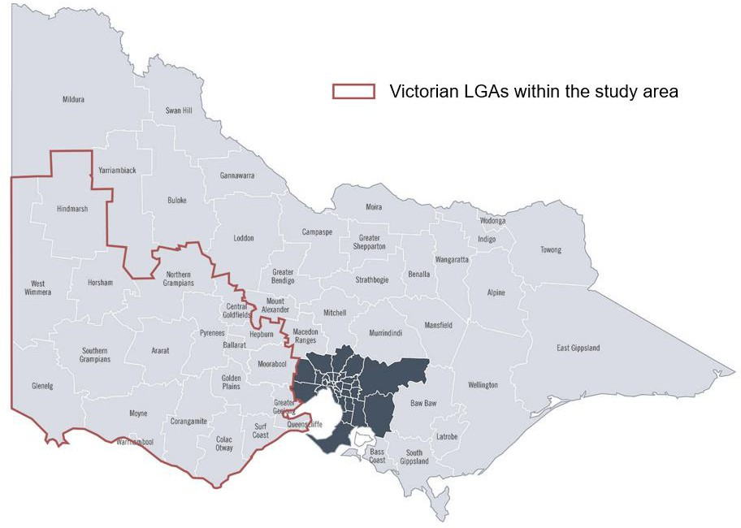

As part of the Study, the current and forecast grain supply chain volumes have been evaluated. This led to the identification and prioritization of road and structure upgrades (to enhance the capacity of the network) into two key networks:
- Priority A – this network is focused on the main arterial links and their connections with major export gateways such as the Port of Portland, Geelong Port and Port of Melbourne. This network cumulatively carries significant volumes and has been recommended to support the use of HPFVs. Key corridors include the Henty Highway, Midland Highway, Western Highway and the Calder Highway.
- Priority B – supports the A network by feeding volumes into the main arterials and often serve as alternatives to larger corridors. In most cases, they are not HPFV approved and have been considered in this instance as part of the infrastructure assessment.

The key carriageways that have been classified within Priority A and Priority B are both utilized by the grain supply chain extensively and are shown in

Figure 2 below (refer to Section 2 for further details such as number of trips and grain tonnage along major corridors).

Figure 2 Priority A and Priority B Network Components
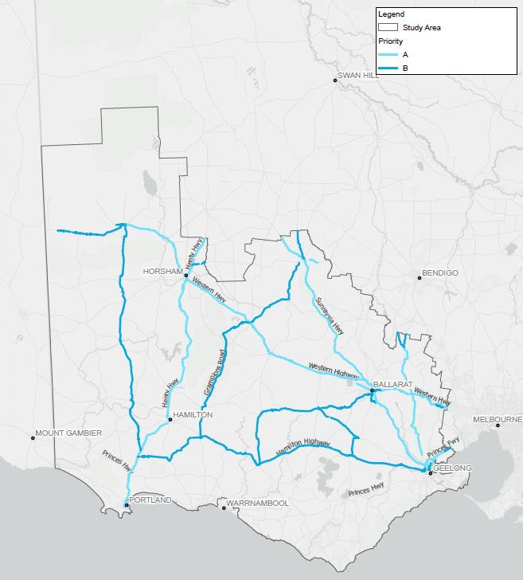

The cost benefit analysis presented in this study will consider the magnitude of the required capital expenditure, and weigh this against the expected benefits, such as operational cost savings for grain supply chain participants.
It is noted that the significance of early transport infrastructure intervention led to many benefits, including reliability, safety, longevity, and cost-effectiveness and the purpose of this study is to highlight the magnitude of these benefits, and provide relevant key insights.

- Western Victoria Grain Haulage
  - Operational Overview
The grain supply chain in Victoria’s South West region is complex and multifaceted, and relies upon both road and rail infrastructure. In its current state, the road infrastructure in the region is constrained due to the design limits and current condition of both road pavement and bridges.
Grain holds a crucial position in Victoria's export activities, leading to a concentration of grain transportation towards key export gateways of Port of Portland, Geelong Port, and the Port of Melbourne, and for domestic consumption.
As part of the Study, four main road corridors in the region were identified, with details pertaining to the grain supply chain listed below in Table 4.
Table 4 Number of trips and tonnage on major corridors

Corridor (north south) | Tonnes per annum¹ | Total trips (max) | Value of grain per corridor
Henty Highway (Priority A) | 813,300 | 14,787 | $293,963,855
Western Highway (Priority A) | 744,800 | 13,542 | $269,204,819
Sunraysia Highway (Priority A) | 562,100 | 10,220 | $203,168,675
Calder Highway (Priority A) | 895,700 | 16,285 | $323,746,988
TOTAL | 3,015,900 | 54,834 | $1,090,084,337
The total value of grain per corridor outlined above demonstrates that these four main road corridors carry over $1 billion worth of grain per year. The total value of one tonne of grain has been determined at $361.45 based on information from Agriculture Victoria² and cross-referenced with weekly commodity prices from the NSW Department of Primary Industries³.
The road freight network encompasses various types of roads, vehicles, and freight types, including light commercial vehicles, rigid trucks, and articulated trucks. Overall, the use of High Productivity Freight Vehicles (HPFVs) is currently constrained, as sections of the main corridors listed above are either:
- in poor condition and require maintenance; or
- are not designed to accommodate HPFVs.
Currently, the grain fleet comprises a series of heavy vehicle types including semi-trailer, B-double, and A-double trucks to offer a variety of load carrying options for differing needs. The largest vehicle that operates on the network is the A-double. If the Priority A and/or Priority B upgrades are completed, it is expected that over time, the vehicles utilized will largely be A-doubles, as this will reduce the overall operating costs for the freight task. This is because, with a greater payload, a reduced number of trips is required to carry the same freight task, which is important as the freight task continues to grow.
Therefore, any improvement to the roads that have been identified in the Priority A and Priority B networks, will result in operational efficiencies for the grain supply chain. This is because A-doubles are considered ideal for transporting grain in Australia due to their increased capacity, efficiency, and cost-effectiveness. Their ability to carry larger loads in a single trip reduces fuel consumption and overall transport costs.

¹ Derived from average payload across the heavy vehicle fleet
² Agriculture Victoria, Victorian Grains Industry Fast Facts, January 2023,
https://agriculture.vic.gov.au/ data/assets/pdf_file/0007/921166/GRAINS_FAST-FACTS_JANUARY-2023.pdf
³ NSW Department of Primary Industries, Weekly Commodity Report, 26 April 2024, https://www.dpi.nsw.gov.au/agriculture/commodity-report

  - Assumptions
An important part of the cost benefit analysis process is the development of assumptions, which ultimately influence the accuracy and robustness of the results. The key assumptions that are foundational for cost benefit analysis are listed below as they apply for the Project Case.
    - The economic life of the road assets post completion of the upgrades is assumed to be 50 years, in line with industry standards (Transport for NSW and ATAP).
    - For modelling purposes, it is assumed that the construction start for Priority A is 30 June 2024, and construction is assumed to take 5 years.
    - For modelling purposes, it is assumed that the construction start for Priority B is 30 June 2029, and construction is assumed to take 5 years.
    - The capital expenditure for Priority A is assumed to be $210.4m over the 5-year construction period and Priority B is assumed to be $406.6m over the 5-year construction period.
    - The composition of the current truck fleet is 15% semi-trailer, 50% B-double and 35% A-double for the grain transport in bulk and 10% semi-trailer, 50% B-double and 40% A-double for the grain transport in containerised form.
    - The composition of the future truck fleet is assumed to be 0% semi-trailer, 25% B-double and 75% A-double for the grain transport both in bulk form and containerised.
    - The transition period from the current truck fleet to the future truck fleet is assumed to be 10 years.
    - The safety costs and environmental cost parameters utilised in the model have been sourced from BITRE Road trauma involving heavy vehicles (2021) and TfNSW Economic Parameter Values (August 2022).
    - Vehicle operating costs (costs per tonne) parameters have been sourced from Western Victoria Grain - Truck Cost Curve Model v1.1.

  - Impact on Haulage Costs
The capital investment identified for Priority A and Priority B will have a significant and positive impact on the competitiveness of the grain industry and related supply chains. Given the interconnectedness of the local economy to the grain industry, these benefits will spill over to the broader economy of the region.
This investment is needed to support expected increases in the freight task from an estimated 4.5 million tonnes per annum (in 2025) to 8.5 million tonnes per annum (in 2074), as per Figure 3 below. This investment will also assist in the transition to a lower cost regime and support an increase in HPFVs.
The grain forecasts consider both average and peak year cases to explore potential infrastructure solutions and assess the impacts of varying grain volumes effectively. The forecasting horizon spans 30 years, offering flexibility to adapt to changing circumstances. This includes climate change impacts which includes potential increased frequency of drought years, declining average rainfall and extremities like a higher number of freezing days⁴
To project grain production, a Compounded Annual Growth Rate (CAGR) is applied, accounting for both average and peak year scenarios, enabling a more nuanced analysis of future trends.

⁴ https://www.monash.edu/ data/assets/pdf_file/0011/2760248/Technical-Report-22-Nov-2021.pdf

Figure 3 Total Forecasted Volume of Grain
9
8
7
6
5
4
3
2
1
-

Bulk volume - Portland Bulk volume - Geelong Bulk volume - Melbourne Container volume - Melbourne Domestic volume - Local
Millions tonnes

2025
2027
2029
2031
2033
2035
2037
2039
2041
2043
2045
2047
2049
2051
2053
2055
2057
2059
2061
2063
2065
2067
2069
2071
2073

By enabling an increased proportion of A-doubles to operate throughout the network, a series of benefits are realised, including reduced operating costs for industry participants and improved environmental outcomes (reduced air pollution, greenhouse gas emissions, noise pollution and water pollution) for the overall supply chain. As per Figure 4 below, the number of trips by truck type is forecasted to reduce for both semi-trailers and A-doubles, while increasing for B-doubles.
Figure 4 Number of Trips by Truck Type
180
160
140
120
100
80
60
40
20
-
Semi trailer B Double A Double
'000 trips

Importantly, there are industry cost savings associated with a reduced number of trips required to transport the grain. This improves international competitiveness for industry participants by reducing transport operating costs. In the long
2024
2026
2028
2030
2032
2034
2036
2038
2040
2042
2044
2046
2048
2050
2052
2054
2056
2058
2060
2062
2064
2066
2068
2070
2072
2074

term, this may lead to increased investment in the grain industry for the region, creating jobs and improving economic conditions. The forecasted trajectory of the average cost per tonne is shown in Figure 5.
To illustrate, one trip of 25 tonnes of grain in 2025 is estimated to cost ~$965, compared to in 2041 where it is ~$802 (a 16.9% decrease). This decrease is primarily driven by the increased capacity and the reduction in operational cost per kilometre of the A-double compared to semi-trailers and B-doubles, which means that less trips are required to transport the same amount of grain.
Figure 5 Average Cost per Tonne for Industry Participants
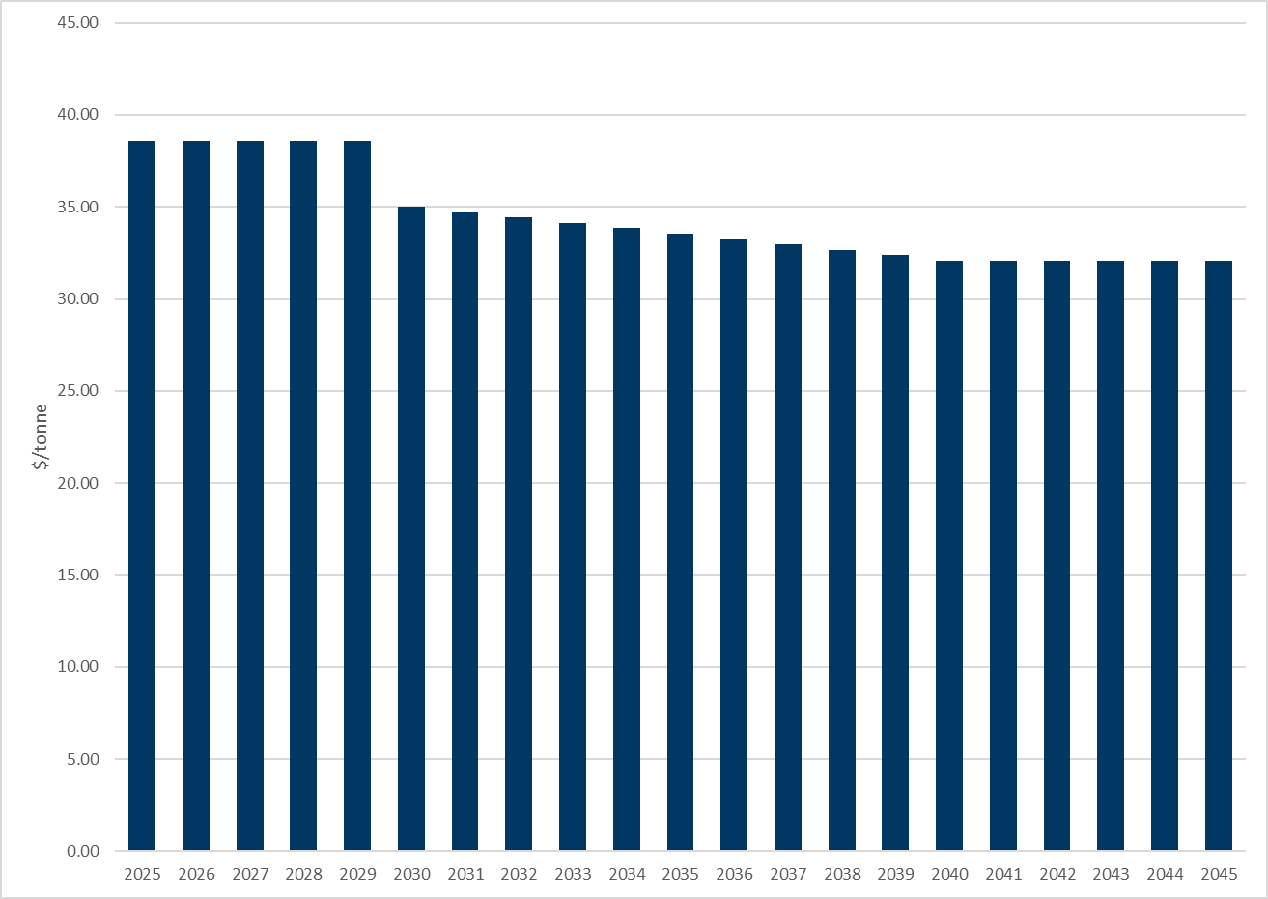

- Cost Benefit Outcomes
The purpose of this study is to demonstrate the expected economic benefit associated with the proposed capital works program (road and bridge upgrades), which will change the grain supply chain fleet configuration by enabling an increased proportion of HPFVs.
There is an increasing freight task over time and costs per unit under the base case are not decreasing. Alternatively, under the Project Case, the marginal cost per unit of transport freight decreases. Figure 6 below demonstrates the whole of life incremental benefits that will be realised under the Project Case.
Figure 6 Composition of Incremental Benefits Realised
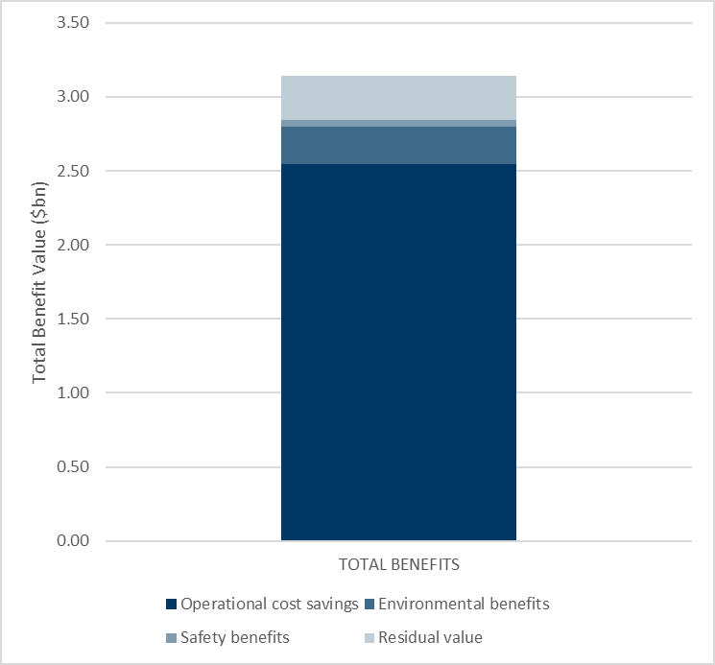

  - Cost Benefit Results
A standard economic analysis entails an analysis of options based on a cost benefit analysis (CBA) framework. The CBA considers benefits accruing against the costs associated with each option, calculating a benefit-cost ratio (BCR) to assist in assessing the economic viability of the selected options.
A CBA monetises the benefits and costs (where possible) and discounts to present value benefits and costs to provide a basis for direct comparison between the selected options and base case. In this study, the options are different scenarios on what investment is required to reduce the cost per tonne of freight. Specifically, this study considers whether the investment needed is justified by the benefits accrued. The results for the Project Case are illustrated below, in Table 4. A full analysis of the benefits and costs of the project case over the study period are set out in
Table 6 at the end of this section in 5-year intervals.
Table 4 Summary of Economic Results

Summary results | NPV
Benefits ($ bn) | 0.43
Costs ($ bn) | 0.44
BCR (x) | 0.99

The base case considers business as usual where there is no capital outlay and no changes to the supply chain fleet configuration. Section 2.2. details the costs considered in this study such as operational costs.
In this study, several benefits are considered on an incremental basis such as operational cost savings, environmental benefits, and safety benefits. Operational cost savings are considered domestically, per container and from bulk to Ports along with the cost per tonne of freight and road maintenance costs. The environmental benefits are the reduction in air pollution, noise, water pollution, impact on nature and landscape and the reduction in greenhouse gas emissions. Safety benefits considers annual fatal crashes per billion, hospitalised injuries as a result of fatal crashes, and the cost per casualty and per crash.

  - Cost Benefit Sensitivities
Aligned with the broader study, this assessment considers a key sensitivity to the Project Case. Namely, a central assumption in the Project Case is the application of a 10-year transition between the current and future state for the truck fleet. The Sensitivity Case assumes that the transition period is reduced to 5 years. Table 5 summarises the high-level results of the sensitivity analysis.
Table 5 Sensitivity Analysis

Option | Base case (no upgrades to network) | Project Case – Priority A and B capex with 10-year of transition period | Sensitivity Case – Priority A and B capex with 5-year of transition period
NPV benefits ($ bn) | - | 0.43 | 0.46
NPV costs ($ bn) | - | 0.44 | 0.44
Average cost per tonne | 38.6 | 33.54 | 32.06
BCR (x) | - | 0.99 | 1.05

For both cases:
    - A-double vehicles remain the most affordable cost per tonne truck type with cost in 2025 at $28.26 per tonne, and
$26.42 per tonne in 2074. Semi-trailer cost per tonne is approximately double at $43.39 in 2025, and $40.63 in 2074. B-double vehicles offer a middle ground at $32.60 per tonne in 2025, and $29.13 per tonne in 2074.
    - Semi-trailers are expected to be phased out by the end of 2040. Over this same period, there is a steep decrease in trips by B-double vehicles and a corresponding increase in trips by A-double vehicles as more A-double vehicles come online and dependence on B-double vehicles is decreased.
Under the Project Case the following occurs:
    - The average cost per tonne is expected to decrease from $38.60 in 2025-2029 to $35.00 in 2030, dropping by
0.30 every year until the cost stabilizes at $32.00 in 2041 where it will remain until the end of the analysis period (2073).
Under the Sensitivity Case the following occurs:
    - The average cost per tonne is expected to decrease from $38.60 in 2025-2029 to $34.76 in 2030, dropping by
0.53 every year until cost stabilizes at $32.08 in 2035 where it will remain until the end of the analysis period (2073).

Table 6 Benefits and costs 2024-2044

Period |  |  | 1 | 5 | 10 | 15 | 20 | 25 | 30 | 35 | 40 | 45 | 50
 | Units | NPV (7%) | 2025 | 2029 | 2034 | 2039 | 2044 | 2049 | 2054 | 2059 | 2064 | 2069 | 2074
Benefits
Operational cost savings | $m | 351 | - | - | 25 | 35 | 39 | 42 | 45 | 48 | 51 | 54 | 58
Environmental benefits | $m | 59 | - | - | 4 | 6 | 7 | 7 | 8 | 8 | 9 | 9 | 10
Safety benefits | $m | 11 | - | - | 1 | 1 | 1 | 1 | 1 | 2 | 2 | 2 | 2
Residual benefits | $m | 11 | - | - | - | - | - | - | - | - | - | - | 295
Total benefits | $m | 433 | - | - | 30 | 42 | 47 | 50 | 54 | 57 | 61 | 65 | 365
Costs
Capital costs | $m | 439 | 42 | 42 | 81 | - | - | - | - | - | - | - | -
Total costs | $m | 439 | 42 | 42 | 81 | - | - | - | - | - | - | - | -
Net Benefit | $m | (6) | (42) | (42) | (51) | 42 | 47 | 50 | 54 | 57 | 61 | 65 | 365
BCR | X | 0.99

- Economic Impact and Job Creation
Economic Impact Assessment (EIA) attempts to capture all induced or flow-on impacts of regional investment projects on a regional economy. There are generally four channels through which the spill-over or flow-on impacts from an investment activity are generated on its regional economy. They are:
- Production and investment induced impacts through input-output linkages of individual industries of a regional economy including inter-regional trades used by other regional industries;
- Consumers’ induced impacts through household spending of their incomes on goods and services produced from a local or regional economy;
- Regional price/wage induced substitution and investment impacts through their impacts on intra- and inter-regional trades, international trades, and labour mobility across regions; and
- Technology induced productivity spill-over impacts through business cost savings and regional competitiveness levels.

  - Purpose and approach
Economic impact assessment has been undertaken to estimate the economic impact and job creation of capital expenditure on Priority A and Priority B upgrades. The approach adopted to estimate the economic impact is Input-Output (IO) modelling, which is a well-established methodology to estimate the flow-on or ‘multiplier’ impact from a direct stimulus to an economic region. The direct stimuli used in the modelling was capital expenditure, and this was split into 85% Heavy & Civil Engineering Construction and 15% Professional, Scientific, and Technical Services.

  - Priority A and Priority B Results – Economic impact and job creation
Economic impact and job creation for Priority A and Priority B are summarised in Table 6 and Table 7 below.
Table 7 Economic impact and job creation over 5-year construction period – Priority A

Impact Measures | Direct Effect | Supply- Chain Effect | Consumptio n Effect | Total Effect | Type 1 Multiplier | Type 2 Multiplier
Output ($m) | 210.4 | 177.9 | 175.9 | 564.2 | 1.85 | 2.68
Employment (Jobs) | 329 | 462 | 464 | 1,255 | 2.40 | 3.81
Wages and Salaries ($m) | 47.7 | 43.3 | 36.0 | 127.0 | 1.91 | 2.66
Value-added ($m) | 86.4 | 74.3 | 84.5 | 245.3 | 1.86 | 2.84
Analysis of results
- In Priority A, direct stimulus including expenditure in the construction of road pavement, shoulder, and bridges amount to $210.4 million over the 5-year construction period. These costs represent capital expenditure in the construction and professional/technical services sectors of the economy, which is a direct generation of economic activity.

- From this direct increase in economic activity, it is estimated that the demand for intermediate goods and services (e.g. fuel, spare parts) would rise by $177.9 million over the 5-year construction period. These supply-chain effects include multiple rounds of flow-on effects, as servicing sectors increase their own output and demand for local goods and services in response to the direct change to the local economy.
- The positive stimulus to the economy from the direct and supply-chain effects is expected to create jobs in the economy, with a corresponding induced increase in total wages and salaries paid to the employees. A proportion of these wages and salaries would typically be spent in the local economy, estimated to be $175.9 million over the construction period.
- Total output in the Priority A case is estimated to be $564.2 million over the construction period.
- In total, the employment impact of this stimulus is 1,255 FTE jobs over the construction period, earning $127 million in wages and salaries over the same period. This is equivalent to an average of 251 jobs per year, earning an average of $101,190 annually.
- From the direct increase in output from the initial Priority A stimulus the corresponding increase in direct value-added is estimated to be $86.4 million over the 5 years. Including the flow-on supply- chain impact of $74.3 million, and the consumption effect of $84.5 million, the total value-added from Priority A is estimated to be $245.3 million over the 5-year period.

Table 8 Economic impact and job creation over 5-year construction period – Priority B

Impact Measures | Direct Effect | Supply- Chain Effect | Consumptio n Effect | Total Effect | Type 1 Multiplier | Type 2 Multiplier
Output ($m) | 406.6 | 343.8 | 340.0 | 1,090.5 | 1.85 | 2.68
Employment (Jobs) | 635 | 892 | 898 | 2,425 | 2.40 | 3.82
Wages and Salaries ($m) | 92.3 | 83.6 | 69.6 | 245.5 | 1.91 | 2.66
Value-added ($m) | 167.1 | 143.6 | 163.4 | 474.0 | 1.86 | 2.84
Analysis of results
- In Priority B, direct stimulus including expenditure in the construction of road pavement, shoulder, and bridges amount to $406.6 million over the 5-year construction period. These costs represent capital expenditure in the construction and professional/technical services sectors of the economy, which is a direct generation of economic activity. Priority B is constructed over the 5- year period subsequent to Priority A.
- From this direct increase in economic activity, it is estimated that the demand for intermediate goods and services (e.g. fuel, spare parts) would rise by $343.8 million over the 5-year construction period. These supply-chain effects include multiple rounds of flow-on effects, as servicing sectors increase their own output and demand for local goods and services in response to the direct change to the local economy.
- The positive stimulus to the economy from the direct and supply-chain effects is expected to create jobs in the economy, with a corresponding induced increase in total wages and salaries paid to the employees. A proportion of these wages and salaries would typically be spent in the local economy, estimated to be $340 million over the construction period.
- Total output in the Priority B case is estimated to be $1.09 billion over the construction period.

- In total, the employment impact of this stimulus is 2,425 FTE jobs over the construction period, earning $245.5 million in wages and salaries over the same period. This is equivalent to an average of 485 jobs per year at an average wage per year of $101,221.
- From the direct increase in output from the initial Priority B stimulus the corresponding increase in direct value-added is estimated to be $167.1 million over the 5 years. Including the flow-on supply-chain impact of $143.6 million, and the consumption effect of $163.4 million, the total value-added from Priority B is estimated to be $474 million over the 5-year period.

- Summary of outcomes
The study identified four main road corridors in the region, key grain supply chain parameters listed below in Table 1. Over 3 million tonnes of grain are moved on these major corridors per annum, with a combined market value of over $1 billion.
Table 9 Number of trips and tonnage on major corridors

Corridor (north south) | Tonnes per annum | Total trips (max) | Value of grain per corridor
Henty Highway (Priority A) | 813,300 | 14,787 | $293,963,855
Western Highway (Priority A) | 744,800 | 13,542 | $269,204,819
Sunraysia Highway (Priority A) | 562,100 | 10,220 | $203,168,675
Calder Highway (Priority A) | 895,700 | 16,285 | $323,746,988
TOTAL | 3,015,900 | 54,834 | $1,090,084,337
Introduction of HPFVs as a result of capital expenditure on the improvement of the road network to the ports, results in:
- A reduction in the number of trips required to transport grain to the key ports, due to increased capacity of the A-double.
- A reduction in the overall kilometers travelled by transport vehicles.
- Improved safety outcomes as a result of reduced kilometers travelled.
- An improvement in vehicle operation externalities associated with less kilometers travelled.
- A commercial improvement in the operating costs for grain supply chain industry participants.
Economic impact assessment demonstrated that a combined Priority A and Priority B approach will generate an estimated 3,680 jobs and total output of over $1.6 billion over a ten-year period. This output includes the direct increase in economic activity, the supply-chain effects, and consumption effects as servicing sectors increase their own output, employment, and consumption in response to the direct change to the local economy. These effects are summarised in Table 3.
Table 10 Economic impact and job creation – combined Priority A and Priority B

Impact Measures | Direct Effect | Supply-Chain Effect | Consumption Effect | Total Effect
Output ($m) | 617.0 | 521.7 | 515.9 | 1,654.6
Employment (Jobs) | 964 | 1,354 | 1,362 | 3,680
Wages and Salaries ($m) | 140.0 | 126.9 | 105.6 | 372.5
Value-added ($m) | 253.5 | 217.9 | 247.9 | 719.3


ghd.com
The Power of Commitment

